# Climate Change

## Introduction

Climate change is affecting California in many measurable ways; sea levels are rising, days and nights are warmer, snowfall is becoming rain and water temperatures are increasing. All of these changes are impacting our water resources now; continuation of these trends has the potential to significantly impact the sustainability of the State’s water supplies, with serious consequences in the State’s ability to meet ever-growing demand. Recently, the ability to meet demands has been further hampered by a multi-year drought. In the future, more frequent and more severe droughts are being predicted. In addition, climate projections point to continued increases in storm intensities.

Climate change is a long-term alteration in global weather patterns such as precipitation, temperature, wind, and severe weather events. Climate change can occur from both natural causes (e.g. influences from the Earth’s natural orbital cycle) and anthropogenic causes (resulting from the influence of human beings on nature). Greenhouse gas concentrations, including methane and carbon dioxide cause warming. Anthropogenic release of these gases interacts with natural drivers of climate change.

Further climate changes are projected to generate water resources vulnerabilities in the Southern Sierra Nevada. These vulnerabilities are discussed in detail later in this chapter in Sections 15.3 and 15.4. Generally speaking, however, increases in temperatures will affect the timing and amount of runoff, thereby affecting timing and quantity of water availability for storage and human consumption. In addition, water quality is vulnerable to increased potential for more frequent and longer duration droughts, severe storms, wildfires and lower late summer flows.

The California Department of Water Resources (DWR) recognizes that climate-change projections have some uncertainty, and thus use a range of projections from different climate models to inform scenarios for future planning (*CalEPA*, 2015). While DWR requires that planning for a changing climate be acknowledged and incorporated to the greatest degree possible into Integrated Regional Water Management Plans, it is also responsible and prudent resource management to use the best available information to guide local and regional planning, even if that goes beyond the minimum requirements of DWR. Further, due to the acknowledged range in temperature and precipitation projections, water managers should acknowledge the range of projected future conditions rather than just the mean, and include uncertainties in the water planning process, including regulatory, environmental, economic, social and other conditions affecting water-related institutions, infrastructure and services.

Paleoclimatic evidence, such as ice cores, lake varves (layers of sediment), and tree rings show a correlation between greenhouse gas concentrations and global temperatures (Ruddiman, 2002). For nearly 30 years there has been scientific concensus that climate change is occurring and that human-caused emissions of heat-trapping gases are the primary causes (Houghton et al. 1990). Two climate extremes, droughts and floods, are of particular interest to California water managers and water users. While California has experienced multi-year droughts in the past century, including a 5-year drought from 2012-2016, the paleoclimate record shows evidence of multiple droughts of this duration per century-decadal droughts during the past millennium (Meko et al., 2014). While multi-year droughts are recurring and natural events, climate warming increases their severity and impact on the southern Sierra (Bales et al., 2018).

The extent and range of climate-change impacts in the Southern Sierra IRWM area include variable (more and less) precipitation patterns and river flows, rising temperatures, and earlier or faster snowmelt. California is expected to experience dramatically warmer temperatures during this century, ranging from 2.0 to 2.9**°**C (3.6 to 5.2**°**F) by mid-century and 2.4 to 4.6**°**C (4.3 to 8.3**°**F) by the end of the century (He et al., 2018). Climate-change impacts projected to affect the Southern Sierra Region, associated with these magnitudes of warming, include: i) more critically dry periods, including multi-year droughts, ii) increasing demand from a growing population as temperatures rise, iii) earlier snowmelt and runoff, and iv) increased competition for water among urban and agricultural water users and environmental needs. These impacts are exacerbated by overpumping of groundwater, which is addressed through the Sustainable Groundwater Management Act, and by increasing wildfire intensity. Climate projections provide a range for future increases in temperature, and even the lowest estimates would have serious impacts.

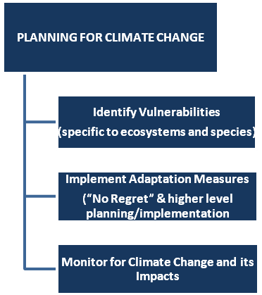

Figure 15‑1 General Strategy to Plan for Climate Change in Southern Sierra IRWMP

Specific topics addressed in this chapter include:

* Key climate change literature sources,
* General impacts from climate change,
* A vulnerability assessment for the Southern Sierra IRWM area using the Vulnerability Assessment forms from the DWR *Climate Change Handbook*
* Vulnerability assessment and adaptation & mitigation strategies for the Southern Sierra Region
* Climate change monitoring
* Consideration of greenhouse gas emissions in the project review process
* Climate Change in other IRWMP Chapters

## Literature Sources

Numerous documents were used to evaluate climate change in the Southern Sierra IRWM area. Published government reports included the *Climate Change Handbook for Regional Water Planning*, (DWR and EPA, 2011). This handbook is the most recent and most practical climate change document published by the DWR, and provides numerous tools for addressing climate change. This document is not required for preparing IRWMPs; however, DWR does recommend its use. Other reports include the *Perspectives and Guidance for Climate Change Analysis*, also published by DWR.

Understanding of the effects of climate change on watershed hydrology in the Sierra Nevada has been rapidly increasing, particularly in regards to the interaction effects with vegetation. Consequently, a heavy emphasis was placed on the recent scientific literature. Other climate change references included California Natural Resources Agency (2009), California State University at Fresno (2008), Conrad (2012), ClimateWise (2010), DWR (October 2008), Institute (2014)*,* California Resources Agency (2008) workshop; final report and presentations (hosted on <http://climate.calcommons.org/>).

Some local water and land use documents address climate change, including the Fresno and Tulare County General Plans. To the extent that they are enumerated, the climate change goals and policies in these documents are generally consistent with this IRWMP. Typical climate change mitigation measures include energy efficiency requirements at new developments, compact urban development and promoting development of renewable energy. Climate change is missing from many older planning documents; however, it is being addressed in most new planning efforts.

## Impacts from Climate Change

Introduction

An increase in global atmospheric greenhouse gas concentrations is contributing to higher temperatures in California (Office of Environmental Health Hazard Assessment, 2018). As greenhouse gas concentrations continue to rise, further changes to California’s climate are anticipated, with additional effects on California water resources, ecosystems, and economy. The extent of these effects will depend on the ultimate level and timing of peak greenhouse gas concentrations, i.e. the extent to which the global community reduces greenhouse-gase emissions to the atmosphere and removes previously emitted greenhouse gases from the atmosphere. Under the Paris Climate Accord in 2015, a framework was established for limiting the rise in global temperatures under two degrees Celsius. In California, policies have been put in place to reduce greenhouse gas emissions to at least 40% and 80% below 1990 levels by 2030 and 2050, respectively (California Air Resources Board, 2017). These policies will help to moderate increases in temperature but uncertainty remains regarding how high greenhouse gas concentrations will be in the future.

Global climate models (GCMs) are mechanistic models used to understand and predict how changes in variables such as greenhouse gas concentrations will affect future climate at global scales. GCMs are developed and maintained by numerous research groups around the world, with each group using a slightly different approach to modeling the underlying atmospheric physics. The 5th Coupled Model Intercomparison Project (CMIP5) is a coordinated experiment to simulate each GCM using the same forcing inputs (i.e. greenhouse gas concentrations). This project permits the comparison of output between different GCMs, providing an estimate of the uncertainty in climate projections. As future concentrations are unknown, CMIP5 uses four different scenarios, or Representative Concentration Pathways (RCPs), to force the models (van Vuuren et al., 2011). The four RCPs, RCP2.6, RCP4.5, RCP6.0, and RCP8.5, represent different levels of greenhouse gas emissions and accumulated concentrations in the atmosphere. The four pathways roughly equate to aggressive, moderate, little and no action being taken to reduce greenhouse gas emissions, respectively.

Spatial output from individual GCMs is generally greater than 100km by 100km, limiting our ability to directly apply GCM results to heterogeneous areas such as the Southern Sierra Region, which is topographically, climatically, ecologically and hydrologically variable. To address this, output from GCMs are downscaled, or transformed to a higher resolution, in order to be analyzed at a regional scale. Two commonly used approaches for downscaling are dynamic and statistical. Dynamic downscaling involves running high-resolution, regional mechanistic models using low resolution GCM output as the driving data. Alternatively, statistical downscaling consists of developing statistical relationships between local-scale climate variables and large-scale climate variables that can be modeled by GCMs (Abatzoglou and Brown, 2012).

In this section, we review of what is known about climate change impacts on California and the Sierra Nevada. In addition, we incorporate new understanding about the how projected changes will affect the Southern Sierra Region by including key findings from a climate change report, *Evaluating Climate Change Effects on the Hydrology of Southern Sierra Nevada Basins*, which was produced by the Sierra Nevada Research Institute (SNRI) at the University of California, Merced with funding provided by the IRWM (Bart et al., 2018). This study was conducted to improve understanding of the effects of climate change on the Southern Sierra Region by investigating 1) how the climate in the Southern Sierra Region will change throughout the 21st century, 2) how these changes in climate will directly impact hydrology in the Region, and 3) how changes in climate will alter vegetation and vegetation disturbances in the Region which will have further effects on the Region’s hydrology. The full report can be found in **Appendix M**. All figures in this section and all results referring specifically to the Southern Sierra Region are derived from the report.

Temperatures

Temperatures throughout California and the Sierra Nevada are increasing. Over the period from 1918 to 2006, maximum and minimum temperatures in California rose an average of 0.07**°**C and 0.17**°**C per decade, respectively (Cordero et al., 2011). These trends have accelerated since 1970 (Cordero et al., 2011) and particularly during the past decade, with the four hottest years on record occurring between 2014-2017 (Office of Environmental Health Hazard Assessment, 2018). These increases in temperature are consistent with climate projections and indicate that California is already seeing the effects of climate change. In the Sierra Nevada, significant warming has also been observed, although the increases have been smaller than for California as a whole (0.08 and 0.21**°**C per decade for maximum and minimum temperatures, respectively) (Cordero et al., 2011). For both the Sierra Nevada and California, nighttime temperatures have been rising faster than daytime temperatures.

California temperatures are projected to continue to increase during the 21st century. Using downscaled CMIP5 GCM projections, He et al. (2018) estimated that California temperatures would increase between 1.8 and 2.0**°**C by mid-century and 2.2 to 2.4**°**C by the end of the century, even under the optimistic RCP4.5 scenario. Slightly higher estimates are projected for the Southern Sierra Region. For RCP4.5, mean annual maximum temperatures are projected to increase 2.5**°**C by mid-century (2040-2069) and 3.3**°**C by the end of the century (2070-2099) (Figure 15-2). Under the RCP8.5, temperatures are projected to increase 3.4**°**C and 5.2**°**C, respectively, over the same time periods. Mean annual minimum temperatures in the Southern Sierra Region are projected to increase 2.3**°**C (2040-2069) and 2.9**°**C (2070-2099) under the RCP4.5 scenario and 3.1**°**C (2040-2069) and 5.0**°**C (2070-2099) under RCP8.5. All of these finding indicate that temperatures in the Southern Sierra Region are going to substantially increase in the future. Further, projections indicate that maximum temperatures will increase more than minimum temperatures. These changes run counter to currently observed temperature increases in California, where minimum temperatures are increasing faster than maximum temperatures. However, He et al. (2018) has reported similar findings throughout California.

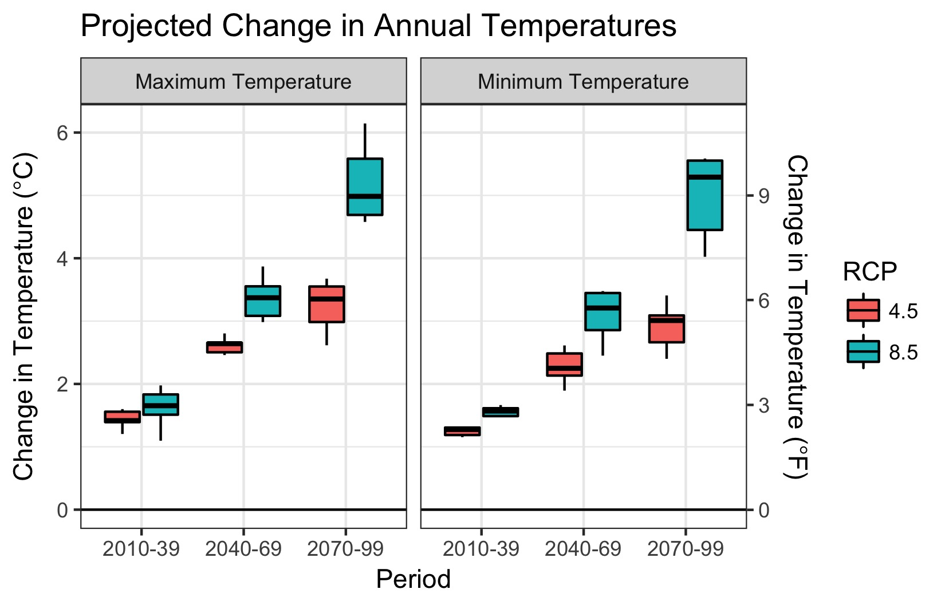

Figure 15-2 Projected changes in mean annual temperatures for the Southern Sierra Region, relative to 1950-2005 baseline. Variability in projections represents different GCMs. Historical baseline values of maximum and minimum mean annual temperatures are 15.4°C and 2.2°C, respectively.

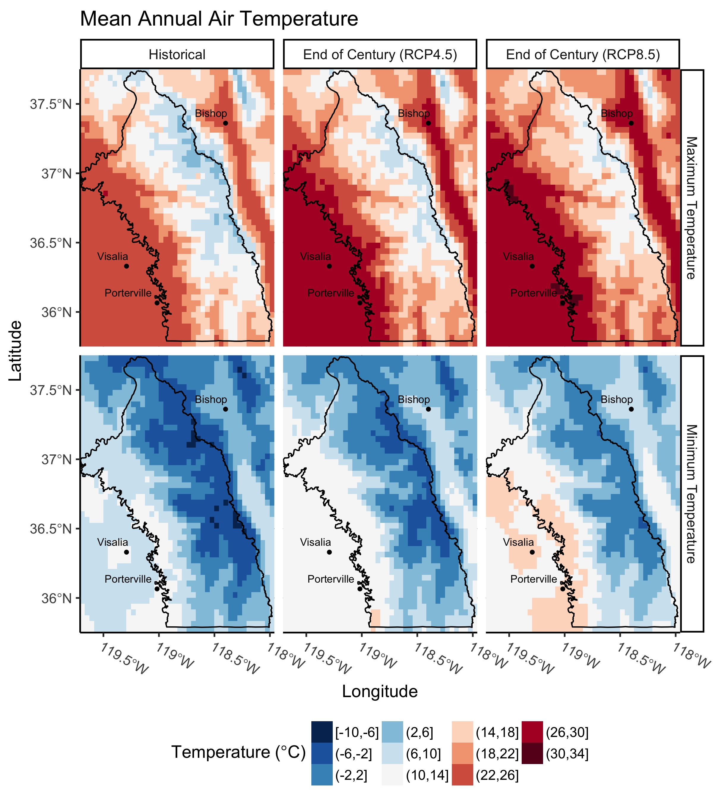

Figure 15-3 Map of mean annual maximum and minimum temperatures under three scenarios: Historical, End of Century (2070-2099) RCP4.5, and End of Century (2070-2099) RCP8.5 using downscaled output from the CCSM4 GCM.

Projected increases in temperatures are expected to vary seasonally in the Southern Sierra Region. Increases in winter (Jan-Feb-Mar) maximum temperatures are projected to be slightly smaller than seasonal maximum temperatures during the remainder of the year (Figure 15-4). While winter maximum temperatures will still be well above historical baseline levels, the relatively smaller increases may aid in snowpack accumulation. However, this will be counterbalanced by relatively larger increases in maximum temperatures during the non-winter months, which will increase evaporative demand, decrease soil moisture and increase forest water stress. For seasonal minimum temperatures, the summer (Jul-Aug-Sep) season is projected to show the largest relative increase in temperature (Figure 15-5).

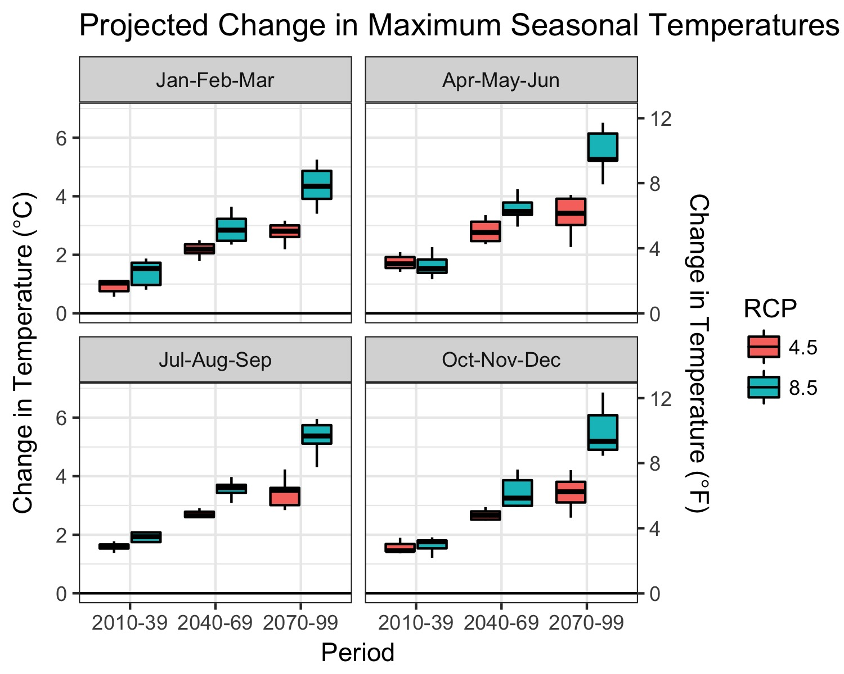

Figure 15-4 Projected changes in maximum mean seasonal temperatures for the Southern Sierra Region. Variability in projections represents different GCMs. Historical baseline values of maximum mean seasonal temperatures are 8.3°C, 17.4°C, 24.4°C and 11.5°C for Jan-Feb-Mar, Apr-May-Jun, Jul-Aug-Sep, and Oct-Nov-Dec, respectively.

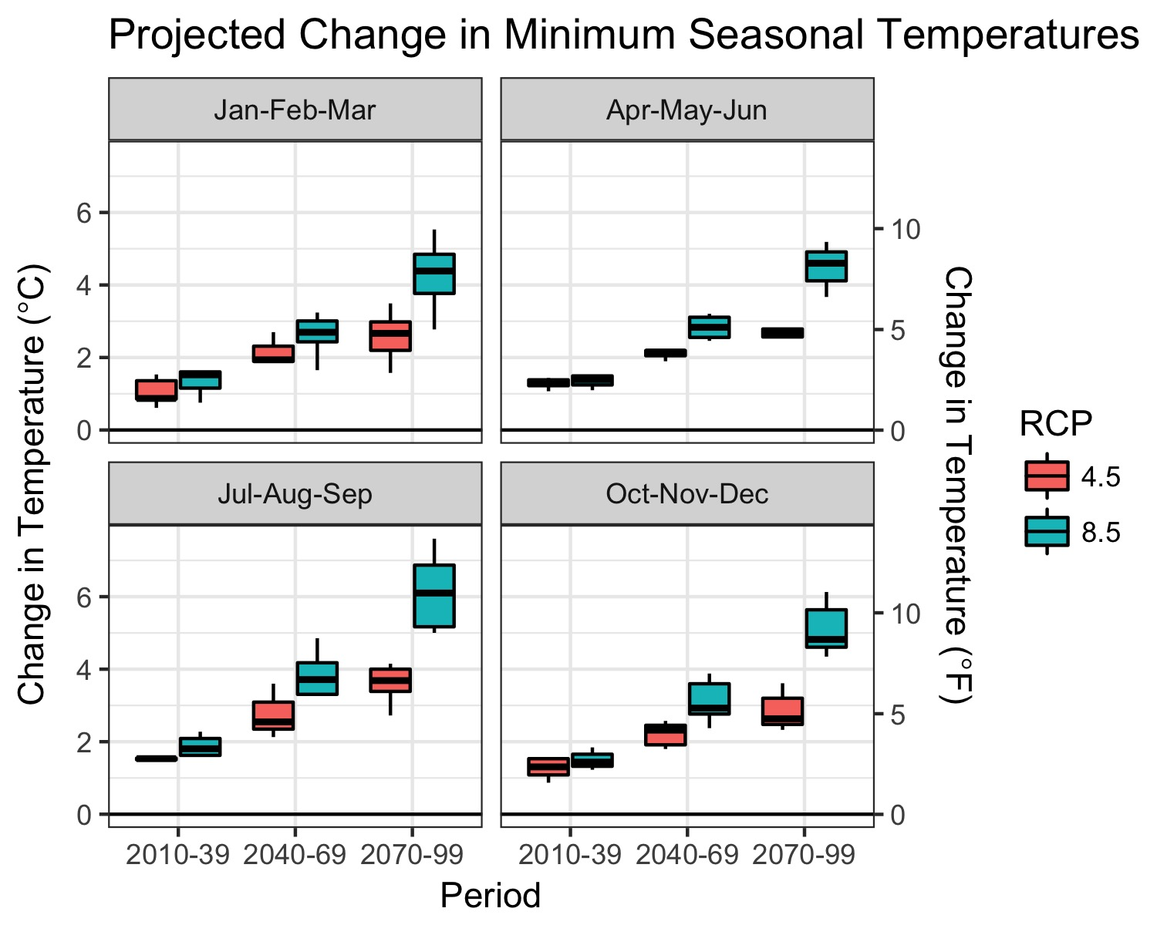

Figure 15-5 Projected changes in minimum mean seasonal temperatures for the Southern Sierra Region. Variability in projections represents different GCMs. Historical baseline values of minimum mean seasonal temperatures are -3.6°C, 3.5°C, 9.6°C and -0.7°C for Jan-Feb-Mar, Apr-May-Jun, Jul-Aug-Sep, and Oct-Nov-Dec, respectively.

The frequency of heat waves, which are defined as when daily maximum and minimum temperatures exceed a respective percentile threshold, are projected to increase in California (Diffenbaugh and Ashfaq, 2010; Gershunov and Guirguis, 2012). Gershunov and Guirguis (2012) found that both humid nighttime heat waves and dry daytime heat waves will increase with climate change in California, though they note the former is expected to increase more intensely. Extreme heat waves are well-documented to have an adverse affect on ecosystems, agriculture and human health (Meehl and Tebaldi, 2004). It will be important for communities within the Southern Sierra Region to take precautions to protect vulnerable populations during extreme heat waves (Guirguis et al., 2013).

Increases in temperature are a primary driver behind many of the other climate change related effects that are documented in the remainder of this section. For example, changes in snowpack, streamflow timing, forest vulnerability, wildfire, and bark beetles are each influenced by increases in temperature. Hence, temperature can be considered a key metric for accurately predicting how climate change will affect the Southern Sierra Region.

Precipitation

Precipitation in California exhibits Mediterranean-climate characteristics, with most precipitation falling during the winter season (November to March) while the remainder of the year is dry. Precipitation in California is also highly variable, with inter-annual variability being the highest in the U.S and annual precipitation totals varying by up to an order of magnitude (Dettinger et al., 2011). This variability is partly due to atmospheric rivers constituting a substantial fraction (20% to 50%) of the total annual precipitation in California (Dettinger et al., 2011). Since California receives relatively few atmospheric river events in a given year, a swing of a few more or less storms during a wet season can produce large differences in total precipitation.

Downscaled GCM climate projections for California have generally indicated minimal changes in annual precipitation under future warming scenarios (Hayhoe et al., 2004). For the recent CMIP5 GCM projections, He et al. (2018) found that projected annual precipitation ranged from +50% to -25% depending on the individual GCM/scenario investigated (He et al., 2018). Collectively however, the models showed small increases in precipitation (1% - 11%) across different regions of California under the RCP4.5 scenario. Similar changes in precipitation are projected for the Southern Sierra Region. The average increase in annual precipitation among all the downscaled models was 5%-10% for the Southern Sierra Region, although the variability in the projections encompasses both positive and negative changes in annual precipitation (Figure 15-6 and 15-7).

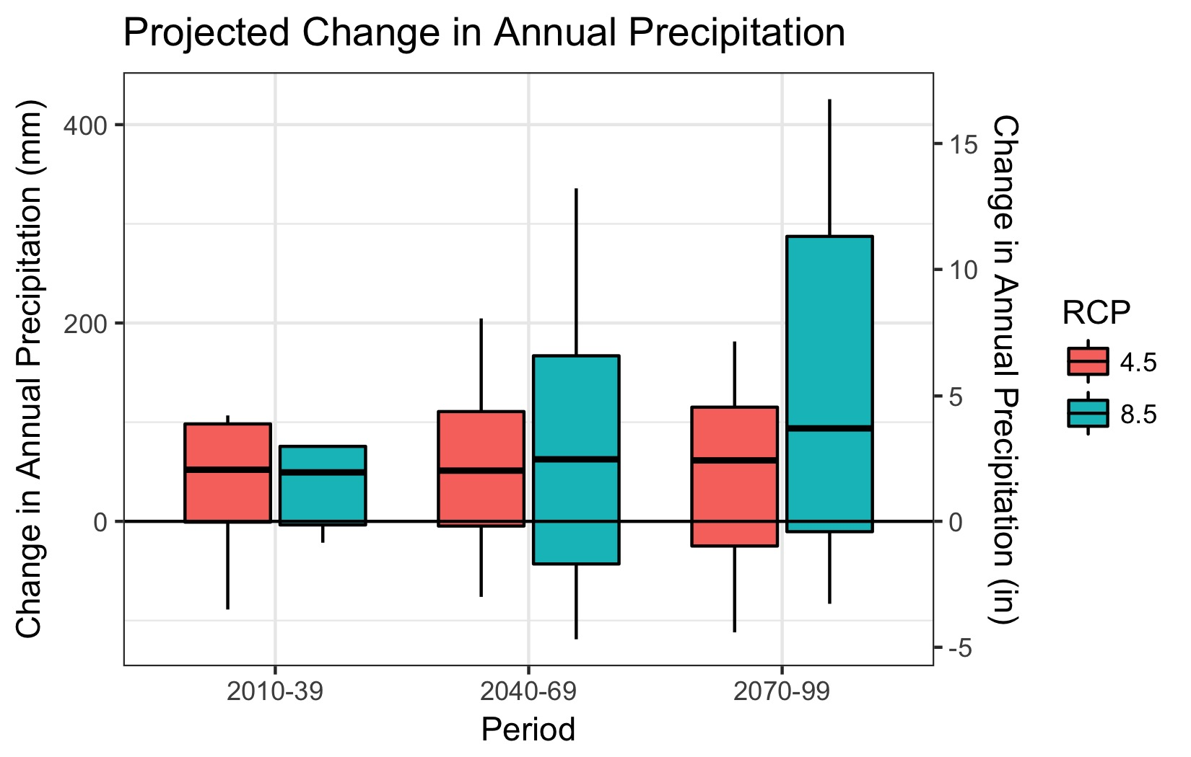

Figure 15-6 Projected changes in annual precipitation for the Southern Sierra Region. Variability in projections represents different GCMs. Historical baseline annual precipitation is 819 mm/year (32 in/year).

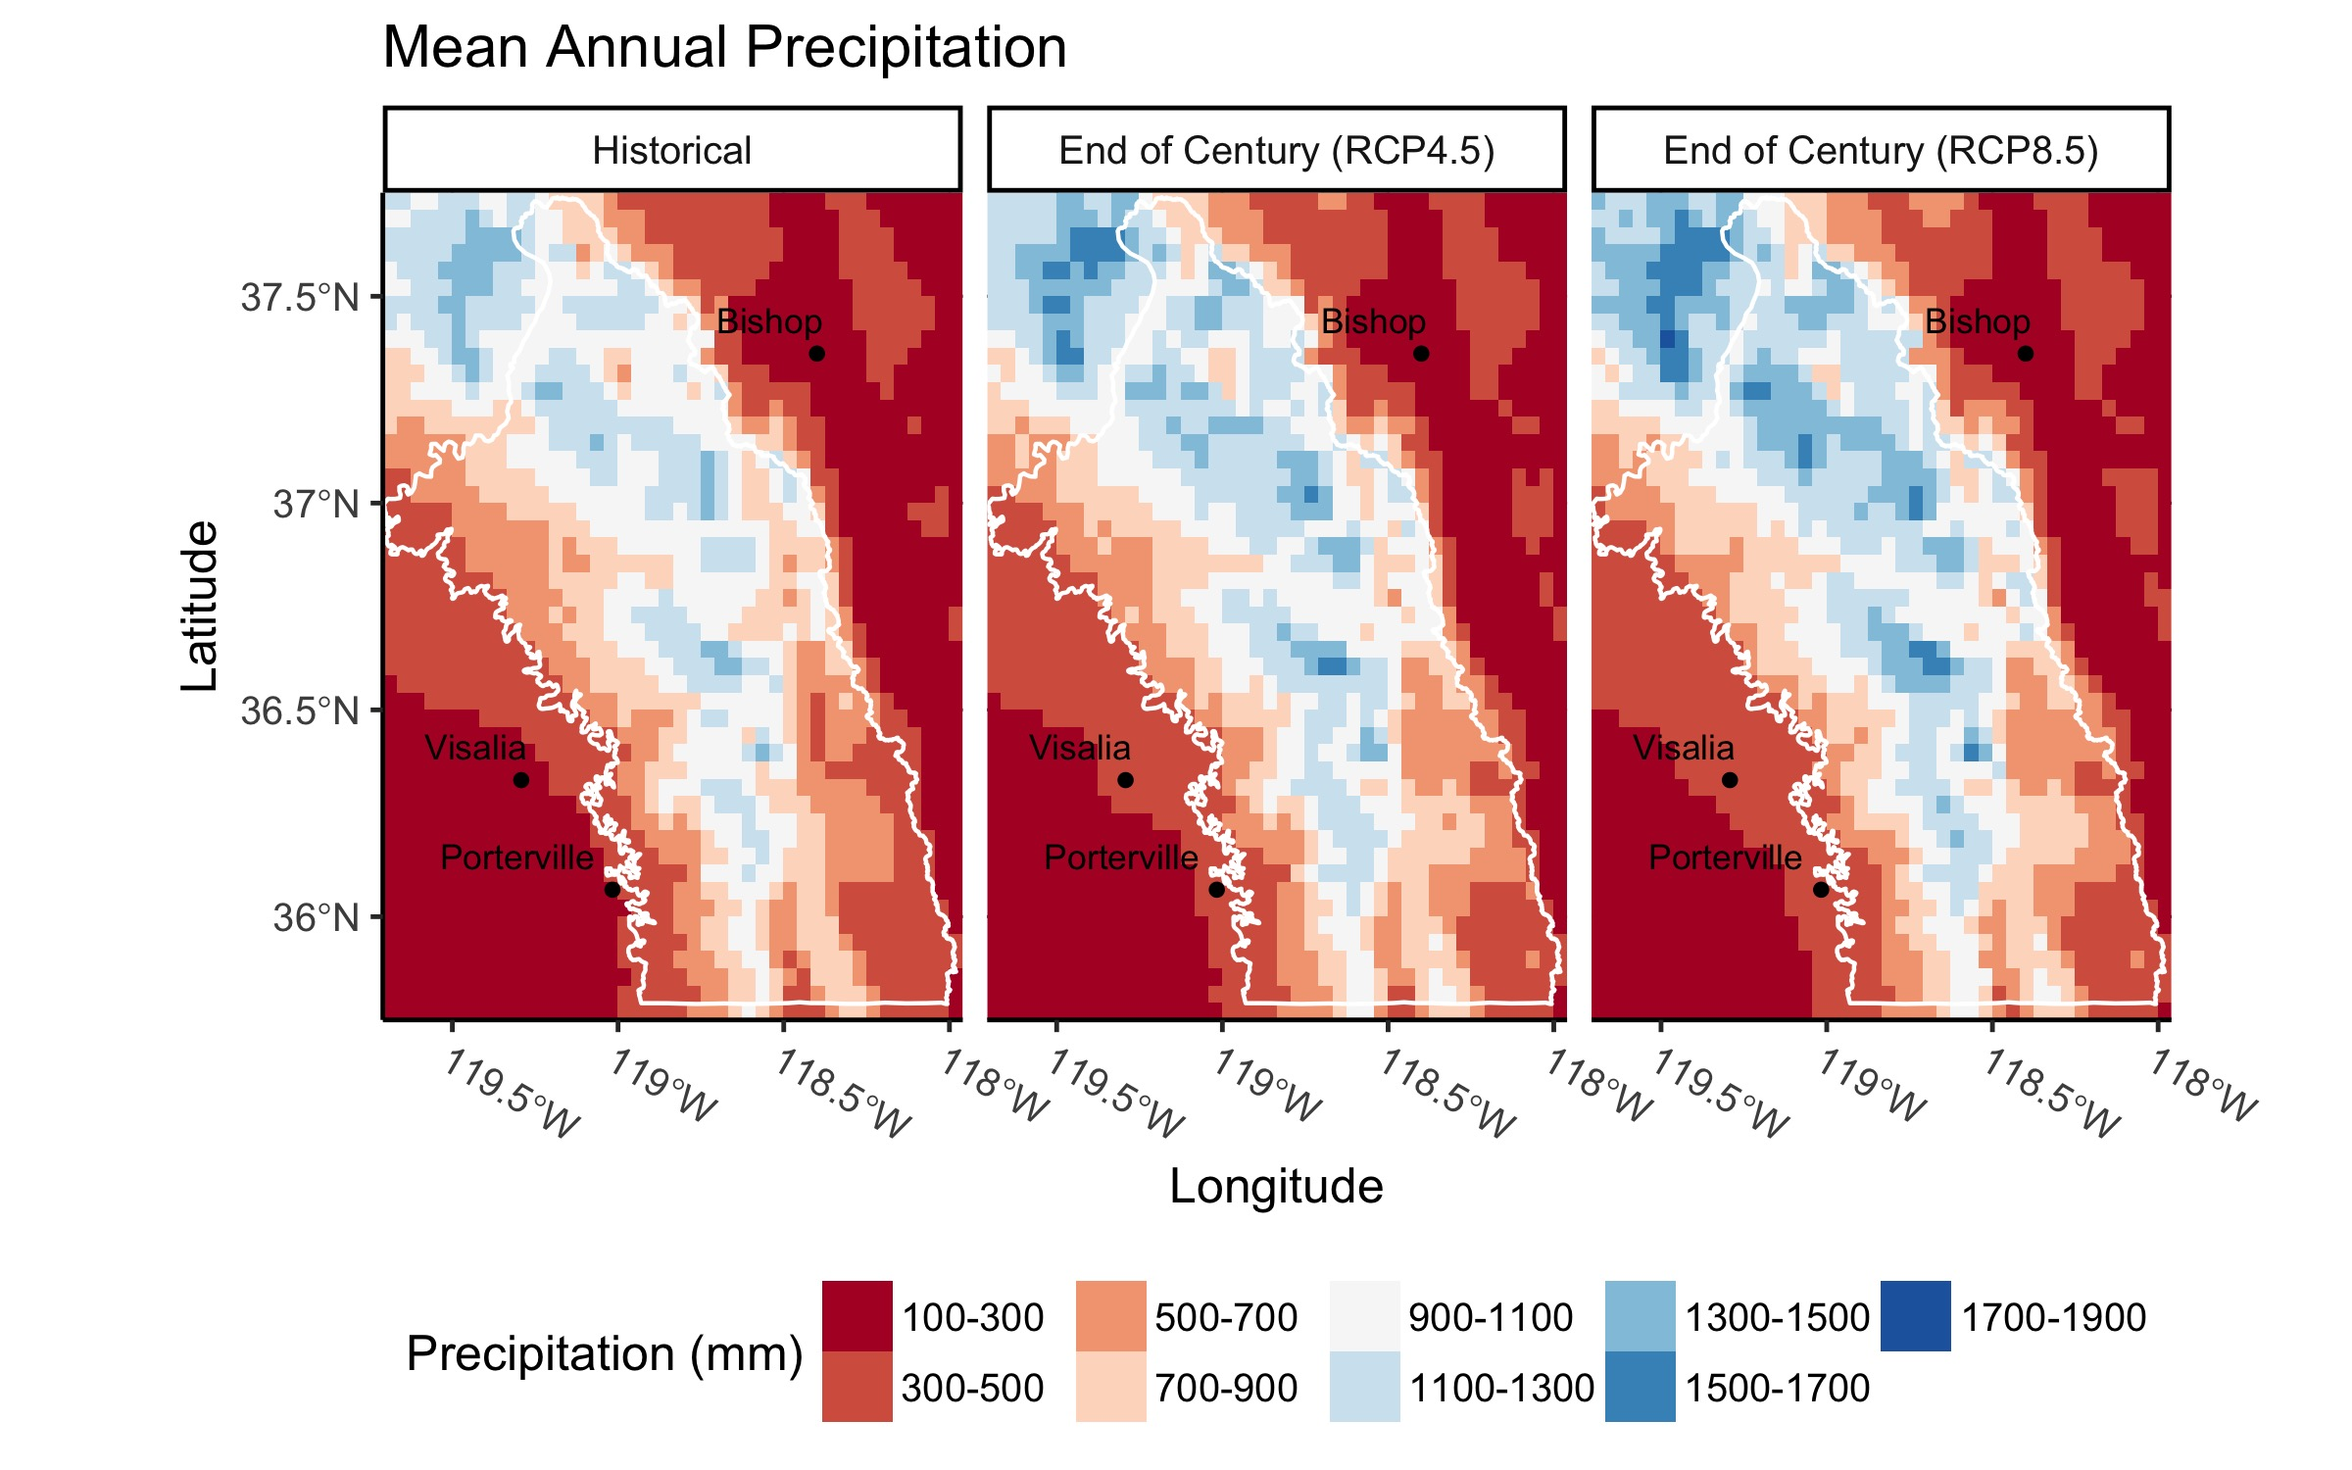

Figure 15-7 Map of mean annual precipitation under three scenarios: Historical, End of Century (2070-2099) RCP4.5, and End of Century (2070-2099) RCP8.5 using downscaled output from the CCSM4 GCM.

Although the average amount of precipitation in the Southern Sierra Region is projected to only slightly increase with climate change, there is mounting evidence that inter-annual variability of precipitation will substantially increase, with dry years becoming drier and wet years becoming wetter (Pendergrass et al., 2017). Berg and Hall (2015) have reported that by the end of the century, extremely dry years will become 1.5 - 2 times more frequent and extremely wet years will become 3 times more frequent, with the number of average years becoming more scarce. Climate change will also increase year-to-year volatility swings. Swain et al. (2018) report that transitions from extreme drought to extremely wet conditions, such as was observed from the 2012-2016 drought to the wet 2016/2017 winter, is projected to increase 25% to 100% by the end of the century.

This increase in precipitation extremes will make management of water resources in the Southern Sierra Region more challenging. Excess precipitation during wet years frequently cannot be stored in reservoirs due to flood risks. Flood risks in the Southern Sierra Region are also increasing due to precipitation shifts from snow to rain. An increase in extremely wet years will only exacerbate this problem. On the other hand, a greater number of very dry years will stretch water supplies in the Southern Sierra Region and the San Joaquin Valley as a whole.

Drought

Due to high precipitation variability, California has always been subject to multi-year droughts, where precipitation totals fall well below normal. However, the recent multi-year drought and projected future droughts are different because periods of low precipitation are more likely to coincide with periods of high temperatures, increasing atmospheric water demands and making conditions drier. It was this combination, very little precipitation and record high temperatures, that contributed to the severity of the California drought (Shukla et al., 2015). As temperatures continue to rise, drought risk is predicted to become even more severe in the future even in the absence of precipitation change (Cook et al., 2015).

For the Southern Sierra Region, the magnitude of droughts under climate change will depend on how dry conditions are, how warm conditions are, and over how many years these conditions persist. In a recent study, He et al. (2018) used a drought index, the Standardized Precipitation-Evapotranspiration Index (SPEI), to investigate changes in future drought severity in California. They found that in the Tulare region of California, which encompassed most of the Southern Sierra Region, that the severity of droughts would increase throughout the century, indicating that small increases in precipitation for the region would not offset the effects of higher temperatures.

Snowpack

Snowpack in the Southern Sierra Region is being affected in numerous ways as temperatures increase in California. Foremost, a larger proportion of precipitation is falling as rain than as snow. This effect is most pronounced near the rain-snow transition zone, as this zone is particularly sensitive to temperature changes since winter temperatures hover near the freezing point. Increasing temperatures cause the rain-snow transition zone to migrate upslope and produce a smaller snow footprint. Throughout the western U.S., the areal extent of historical snowfall area is expected to decrease by an average of 30% under RCP8.5 scenarios (Klos et al., 2014). For the Southern Sierra Region, the amount of area that is predominately snowfall-driven, defined as locations where the probability of snowfall compared to rainfall is greater than 90%, is projected to decrease by approximately 50% by the mid 21st century under a RCP 8.5 scenario (Figure 15-8).

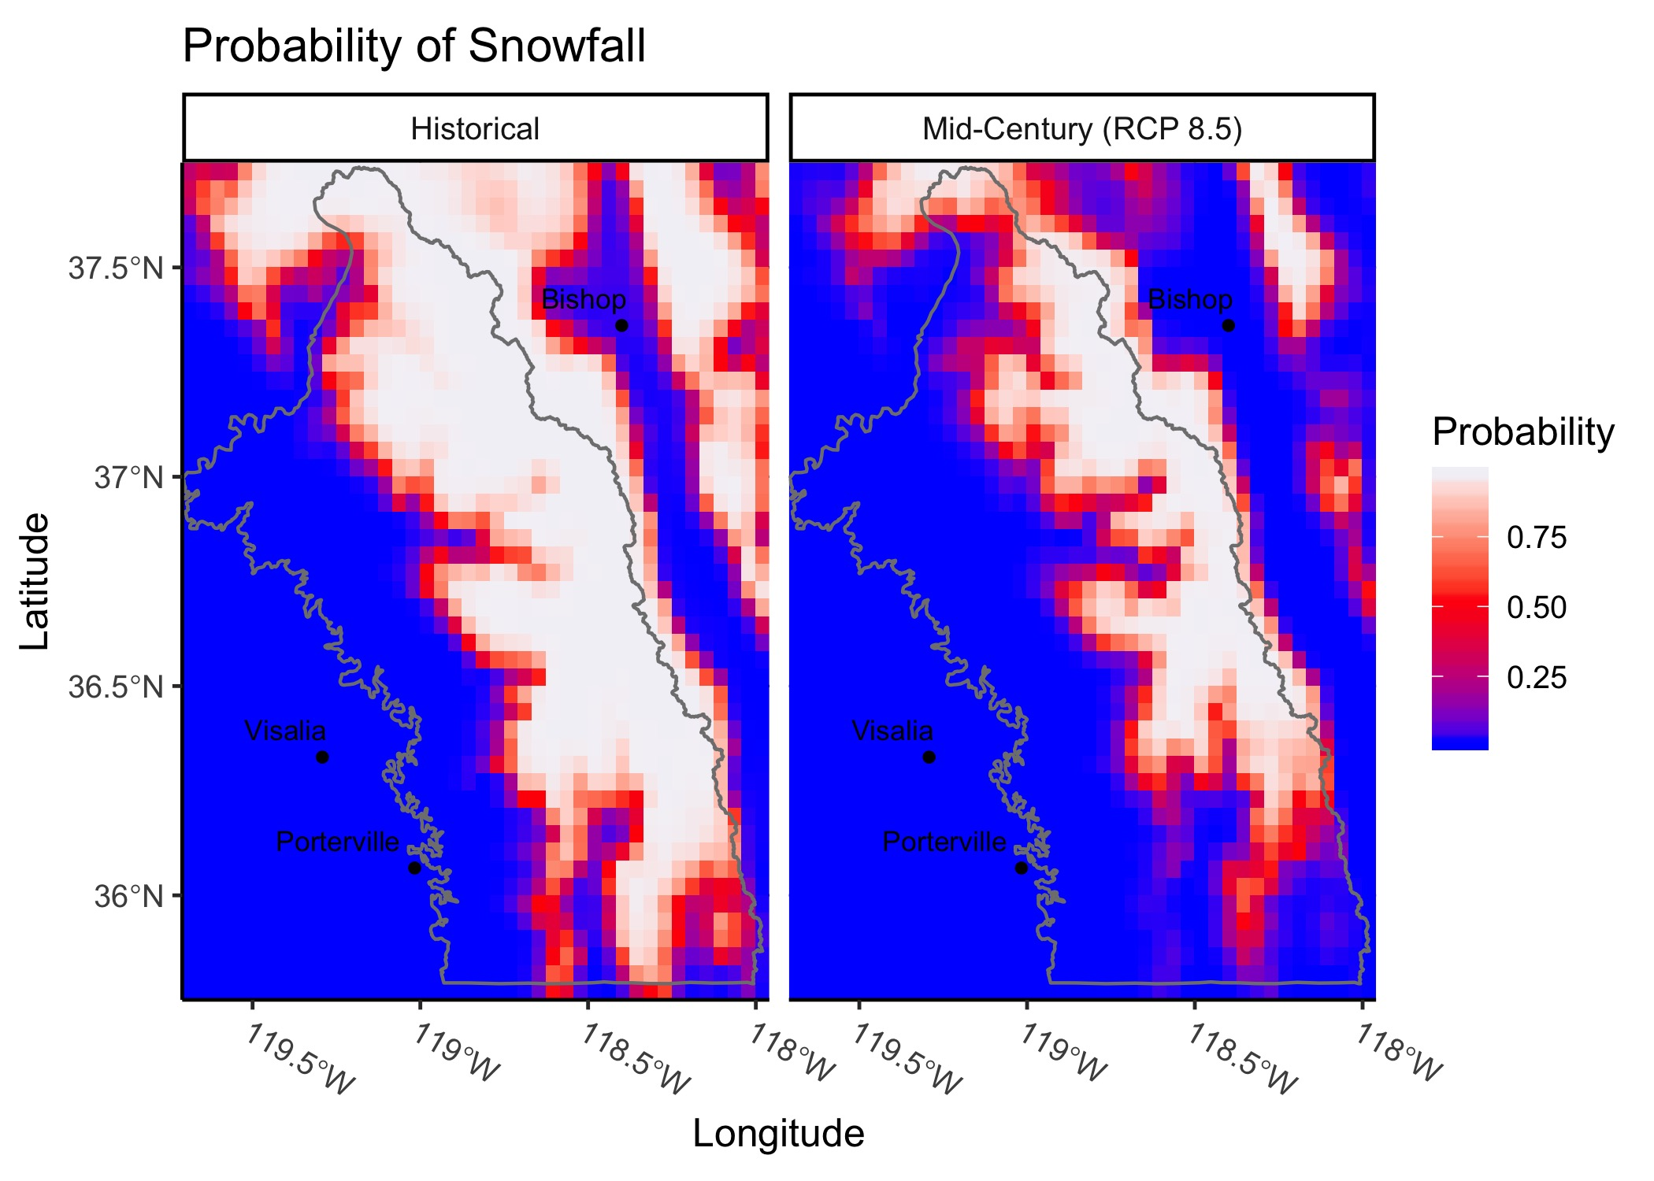

Figure 15-8 Map of the probability of snowfall compared to rainfall for the Southern Sierra Region under two scenarios: Historical (1979-2012) and Mid-Century (2035-2065) RCP8.5 using a 20-model GCM mean. Blue indicates areas of predominately rainfall, white is predominately snowfall and red is the rain-snow transition zone. Data from Klos et al. (2014).

Winter snowpack will persist for a shorter period of time with climate change. This is partly due to less snow accumulation and partly due to more rapid snowmelt. Projections for the western U.S. suggest that the snow-covered period may decrease by 25 days/year by the mid-century under RCP8.5 (Naz et al., 2016). A more transient snowpack will also have implications for the measurement of snow water equivalent (SWE) on April 1st, the traditional date when the snowpack is measured for forecasting spring streamflow. Naz et al. (2016) project that April 1 SWE may decrease by 50% by mid-century across the western U.S. (RCP8.5). Further, a study by Young et al. (2009) found that the greatest reduction in snowpack would be at mid-elevations between 1750-2750m.

To understand how climate change will alter snowpack and streamflow in the Southern Sierra Region, downscaled temperature and precipitation projections for the Kings River watershed, a major river in the central part of the Southern Sierra Region, were used as inputs into the Variable Infiltration Capacity (VIC) hydrologic model. Results from the VIC model indicate that for the Kings River watershed, snowpack is projected to decrease during all months, with the greatest decreases being observed during the early spring months (e.g. March, April, May) (Figure 15-9). These changes will have considerable implications for water resources. In the Southern Sierra Region, snowpack accumulation during the winter wet season acts as a water reservoir that is slowly released as temperatures warm throughout the spring and summer. Reductions in this reservoir will complicate water resource management in the Region and will likely necessitate that alternative storage solutions be found such as groundwater banking.

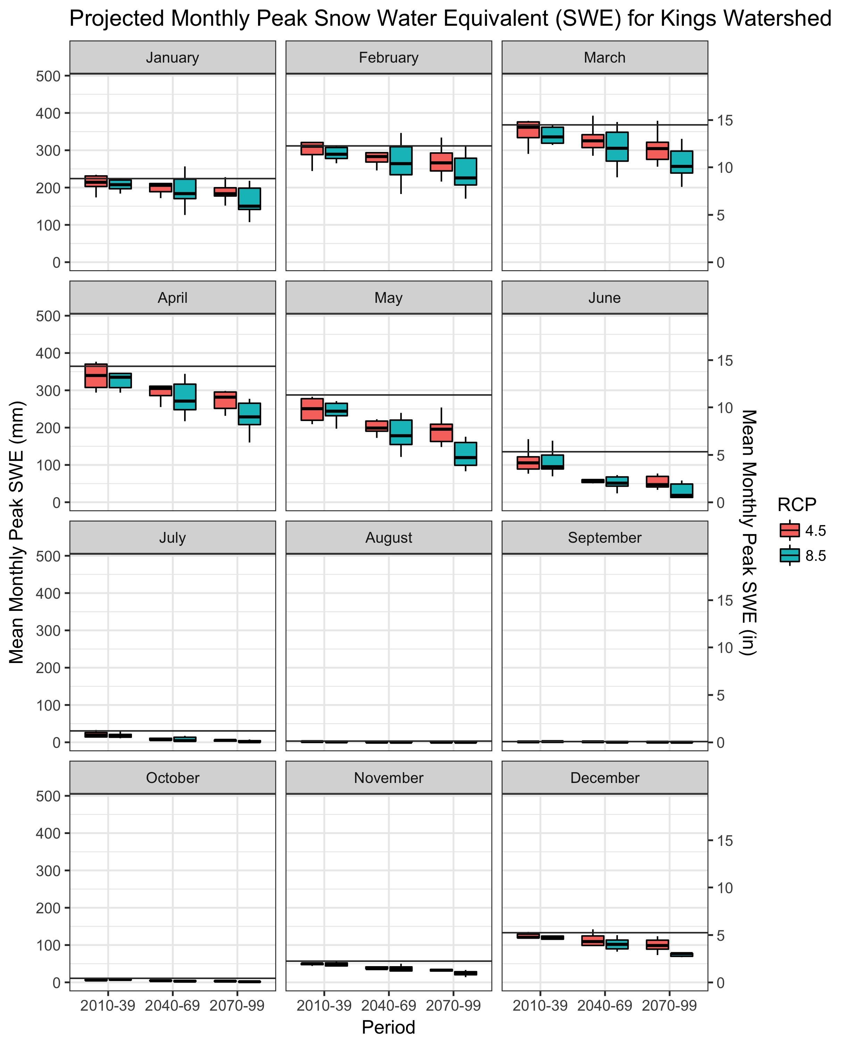

Figure 15-9 Projected changes in mean monthly peak snow water equivalent (SWE) for the Kings River Watershed in the Southern Sierra Region. Variability in projections represents different GCMs. Horizontal dark grey lines represent historical mean monthly peak SWE.

Streamflow

Climate change is already affecting both the timing and total amount of streamflow that feeds downstream reservoirs in the Sierra Nevada and this effect is expected to grow as temperatures continue to rise (Vicuna and Dracup, 2007). Reductions in snowpack and higher temperatures will shift streamflow to the winter months, leaving less water available for spring and summer flows when water resource demands are greatest. Less streamflow during the summer months will also worsen water quality, as many quality issues are flow dependent. Combined, these issues will likely strain the existing 20th century water resource infrastructure that is not equipped to handle a 21st century streamflow regime.

For the Kings River in the Southern Sierra Region, total mean annual streamflow is not expected to change substantially under future climate change (Figure 15-10). The range of streamflow change projections for the six GCMs used in the analysis includes both small increases and decreases in annual streamflow, with the median estimate being slightly positive. Nevertheless, while total annual streamflow is not projected to change substantially, changes in snowpack accumulation will have a major effect on the timing of streamflow.

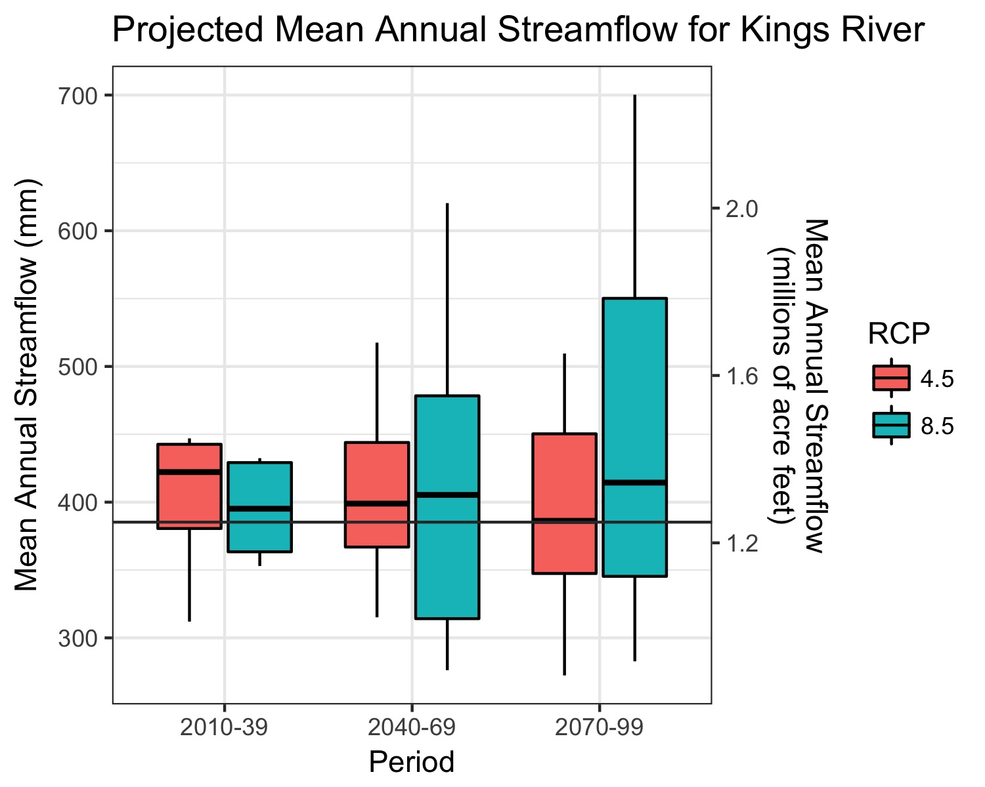

Figure 15-10 Projected changes in mean annual streamflow for the Kings River in the Southern Sierra Region. Variability in projections represents different GCMs. Horizontal dark grey line represents historical mean annual streamflow.

Precipitation in the Southern Sierra Region is a mix of rain at lower elevations and snow at higher elevations. Streamflow generation from rainfall occurs relatively quickly, with streamflow often peaking within hours/days of a rainfall event. Streamflow generation from snowpack, on the other hand, is delayed and depends on subsequent changes in energy inputs (e.g. temperature, radiation) to melt the snowpack. Since most precipitation in the Southern Sierra Region occurs during the winter and since the Southern Sierra Region is characterized by very high elevations, streamflow generation from snowpack has historically been the dominant control on streamflow. However, as rising temperatures shift the rain-snow transition zone to higher elevations, a higher fraction of streamflow will be generated from rainfall, increasing streamflow during the wet winter months. Across the western U.S, Li et al. (2017) has estimated that the contribution of streamflow originating from snowpack by the end of the century will decrease by one third under an RCP8.5 scenario. This earlier shift in the timing of streamflow has already been shown to be impacting streamflow. Stewart et al. (2005) demonstrated that across Western North America, streamflow timing has shifted 1 to 4 weeks earlier since the mid-20th century. This trend will continue as temperatures continue to rise. Schwartz et al. (2017) project that by the end of the century, streamflow may shift up to 80 days earlier under an RCP8.5 scenario and up to 30 days earlier under an RCP4.5 scenario.

For the Kings River Basin, the effect of projected higher temperatures on streamflow timing can be illustrated by comparing projected changes in monthly streamflow (Figure 15-11). Under both RCP 4.5 and RCP 8.5 scenarios, monthly streamflow increases during the winter and early spring (January through May) due to less snowpack accumulation. Peak runoff, which has historically occurred during June, will shift to May with climate change and streamflow during the months of June and July will decrease. Other watersheds within the Southern Sierra Region are likely to show a similar pattern of streamflow change as the Kings River, although the magnitude of change may differ due to differences in watershed characteristics.

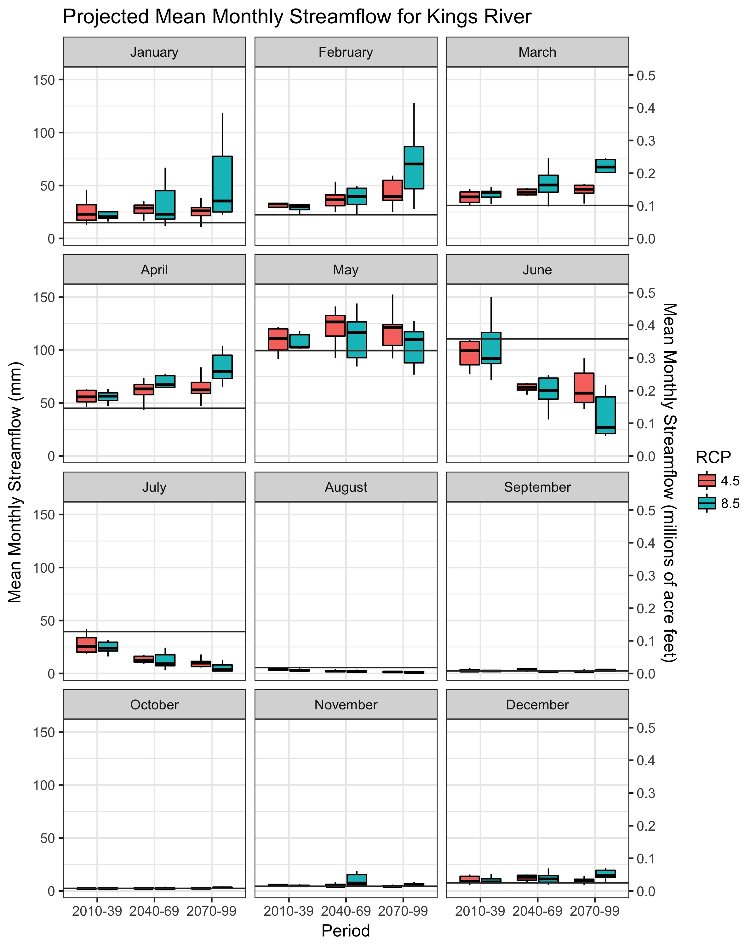

Figure 15-11 Projected mean monthly streamflow for the Kings River in the Southern Sierra Region. Variability in projections represents different GCMs. Horizontal dark grey lines represent historical mean monthly streamflow.

A shift towards greater winter streamflow will increase the risk of floods within and downstream of the Southern Sierra Region. Das et al. (2013) found that by the end of the 21st century, streamflow flood events with 50-year return periods in the southern Sierra Nevada would increase by 50% to 100%. These increases were attributed in part due to warm storms that produce rainfall at higher elevations, but also in part to an increase in the size and frequency of large storms events (Das et al., 2011). Many of the largest floods in the Sierra Nevada are associated with rain-on-snow events, when high snowlines cause rain to fall on previously established snowpack and streamflow contributions include both rain and melted snow. Rain-on-snow events are disproportionately associated with warm atmospheric rivers (Guan et al., 2016) and atmospheric rivers are projected to become more frequent and more severe under climate change (Dettinger, 2011; Hagos et al., 2016).

Increased flood risk will introduce additional constraints on the operation of major water supply/flood-protection reservoirs downstream of the Southern Sierra Region. To minimize flooding in the San Joaquin Valley during the winter months, reservoirs are required to draw down water levels to provide space to accommodate large runoff events, such as those associated with atmospheric rivers. As the risk of larger winter runoff events increases with climate change, the rules governing reservoir flood space may need to be revised to allow for more space, as the current rules reflect historical streamflow regimes, not future ones (Brekke et al., 2009). This would reduce the amount of water that can be stored during the winter season. In the spring, snowmelt has historically been used to fill the reservoirs. However, the reliability of snowmelt being sufficient to fill the flood reserve space in reservoirs is decreasing as the Sierra snowpack is diminished. These issues with surface storage suggest that alternative methods for storing water may need to be pursued in the Tulare/San Joaquin basins, including groundwater recharge. Changes in reservoir operations may also impact hydropower generation, which will affect energy production in California.

With more winter streamflow projected under climate change, a corresponding decrease in summer flows is also projected. These flows, which occur when seasonal temperatures are highest and water demand is greatest, are important for both riparian ecosystems and water management. In the Sierra Nevada, Godsey et al. (2014) found that for every 10% decrease in snowpack, annual minimal flows may decrease by 1% to 22%, depending on the watershed. An additional concern is that the length of the low flow season will be extended under climate change, further stressing aquatic ecosystems in the Southern Sierra Region.

Water Quality

Climate change will impact water quality in the Southern Sierra Region by altering stream temperatures and sediment loads. Stream temperature is a key regulator of riparian ecosystems and higher water temperatures frequently have an adverse affect on native species, affecting species distributions, growth rates and reproduction (Isaak et al., 2017). Stream temperature has been found to be sensitive to rising temperatures. Ficklin et al. (2013) projected that, depending on the watershed, spring and summer stream temperatures in the Sierra Nevada will increase between 1.0and 5.5**°**C by the end of the century under a high greenhouse gas scenario. Isaak et al. (2017) found that August stream temperatures in Central California will increase by about 1.0**°**C by the end of the century. Using the same dataset generated by Isaak et al. (2017), August stream temperatures for the Southern Sierra Region are projected to increase from 0.3**°**C to 1.6**°**C, with an average change of 0.9**°**C (Figure 15-12). In each of these studies, lower elevation streams showed a greater increase in temperature than higher elevation streams.

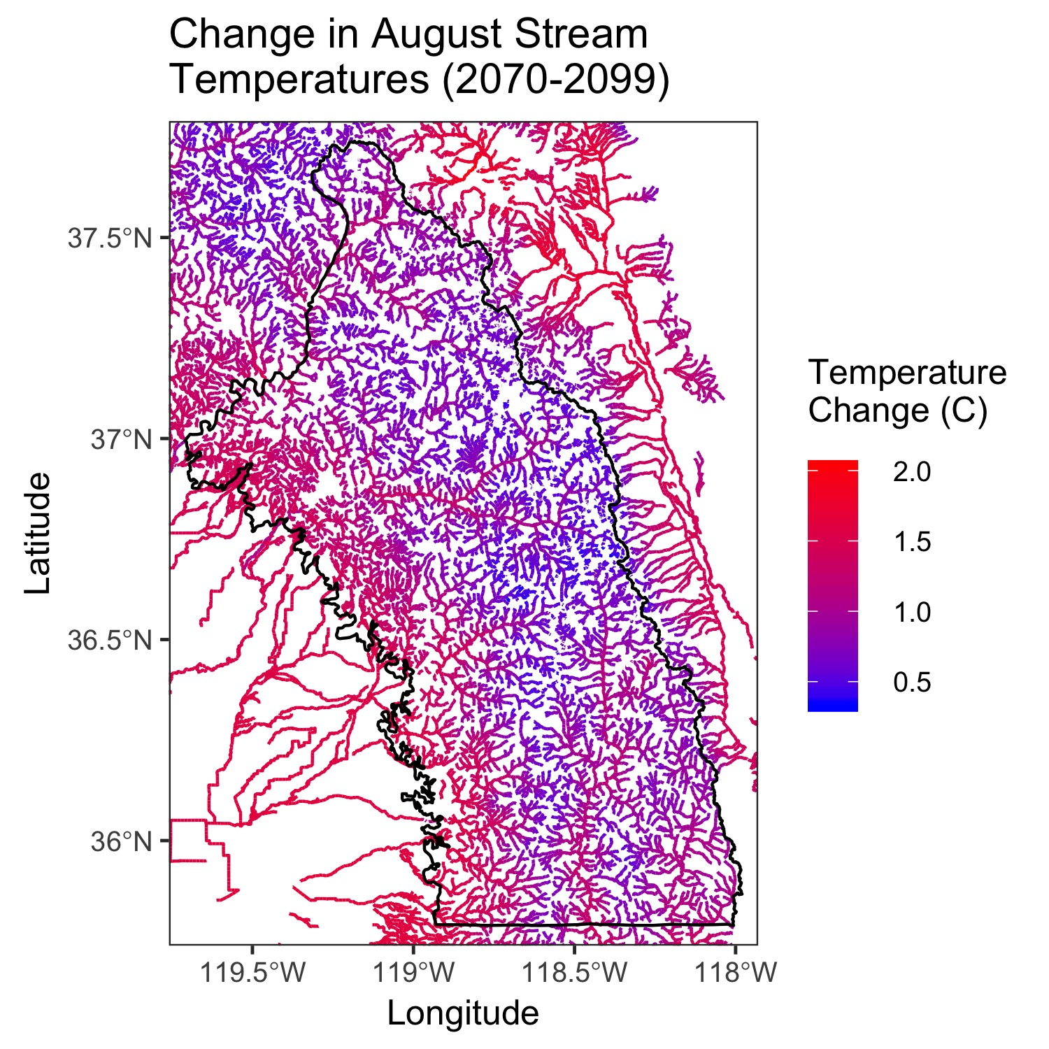

Figure 15-12 Projected change in August stream temperatures in the Southern Sierra Region for the period 2070 to 2099. Data from Isaak et al. (2017).

Changes in land cover and streamflow regimes may alter stream sediment load in the Southern Sierra Region. Due to granitic substrate, many rivers in the Southern Sierra Region are sediment limited (Riebe et al., 2001). However, an increase in winter flows has the potential to increase sediment erosion and transportation. During the spring and summer seasons, Ficklin et al. (2013) reported that sediment concentrations in Sierra Nevada steams should decrease under future climate change scenarios. However, the effect on sediment loads during the winter season remains unclear and points to the need for further research. The trend of increasing wildfire in a warmer climate is a special concern for sediment.

Vegetation Transformation

Vegetation affects watershed hydrology in the Southern Sierra Region through processes such as canopy interception and transpiration, which influences how much water is available for streams or groundwater recharge. Vegetation water use differs by vegetation type (e.g. forests, shrubs, grasses) as well as through time as vegetation grows. Consequently, changes in the distribution of vegetation on a landscape will have an effect on hydrology and the management of water resources. One of the main drivers of vegetation change on a landscape is vegetation disturbance, including drought, wildfire, and bark beetles. In this section, we document how climate change is altering vegetation disturbances in the Southern Sierra Region and how these changes affect both vegetation and water resources in the region.

During the 2012-2016 California drought, an unprecedented forest mortality event produced over 129 millions dead trees in forests throughout California (Moore, 2017). The Southern Sierra Region was one of the hardest hit regions in the state, with exceptionally high levels of mortality observed in the lower montane forest. The severity of the mortality event was a direct consequence of the severity of the drought, which combined multiyear low precipitation levels with record high temperatures. Forest vulnerability to drought is projected to increase with climate change and mortality events such as the California incident are likely to become more common and widespread (Allen et al., 2015). Young et al. (2017) found that during the California drought, mortality throughout California was concentrated in areas with higher levels of water stress. Using a similar dataset for the Southern Sierra Region, Figure 15-13 shows that forest mortality (mort.tph) in 2015 occurred in areas that had relatively dense vegetation (i.e. high tree per hectare) for a given level of water stress, which was represented as the difference between precipitation and potential ET. This supports the notion that forest mortality is linked to both forest management and meteorological conditions. Forest water stress will continue to increase as temperatures rise with climate change, increasing mortality rates. In the Southern Sierra Region, a drought with comparable precipitation to the 2012-2016 drought but with temperature increases representative of the end-of-century RCP4.5 and RCP8.5 scenarios could be expected to increase forest mortality by 15% and 27%, respectively, compared to the 2012-2016 event (see **Appendix** **M** for full methodological details). The effects of forest mortality can linger for decades and it will be necessary to account for mortality in the management of water resources in the Southern Sierra Region. A recent study by Bales et al. (2018) estimated that the large number of dead trees in the Kings River watershed decreased forest ET during the recent drought, which may have increased water availability for streamflow by up to 15%.

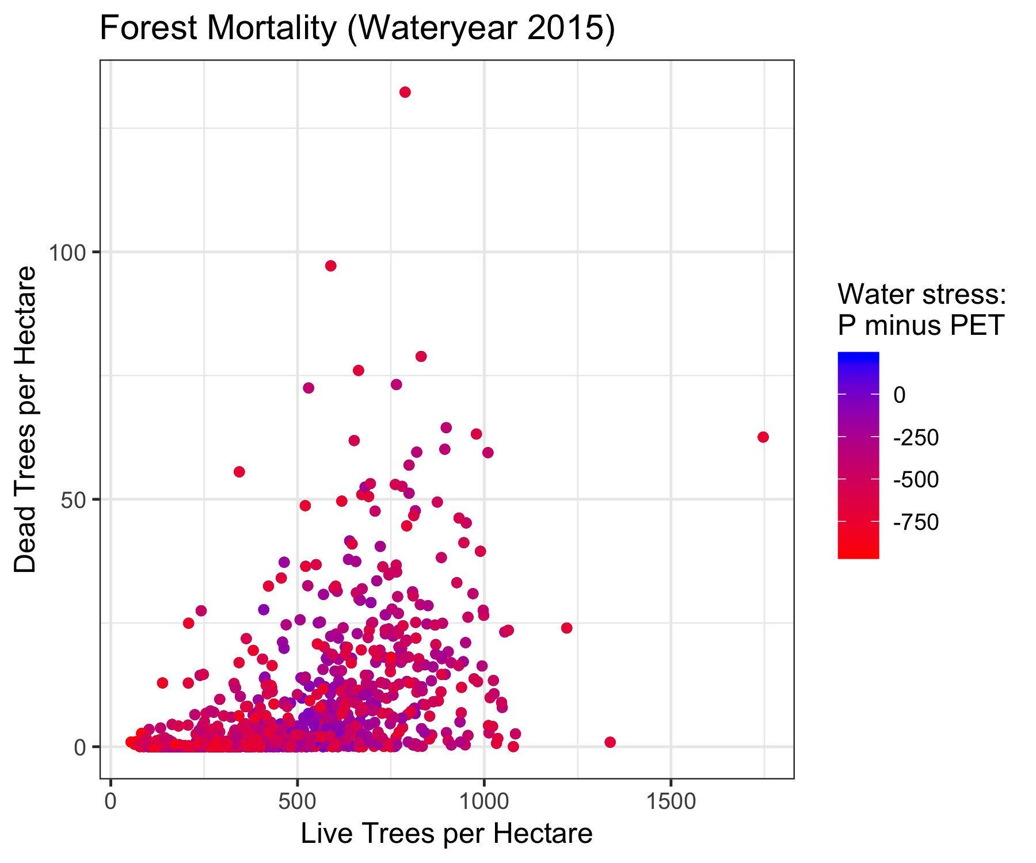

Figure 15-13 Relation between mortality (trees per hectare) and forest density (trees per hectare) in the Southern Sierra Region during the 2015 wateryear. Each data point represents mortality for a 4-km2 pixel within the Region. More negative water stress (precipitation minus potential ET) values indicate greater water stress.

Wildfires are an episodic form of land-cover change in the Sierra Nevada. Lower montane forests in the Sierra were historically characterized as having a low-severity fire regime, where the forest understory would regularly burn from wildfire but the forest canopy burned less frequently due to a lack of ladder fuels. Fire suppression over the past century has led to a build-up of understory fuels in many Sierra Nevada forests and made these forests more susceptible to high severity wildfire that affect the forest canopy. Climate change is magnifying this problem, as higher air temperatures increase fire intensities by drying out dead fuels more rapidly. In recent decades, wildfires in the western U.S. have been found to be increasing in size (Dennison et al., 2014) and in total area burned (Westerling, 2016). Indeed, the two largest wildfires ever recorded within the Southern Sierra Region occurred in the last two decades, the 2002 McNalley Fire and the 2015 Rough Fire. Some of this increase is likely due to the fuels buildup, but Abatzoglou and Williams (2016) have demonstrated that part of this increase can be attributed to higher temperatures associated with climate change. Stephens et al. (2018) has suggested that the recent forest mortality event in the Sierra Nevada has increased the risk of surface fires, though this is counterbalanced by a decrease in the risk of crown fire.

Wildfire is expected to become more common in the Southern Sierra Region throughout the 21st century under climate change. The mean annual percent area burned averaged over the Southern Sierra Region is projected to increase from 0.5% per year historically to between 0.75% and 1% by the end of the century under the RCP 4.5 scenario (Figure 15-14). The projections for mean annual percent area burned under the RCP 8.5 scenario are higher than the RCP 4.5 scenario but also more uncertain, suggesting that the Southern Sierra Region could experience substantially more wildfire than currently occurs (Figure 15-14).

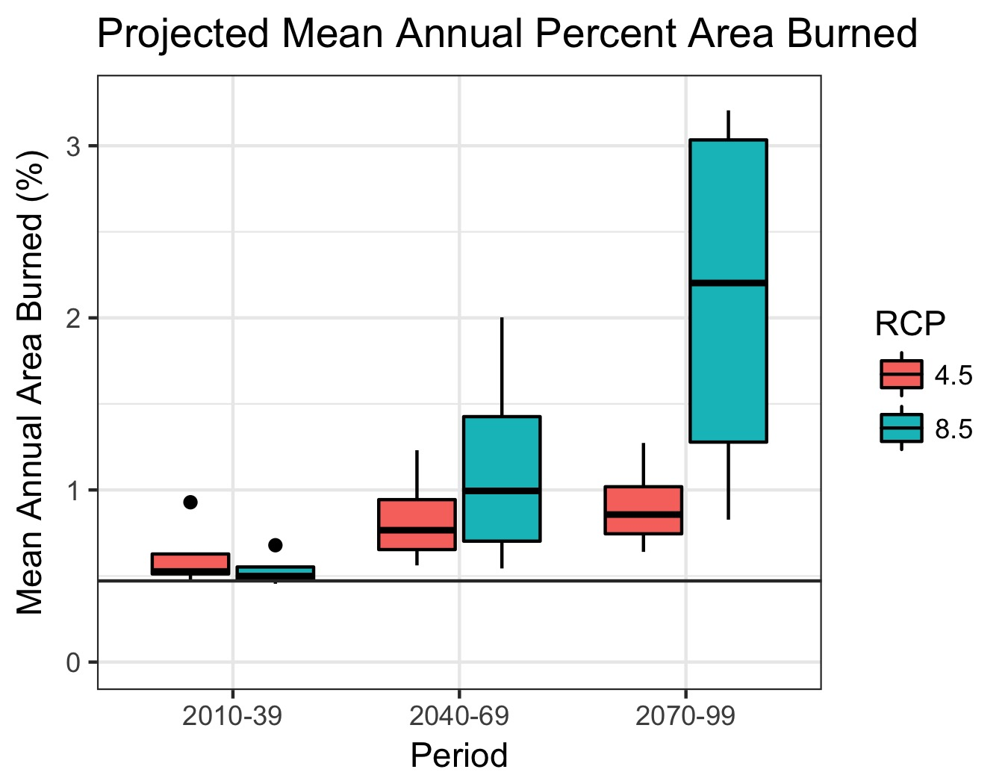

Figure 15-14 Projected changes in mean annual area burned by wildfire for the Southern Sierra Region under a medium population growth scenario. Variability in projections represents different GCMs. Horizontal dark grey line represents historical mean annual area burned. Data provided through www.cal-adapt.org.

Wildfire, through modification of vegetation and soils, affects watershed hydrology. The elimination of vegetation decreases vegetation interception and transpiration, which in the short term may increase annual streamflow. Across the Western U.S., Wine et al. (2018) estimated that 2 to 14% of long-term annual streamflow is generated from vegetation reductions brought about by wildfire. Wildfire may also increase baseflows, though the magnitude of this effect varies from watershed to watershed (Bart and Tague, 2017). Wildfire also impacts soil properties through a process that increases the hydrophobicity of soils. Hydrophobicity decreases soil infiltration during rainfall events and increases overland flow. This change can increase peak flows and the potential for large erosional events (Carroll et al., 2007; Doerr et al., 2006). Given that the frequency of wildfire is being altered under climate change, the modified effect of wildfire on streamflow and water resources will need to be accounted for in water management.

Bark beetles are a pathogen in western U.S forests, invading vulnerable trees in order to reproduce. Although outbreaks of beetles are natural, their spread has historically been kept in check by cold winter temperatures (Bentz et al., 2010). As winter temperatures rise with climate change, outbreaks are becoming larger and more severe (Bentz et al., 2010). Bark beetles contributed to forest mortality event during the recent California drought and will likely have a larger impact on Sierra Nevada forests in the future.

Forest management is frequently used to decrease forest vulnerability to vegetation disturbances and climate change. Forest management may include mechanical treatments such as forest thinning where individual trees are removed from a forest stand to reduce the density of the remaining forest. It may also include prescribed fire, which attempts to replicate the effects of low severity wildfires and remove understory vegetation. Managed wildfire offers perhaps the greatest potential for fuels reduction, though the outcomes are not as predictable as for fuels management by prescribed fire or mechanical thinning. Forest management can help to improve forest health by creating less competition for water resources (Grant et al., 2013). Forest management also has the potential to reduce overall forest ET, which in some cases may increase streamflow. There is evidence that increases in streamflow following forest thinning are greatest in watersheds that are not water limited and that the magnitude of streamflow change depends on the level of treatments conducted (Roche et al., 2018; Saksa et al., 2017). Thus, the management of water resources in the Southern Sierra Region will necessitate accounting for forest management practices.

Most vegetation species in the Sierra Nevada are adapted to the precipitation and temperature range of their present distribution. In general, vegetation growth at the lower elevations of a species distribution is water-limited, as evaporative demand is greater at lower elevations due to higher temperatures. Vegetation growth at higher elevations of a species distribution, on the other hand, is generally cold-limited. As temperatures rise with climate change, an upslope shift in vegetation is expected in the Sierra Nevada. This shift is not expected to be uniform, however, as some species are likely to migrate more easily than others. Also, in many cases, invasive vegetation may replace former species. At lower treeline in the Sierra Nevada, recent evidence has shown that a transition from forest to shubland and/or grasslands is already occurring in some regions (Collins and Roller, 2013; Stevens and Latimer, 2015). Likewise, increased vegetation growth in the high elevation sub-alpine forest in the Sierra Nevada has also been observed in the last decade (Millar et al., 2004). The effect of vegetation transformations on watershed hydrology is likely to vary based on watershed characteristics and the extent/timing of vegetation transformation. In the lower montane forest of the Southern Sierra Region, Bart et al. (2016) found that tree-to-shrub type conversion may increase streamflow up to 40%, depending on the species and size of invading shrubs. This contrasts with the effect of vegetation expansion at higher elevations, as Goulden and Bales (2014) reported that vegetation expansion could decrease streamflow by up to 26% in the Kings River watershed. The ultimate effect of vegetation transformations on streamflow in the Southern Sierra Region will depend on the balance of vegetation changes across the full elevational gradient of the Sierra Nevada.

Besides water, vegetation transformation also has implications on carbon sequestration, as vegetation and soils in the Sierra Nevada are an important store for carbon. Recent studies that incorporate climate change, vegetation change and wildfire into predictions have found that the amount of carbon that is stored in the Sierra Nevada will severely decrease by the end of the century (Liang et al., 2017). This process is largely due to the transition from forests to shrublands and grasslands in the Sierra, which do not store as much carbon. This transition of the Sierra Nevada to a net source of carbon to the atmosphere will further contribute to the problem of climate change.

Summary

The California water system is especially vulnerable to climate change due to its dependence on mountain snow accumulation and snowmelt processes. The Sierra Nevada snowpack is the largest seasonal water “reservoir” in California. Rising temperatures decrease snow accumulation, resulting in earlier stream runoff. This will also reduce usable seasonal storage behind the large mountain-front dams, owing to the need to reserve more space for flood control as the large winter snowstorms transition to large winter rainstorms. This has implications for linking downstream water-storage and flood-control solutions, e.g. through managed aquifer recharge.

Climate change could have some limited positive effects on the Southern Sierra Region such as less frost damage to crops, longer grazing seasons, less demand for winter heat, longer summer recreation seasons, higher overall precipitation in some areas, and less extreme cold during harsh winter storms. However, these positive aspects will be small in comparision to the many negative effects of climate change on the Region. With significant portions of forest lands having not burned for over 100 years, the risks of catastrophic wildfires has increased. Many special species of the Southern Sierra Region, (Giant Sequoia, Pacific Fisher) adapt very slowly if at all due to their dependence on special ecosystems which may change at a faster rate. Furthermore, water systems are designed for historic climate patterns, and warmer temperatures will generally be detrimental since they will increase water demands and reduce snowpack storage. The risks to the Region from no action are clear and include a reduction in available water supply, greater groundwater overdraft, urban water shortages, higher water costs, and lower agricultural output.

## Vulnerability Assessment Checklist

The SNRI report for this IRWMP (**Appendix M**) provides information on potential climate change vulnerabilities for water-related resources of the Southern Sierra Nevada. (The primary water features in the Southern Sierra Region are fully described in Chapter 3 - Region Description.) Overall, the timing of water availability for storage and human consumption is highly vulnerable due to the projected seasonal changes in runoff. In addition, water quality is highly vulnerable based on the greater potential for drought, severe storms, wildfire, and lower late summer flows.

In addition, a local vulnerability assessment (VA) was performed using the ‘Vulnerability Assessment Checklist’ found in the *Climate Change Handbook for Regional Water Planning* (EPA and DWR, 2011). This checklist, provided below, evaluates vulnerabilities to water demand, water supply, water quality, flooding, ecosystems and habitats, and hydropower from potential climate change.

**1. Water Demand**

***1.a - Are there major industries that require cooling/process water in your planning Region?***

No. The Region is primarily foothill and mountain terrain with no major industrial facilities. Although neighboring IRWM regions have many such industries the Southern Sierra area contains mostly family-operated agricultural operations (primarily citrus and stone fruit orchards and animal grazing) and rural and recreational residential and locally oriented commercial activities, as well as recreational uses and support commercial. Therefore, the more common cooling processes are likely to occur at food processing/cold storage facilities, restaurant and hotels.

***1.b - Does water use vary by more than 50% seasonally in parts of your Region?***

Yes. Summer water demand is significantly higher due to the especially large influx of tourists visiting the National Forests and National Parks and to support the summer season agricultural uses and irrigated pastures. Ditch companies in the Southern Sierra area frequently divert water year-round, but most of the water diversions occur mainly June through September for agriculture, residential and commercial use.

***1.c - Are crops grown in your Region climate-sensitive? Would shifts in daily heat patterns, such as how long heat lingers before night-time cooling, be prohibitive for some crops?***

Yes. As noted above, the area does contain some agricultural operations. A large portion of the foothill area is grass- and range-land used primarily for cattle grazing. Significant increase in temperatures could result in heat stress for cattle. Crops grown are primarily orchards and vineyards on a relatively small scale. The Region typically experiences hot dry summers, and, as a result, most of these crops have so far relatively good heat resistance in this Region. Changes in heat patterns will impact crop and vineyard yields if there is a significant increase in temperature. Within the range of model projections, changes in heat patterns will increase the demand for crop irrigation water. Although freezing temperatures are harmful to vineyards, stone fruit and other crops, they are beneficial to some permanent crops that need a certain number of chilling hours below freezing for an effective dormancy. Freezing temperatures also kill some types of pests. Therefore, a reduction in the number of freezing days could negatively impact some crops.

***1.d - Do groundwater supplies in your Region lack resiliency after drought events?***

Yes. Groundwater provides the critical water supply, however, the supply is held in highly fractured bed rock and therefore its resilience is not dependable during or after prolonged drought. Water levels in wells will drop as a function of the size, number and connectedness of the fractures intersected by the individual well. Again due to the fractured nature of the sub-strata, forced or artificial recharge is not effective. No accurate or reliable data exists on the amount/supply of water in the fractured aquifers, but it is well understood that the amount of water is dependent on recharge via precipitation and snow melt, all of which are highly effected by a warming climate.

***1.e - Are water use curtailment measures effective in your Region?***

Perhaps, to the extent that water conservation measures may be practiced on a voluntary basis by residences due to the cost to pump from private wells. Additional education from the smaller mutual water companies concerning the benefits to conservation may prove helpful in increasing conservation measures. For example, Springville Public Utility District (SPUD, or District) has a phased water use program in place, where currently they are in Phase II which restricts residential landscape watering to two times per week for one hour total duration each time. Water for agricultural purposes is not currently restricted. Phase III restrictions would be implemented at such time as the District determines that not enough water can be pumped from the existing Tule River pump to keep the 1.8 million gallon reservoir filled. At that point all outside domestic water use would be restricted. With these restrictions in place 45% less water (7 million gallons) has been used so far during the summer months of 2014.

***1.f - Are some in-stream flow requirements in your Region either currently insufficient to support aquatic life, or occasionally unmet?***

Yes, however the impact is more keenly felt on flows downstream of the South Sierra Region. Pursuant to the San Joaquin River Restoration Agreement, minimum in-stream flow requirements have been instituted beginning at Friant Dam (Reach 1) which provide for flows sufficient to support aquatic life all along the rivers to the Delta. These flows have one of the highest priorities for the surface waters, and flows are insufficient only in an extreme drought. Kings River has a minimum 100cfs minimum flow below Pine Flat Dam; insufficient in most years during warmest portion of summer and in both extreme and exceptional drought years. Under Climate Change that period of unsuitable water temperatures will expand to the majority of the reproductive period of cold water fishes.

**2. Water Supply**

***2.a - Does a portion of the water supply in your Region come from snowmelt?***

Yes. The majority the surface water comes from snowmelt in the upper headwaters of the watersheds and is the source of groundwater and surface water. Surface water, however is not the primary source of water used in the Southern Sierra Region, but rather groundwater extracted from the fractured bed-rock. Therefore, the Southern Sierra Region is vulnerable to climate change impacts related to rising temperatures and shorter winter seasons, particularly on snow pack including earlier spring runoffs, less water storage as snowpack, and more frequent rain-on-snow events that could cause increased erosion and early or more prolonged flood releases out of reservoirs. SPUD and Three Rivers Community Services District are served by surface water from the Tule and Kaweah Rivers respectively. Three Rivers CSD users are currently under “boil water” orders; these orders have been in effect beginning every year in June in the most recent past few years.

***2.b - Does part of your Region rely on water diverted from the Delta, imported from the Colorado River, or imported from other climate-sensitive systems outside your Region?***

Yes. The closest community that falls within Southern Sierra boundary might be Millerton new town community of Brighton Crest. The community is dependent on a water contract that County has for Cross Valley Water which originates from the Delta. Also, the Edison and PG&E power companies’ ability to store water for energy generation in the upper reaches of the San Joaquin River are subject to certain restrictions that require release of water to downstream water users in the Los Banos area when water deliveries from Delta are insufficient to meet Water Exchange Contractor needs for delivery. For the first time in over 60 years, The Power Companies with dams on the San Joaquin had to release water this year from their storage facilities to make up for lack of Delta water for Los Banos area users.

***2.c - Does part of your Region rely on coastal aquifers? Has salt intrusion been a problem in the past?***

No, the Region does not rely on coastal aquifers.

***2.d - Would your Region have difficulty in storing carryover supply surpluses from year to year?***

Occasionally. The local reservoirs have some capacity to store carryover water from year to year without encroaching on flood control space for neighboring IRWM regions. The space to store the water and ability to keep it in storage, depends on the hydrology and to some extent determinations of the associated power companies. In some years, agencies can carryover water and in other years they cannot. Additional carryover storage capacity would be welcomed by the local water agencies. Of the known 33 dams in the Region, 24 are operated by Southern California Edison or PG&E. The other reservoirs/dams are operated by the Army Corps of Engineers, Bureau of Reclamation, US Forest Service, County of Tulare, and a couple private interests. Please refer to Chapter 3 Region Description for additional information about the area dams/reservoirs. Under climate change we may lose capacity from more precipitation in the form of rain and less as snowfall.

***2.e - Has your Region faced a drought in the past during which it failed to meet local water demands?***

Yes, and currently, PUDs, CSDs and mutual water companies are having difficulty meeting demand in the current drought conditions. Drought conditions are expected to increase in intensity and duration as a result of predicted climate changes. There are known serious issues for PUDs and CSDs when there are competing with adjacent users. Stressors will all be intensified with climate change. During this current drought, groundwater shortages have also been experienced in the National Parks and Forests.

***2.f - Does your Region have invasive species management issues at your facilities, along conveyance structures, or in habitat areas?***

Yes. Invasive species threaten many ecosystems especially in the lower elevations. Many non-native species are naturalized and alter disturbance regimes and evapotranspiration. Many higher elevation ecosystems in the Southern Sierra remain relatively exotic-free. Some invasive plant species can clog natural waterways if they are not properly managed, so most agencies include vegetation clearing as part of their maintenance activities. Agencies in the area have been alerted to the potential for invasive species and how to help prevent their spread. Predatory striped bass are currently in many of the foothill reservoirs. Non-native wild pigs can disrupt many foothill ecosystems, through extensive soil disturbances especially ecosystems along warm waterways. Trout are not typically considered native above 6,000 ft. elevation (except in the Kern River watershed where they are native up to 9,000 ft.). Above 6,000 ft. they were stocked fish and now prey on native amphibian species’ larvae. The combination of these stressors – predation and climate change, will significantly reduce already threatened populations.

**3. Water Quality**

***3.a - Are increased wildfires a threat in your Region? If so, does your Region include reservoirs with fire-susceptible vegetation nearby which could pose a water quality concern from increased erosion?***

Yes. Increased wildfires are a threat in the Southern Sierra Region due to the increased density of vegetation and the lack of prescribed burns in both the Sequoia National Forest and National Park. There are 33 reservoirs located in the Region (please refer to Chapter 3 Region Description). Vegetation surrounds these reservoirs, and it is generally sparse in the immediate vicinity of the lower elevation reservoirs. But because these reservoirs collect water from the entire watershed, fires and disturbances from higher elevations pose a large water quality concern. Higher elevation reservoirs have thick forest on the reservoir rim and in the watershed, or are located in steeper terrain where post-fire erosion could potentially affect water quality. Following intense fires the ground is littered with fire debris which is somewhat thick and oily or slick making it somewhat impervious (hydrophobic) and therefore contributes to excessive runoff if the fire is followed immediately by heavy rain. Current predictions suggest higher fire frequency and intensity, and longer fire seasons. This increases the risk of erosion and water quality concerns.

***3.b - Does part of your Region rely on surface water bodies with current or recurrent water quality issues related to eutrophication, such as low dissolved oxygen or algal blooms? Are there other water quality constituents potentially exacerbated by climate change?***

Yes. There are known impaired or potentially impaired water bodies. These are discussed in Chapter 3.11 – Water Quality. However, most reservoirs are high enough in elevation that they do not receive significant concentration of nitrogen or other nutrients that encourage unnatural algal conditions. However aerial deposited nitrogen and pesticide residues are increasing over time and studies are being conducted to monitor the effects in ponds, lakes and aquatic environments. These reservoirs are not typically storage for domestic use; rather their primary purposes are to store water for agriculture, flood prevention and for recreational purposes. Domestic water is primarily drawn from wells. However, several districts use surface water supplies for domestic use.

Eutrophication is the process by which a body of water becomes rich in dissolved nutrients from fertilizers or sewage, thereby encouraging the growth and decomposition of oxygen-depleting plant life and resulting in harm to other organisms. Warmer water could cause conditions that lead to eutrophication. However, the surface waters in the Region, Kings River, San Joaquin River, Kaweah River and Tule River, (and related tributaries) are derived from Sierra snowmelt, and are cold and very pure, but with elevated nitrogen from atmospheric (airborne) deposition. These waters have few nutrients that support algae growth and it is generally not a problem. However, algae is a problem in the streams, canals, and other water bodies that carry Sierra waters to downstream users and other end points and can become a problem during very low flows at the distal end of the rivers.

***3.c - Are seasonal low flows decreasing for some water bodies in your Region? If so, are the reduced low flows limiting the water bodies’ assimilative capacity?***

Decreases are projected, however the trends are not yet clear. Water bodies in the Region are vulnerable to very low seasonal flows during extreme and exceptional drought. Decreases in low flows for the local water bodies have been observed, although no detailed analysis has been performed. Changes in annual low flows from climate change would be difficult to identify in reservoirs, unless significant and statistically significant over time, since low flows already vary due to natural climate variations and management of reservoir releases. If snow-pack does decrease as predicted it will leave many water bodies without a low flow and maybe entirely dry late in the season.

***3.d - Are there beneficial uses designated for some water bodies in your Region that cannot always be met due to water quality issues?***

Yes. Quality of many local surface waters decline dramatically in drought. For example, supplies in 2014 were not able to meet all beneficial uses, which include recreation, hydropower, aquatic habitat, irrigation, and municipal water use. Groundwater quality varies throughout the Region and is not suitable for municipal use in some areas owing to natural and human-caused water quality issues. Groundwater quality may degrade further as groundwater levels decline. Climate change impacts are likely to exacerbate.

***3.e Does part of your Region currently observe water quality shifts during rain events that impact treatment facility operation?***

Yes, even though surface waters in the Region generally have excellent water quality, storm activity can cause very high turbidity. Climate change is expected to increase these turbidity-causing events.

**4. Sea Level Rise**

The Southern Sierra Region is at elevations ranging from 600 to 14,500 feet above mean sea level and is approximately 150 to 400 miles from the ocean. Therefore, sea level rise is not a threat to the Region.

**5. Flooding**

***5.a - Does critical infrastructure in your Region lie within the 200-year floodplain? DWR’s best available floodplain maps are available at:***

[***http://www.water.ca.gov/floodmgmt/lrafmo/fmb/fes/best_available_maps/***](http://www.water.ca.gov/floodmgmt/lrafmo/fmb/fes/best_available_maps/)***.***

Comprehensive reliable flood data for the Southern Sierra Region is generally not available. Flood data generally does not extend into the foothill and mountain regions, except where flood plains were recently re-mapped extending 100 and 500 year flood zones on waterways upstream of population centers. Areas of potential flooding in the foothill and mountain area are most likely to occur adjacent to the major rivers in incised river canyons. It is assumed that major structures and infrastructure built with State or Federal funds would be located outside the 100 or even 500 year flood zones, although this may only be true for more recent construction. Some houses, roads, and water supply and treatment infrastructure (wells, canals, etc.) are also located in the localized floodplains adjacent to the rivers. Major flooding affecting limited roadways in and out of developed areas could cause serious disruptions to essential emergency-response services. Climate change is expected to exacerbate these conditions. Austin (2012) provides detailed discussions on historical floods in the Region.

***5.b - Does part of your Region lie within the Sacramento-San Joaquin Drainage District?***

No.

***5.c - Does aging critical flood protection infrastructure exist in your Region?***

Yes. The majority of dams and reservoirs in the area exceed 50 years in age and therefore are likely subject to regular, thorough inspections for signs of weakening or serious disrepair. Major flood control facilities are generally at the lower elevations in the foothill Region and include Friant Dam/Millerton Lake Terminus Dam/Lake Kaweah, Success Dam/Lake Success, Shaver Lake Dam/Lake, and Pine Flat Dam/Lake. In addition, Friant Dam on the San Joaquin River impacts flooding along the San Joaquin River, at the northern boundary of the adjacent Madera Region. With the possible exception of Success Dam, these facilities are all considered to be in good condition.

***5.d - Have flood control facilities (such as impoundment structures) been insufficient in the past?***

No. Major flood control facilities including dams have been sufficient in past years. Levee systems are typically found on the valley floor, consequently levee breaks along the Kaweah, Tule, San Joaquin, and Kings Rivers would likely not cause serious problems in the Southern Sierra area, but in most cases would flood farmland and perhaps portions of population center. There are numerous small impoundments of unknown structural integrity in the Southern Sierra Region that may already be at risk. Climate change could pose heretofore unidentified additional risks to this infrastructure.

***5.e - Are wildfires a concern in parts of your Region?***

Yes. Wildfires are a particular concern in the foothill and mountain areas of all the watersheds in the Sierra Nevada. Fire risk is one of, if not the most, critical issue facing the Southern Sierra Region. The Sierra Nevada watersheds, including the Southern Sierra Region are a primary source of the State’s water supplies. Therefore the health of these watersheds is crucial to a sustainable yield of water supply, not only with this Region, but within the State as well. Under climate warming, wildfire risk will be exacerbated. Vegetation will play a role as well in future wildfire patterns, particularly since [adaptive] changes in vegetation may take decades or centuries to keep pace with changes in climate.”

Currently foothill and mountain watersheds are largely heavily forested with overgrown stands of trees and brush that have not burned in many years, thereby raising risk of catastrophic, stand-destroying wildfires such as the McNally Fire of 2002 in the Southern Sierra Region or the Rim Fire of 2013 in the Yosemite-Mariposa Region.

While many wildfires cause little damage to the land and pose few threats to fish, wildlife and people downstream, catastrophic fires result in severe short- and long-term problems: loss of vegetation exposes soil to erosion; runoff may increase and cause flooding; sediments may move downstream and damage houses or fill reservoirs, degrade surface water quality, put endangered species and community water supplies at risk; and increasing acreage of ground stripped by catastrophic fires of all water holding vegetation will result in increases in flood potential, as well. Coupled with earlier snow melt from rising temperatures, the timing of surface water supply to the urban and agricultural areas on the Valley floor outside the Region, will also change. The Forest Service Burned Area Emergency Response (BAER) program addresses these situations with the goal of protecting life, property, water quality, and deteriorated ecosystems from further damage after the fire is out.

The numerous other fires occurring throughout foothill and mountainous areas of the Sierra Nevada during the summers of 2013 and 2014 seem to be an indicator of the increasing frequency and intensity of fires occurring in the Southern Sierra Region (e.g. Aspen Fire (2013) and French Fire (2014). Public expenditures for fire suppression rise with increasingly catastrophic fire events. Southern Sierra Region federal land management agencies are beginning to shift their focus to proactive fire suppression through emphasizing wildfire prevention policies which may have greater effects on both forest and watershed health and significant benefits to water management.

Although, in a different Region, the two historical photographs below taken of Yosemite Valley[1] clearly show the increase of forest density over a century’s time. These photos likely reflect forest density conditions in many of the National Forests and Parks in the Sierra Nevada of California, where once timber harvesting was good not only for the economic reasons, but for the health of the forest ecosystems and watershed itself.

View from Union Point, 1866 View from Union Point, 1961

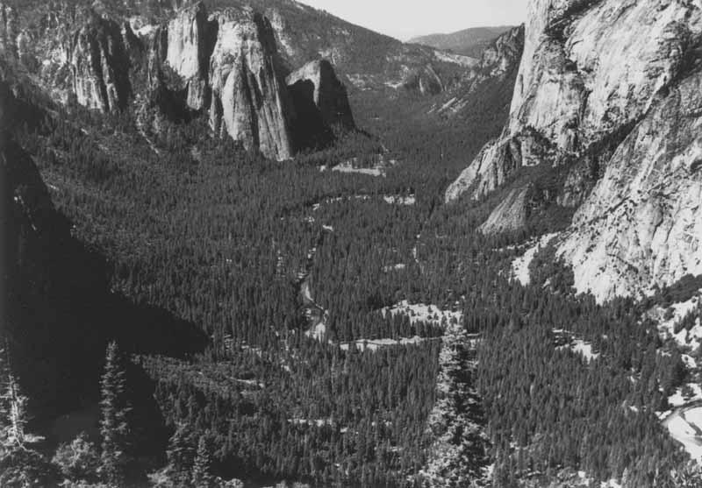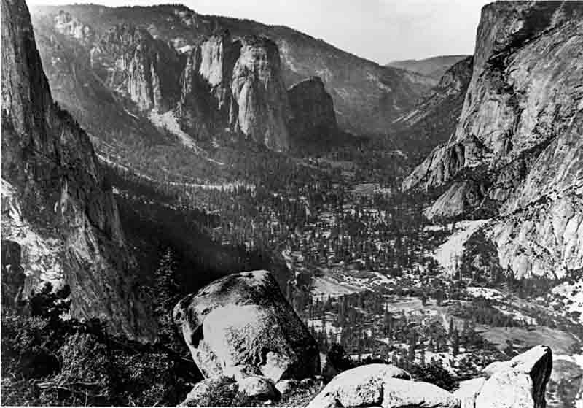

**6. Ecosystem and Habitat Vulnerability**

***6.a - Does your Region include inland or coastal aquatic habitats vulnerable to erosion and sedimentation issues?***

Yes. Substantial sedimentation and erosion issues occur along nearly all of the Region’s inland aquatic habitats. There are numerous sources of these issues. Climate change will likely pose substantial risks to these habitats.

***6.b - Does your Region include estuarine habitats which rely on seasonal freshwater flow patterns?***

No.

***6.c - Do climate-sensitive fauna or flora populations live in your Region?***

Yes. The westerly aspect of the Sierra Nevada is characterized by steep slopes. Associated with the steep slopes are individually unique and well-defined bands containing specific bio-physical correlations at specific gradients and elevations. This means elevation-dependent vegetation bands characterize the mountainous area of the Southern Sierra Region. The result of this phenomenon, especially with the added influences of climate change, is that as the upper elevations warm, the vegetation bands will contract, and bio-specific habitats will contract, or even disappear; leaving plants and animals vulnerable to potential extinction. A variety of native and imported flora and fauna live in the area and many are climate sensitive because they have restricted distributions, populations, or are unable to migrate or their migration routes are modified or eliminated. This natural climate sensitivity is compounded by pockets of current and future rural and agricultural development.

***6.d - Do endangered or threatened species exist in your Region? Are changes in species distribution already being observed in parts of your Region?***

Yes. Many State and Federally listed threatened and endangered species (for example three sub-species of golden trout) are found in the area. Several studies document noticeable changes in species distribution owing solely to climate change. Potential future development together with climate change poses significant risks to endangered and threatened species

***6.e - Does the Region rely on aquatic or water-dependent habitats for recreation or other economic activities?***

Yes. Passive and motorized recreation is an important part of the local culture in all watersheds, especially local reservoirs, including fishing and water sports. These recreational opportunities also provide a major benefit to the local economy.

***6.f - Are there rivers in your Region with quantified environmental flow requirements or known water quality/quantity stressors to aquatic life?***

Yes. The San Joaquin River and Kings River both have schedules for minimum environmental flows sufficient to support aquatic life all along the rivers to the Delta. These flows are the highest priority water uses, and are likely to be met, except possibly in an exceptionally dry year. These flows have one of the highest priorities for the surface waters, and flows are insufficient only in an extreme drought. Pursuant to the San Joaquin River Restoration Settlement Agreement, minimum in-stream flow requirements are prescribed as the flow necessary to restore reasonable habitat to support a spring salmon run and have been instituted up to Friant Dam (where Reach 1 begins) at which provide for flows. Kings River has a min 100cfs minimum flow below Pine Flat Dam; insufficient in most years during warmest portion of summer and in both extreme and exceptional drought years. Under Climate Change that period of unsuitable water temps will expand to the majority of the reproductive period of cold water fishes. During the warmest summer months water temperatures may reach levels unsuitable for old water fisheries which the minimum flows are designed to maintain.

***6.g - Do estuaries, coastal dunes, wetlands, marshes, or exposed beaches exist in your Region? If so, are coastal storms possible/frequent in your Region?***

No.

***6.h - Does your Region include one or more of the habitats described in the Endangered Species Coalition’s Top 10 habitats vulnerable to climate change (***[***http://www.itsgettinghotoutthere.org/***](http://www.itsgettinghotoutthere.org/)***)?***

Yes. The Southern Sierra Region which encompasses areas of the California Sierra Nevada Mountains which are included in the list of top 10 habitats vulnerable to climate change. The *It’s Getting Hot Out There* report notes the area is home to a variety of State and Federal listed threatened and endangered species. Climate change threats include rapid warming, having more winter rains instead of snow and experiencing an earlier snowmelt with less snowpack. Other threats include population growth, recreation and changing land use.

***6.i - Are there areas of fragmented estuarine, aquatic, or wetland wildlife habitat within your Region? Are there movement corridors for species to naturally migrate? Are there infrastructure projects planned that might preclude species movement?***

Yes. In the foothills and forested areas east of the valley floor area, large un-fragmented wilderness areas are found.

**7. Hydropower**

***7.a - Is hydropower a source of electricity in your Region?***

Yes. Hydropower is generated at 24 of the 33 dams in the SS Region. The bulk of the electricity is sold to the local power company and delivered to the electric grid, so it is not necessarily used directly in the Southern Sierra Region, although small amounts of this valuable resource are used in the Region.

***7.b - Are energy needs in your Region expected to increase in the future? If so, are there future plans for hydropower generation facilities or conditions for hydropower generation in your Region?***

Yes. Energy demands are likely to increase in the Region due to population growth, and to accommodate any climate change. No new major hydropower projects are planned for the area and are probably not likely to be pursued due to permitting difficulties. Some small hydropower projects are being considered along canals or at existing dams to utilize fish release flows. However, the energy generated from these projects would be small.

## Vulnerability Assessment and Adaptation Strategies

The DWR’s October 2008 publication “Managing an Uncertain Future: Climate Change Adaptation Strategies for California’s Water”, suggests there are multiple strategies that can help reduce the risks presented by climate change. To be successful, however, the report states these adaptation strategies must be well-coordinated at the state, regional and local levels in order to maximize their effect: “No single project or strategy can adequately address the challenges California faces, and tradeoffs must be explicitly acknowledged and decided upon. That said, planning and investing now in a comprehensive set of actions that informs water managers and provides system diversity and resilience will help prepare California for future climate uncertainty.” The requirement to fully develop the potential of Integrated Regional Water Management planning is Strategy No. 2 of ten strategies set out in the report.

Table 15.1 - Climate Change Adaptation Strategies for California’s Water[2]

|  |  |
| --- | --- |
| **Type of Strategy** | **Purpose of Strategy** |
| **Investment Strategy** | Strategy 1: Provide Sustainable Funding for Statewide and Integrated Regional Water Management |
| **Regional Strategies** | Strategy 2: Fully Develop the Potential of Integrated Regional Water Management |
| Strategy 3: Aggressively Increase Water Use Efficiency |
| **Statewide Strategies** | Strategy 4: Practice and Promote Integrated Flood Management |
| Strategy 5: Enhance and Sustain Ecosystems |
| Strategy 6: Expand Water Storage and Conjunctive Management of Surface and Groundwater Resources |
| Strategy 7: Fix Delta Water Supply, Quality and Ecosystem Conditions |
| **Improving Management and Decision-Making Capacity Strategies** | Strategy 8: Preserve, Upgrade and Increase Monitoring, Data Analysis and Management |
| Strategy 9: Plan for and Adapt to Seal Level Rise |
| Strategy 10: Identify and Fund Focused Climate Change Impacts and Adaptation Research and Analysis |

The DWR also defines ‘no-regret’ strategies as actions that provide measurable benefits today while also reducing vulnerability to climate change (EPA and DWR, 2011). In other words, they are strategies that provide benefits with or without climate change or reductions of greenhouse gases. As such, these are actions that can be taken within each IRWM planning area, independent of, but in furtherance of strategies, particularly Strategy 2, being pursued on a statewide level. For instance, constructing a water bank would provide needed water supply benefits in the present (Strategy 6), but could mitigate climate change impacts through floodwater capture (Strategy 4), increasing water storage, and enhancing wetland habitat (Strategy 7). The Water Education Foundation (2010) believes that planning for climatic uncertainty will also benefit planning for regulatory, environmental, economic, and social uncertainty.

The IRWMP RWMG concluded that no-regret strategies should comprise the majority of adaptation measures. Achievable “no-regret” management practices for tackling climate change concerns that the Southern Sierra Region can employ include:

1. Continued investment in local water conservation;
2. Diversification of local water supply portfolio;
3. Practicing integrated flood management;
4. Increasing conjunctive use of available water supplies;
5. Protecting and restoring water-related ecosystems;
6. Increasing water reuse and recycling;
7. Monitoring local and regional water use activities;
8. Tracking related legislation;
9. Investigating water supply/energy relationships and coordinating with larger water utilities; and
10. Following the State’s required adaptation strategies and legislation.

Although these ‘no-regret” strategies provide benefits with or without climate change or reductions of greenhouse gases , the threat of climate change further justifies the need for many water management strategies already being used in the Region, as well as putting in place many that are not. Furthermore, climate change adaptation is not in conflict with current Goals and Objectives of the Region or the State.

Most of the resource management strategies described in Chapter 5 would assist with climate change adaptation. However, the following strategies were deemed the most practical and effective for climate change adaptation in the Southern Sierra Region:

* Improve urban and agricultural water use efficiency
* Increase use of recycled water (where energy efficient and/or where minimal greenhouse gases result)
* Revise land use planning policies to encourage conservation (e.g. low impact development or water efficiency and conservation standards)
* Develop groundwater recharge and banking projects
* Develop water storage projects inside and outside of the Southern Sierra Region
* Increase ability to capture floodwater both for flood control and water supply
* Encourage forest thinning (mechanical, prescribed burn and other management options), restoration of mountain meadows, wetlands, and riparian areas to possibly increase and regulate flows resulting in more summer runoff
* Change crop types to accommodate climate change

The overall theme with these strategies is to expand the tool box of accommodations and actions that can be taken to help the Region adapt to extreme conditions (drought and floods) that climate change and increase of greenhouse gases may cause.

Table 5.1 in Chapter 5 – Resource Management Strategies is a matrix of the range of water management strategies set forth in the 2013 California Water Plan and their relative potential benefits for the Southern Sierra IRWMP area. The benefits are evaluated based upon whether the listed strategies are not applicable to the Region, applicable to Region, or applicable, but limited in area or in the potential for project approval. Drought Planning was added as a strategy by the Southern Sierra RWMG.

On June 5, 2014, a Climate Change Workshop was hosted by the Southern Sierra Regional Water Management Group. Dr. Marni Koopman of the GEOS Institute, who prepared a report interpreting various climate change models in support of the 1st IRWMP, was the featured speaker. Other speakers included team members of Provost & Pritchard Consulting Group (co-author of the 1st IRWMP), Sequoia National Forest and Sequoia and Kings Canyon National Parks. Attendees of the workshop included staff of various local, state and government agencies, local non-profits, other private-sector consultants.

Dr. Koopman and a series of other speakers defined key terms such as vulnerability, adaptation and mitigation and noted that the scale and extent of climate change impacts can vary based on how people in a particular Region respond. Dr. Koopman and others described and commented on current and potential strategies for mitigation of climate change relative to agriculture, forests, the economy, water supply and habitat. Dr. Koopman and others described and commented on current and potential strategies for adaptation and mitigation. At this workshop it was noted that the scale and extent of climate change impacts can vary based on how people in particular Region respond. “No Regret’ strategies were encouraged for consideration since they enhance resource conservation with or without climate change. Presenters stressed that vested interests within the Region as well as in the downstream regions can benefit from climate change adaptations and mitigation measures implemented in the South Sierra Region; activities in the Southern Sierra IRWM could affect water resource vulnerabilities in other water management regions, so actions need to be coordinated across boundaries.

Climate change adaptation is one or a series of actions that seeks to reduce the severity of climate change impacts to human and natural systems. The adaptation measures identified below do not address a specific quantified impact, but rather focus on a range of potential measures implemented to begin to minimize the negative effects of reductions in snowpack, river flows, flooding, and sea levels, and maximize groundwater storage capabilities, water conservation and water re-use where appropriate. Since climate change predictions will never be perfect, flexibility and diversity in adaptation measures is fundamental. The adaptation measures will also help the Region to improve resiliency, which is defined as the ability to return to original conditions after a disturbance or impact.

One of the primary impacts of climate change will be its exacerbating influence on existing stressors, which occur primarily through land management practices. As climate change progresses, reducing existing stressors will become increasingly necessary for retaining many of the services provided by functioning watersheds.

At the conclusion of the workshop presentations, a breakout exercise was conducted. Four groups were formed and asked to brainstorm climate change vulnerabilities and adaptation and mitigation strategies for four pre-determined categories:

* Watersheds and Water Quality
* Changing Precipitation Patterns and Management (including flooding)
* Effects of Wildfire Reoccurrence on Water Quality and Quantity
* Groundwater Resources (fracture flow and diminishing well capacity)

Initial breakout results are shown below in **Table 15.2.**

**Table 15.2 – Climate Change Workshop - Breakout Group Results**

| **Climate Change Category** | **Vulnerabilities** | **Adaptation & Mitigation Strategy** |
| --- | --- | --- |
| **Watersheds and Water Quality** | * Ephemeral Streams   + Vulnerable to irregular hydrology   + Fire, floods, decreased water quality (erosion)   + Human communities     - Increased early spring run-off     - Increase in fire     - Increased cost   + Animal and plant communities   + Recreation | * Forest and vegetation management   + Restoration (streamside)   + Land use designations/ policy (buffer; conservation easements) * Create more water storage * Education   + Planning (e.g. community and disaster)   + Conservation * Increase storage through recharge * Planning and implementing conservation planning (corridors)   + Prescribed fire   + Invasive species control * Restoration (water quality)   + Education   + Planning   + Diversity   + Community involvement |
| **Changing Precipitation Patterns and Management** | * Inadequate water storage * Drought * Flood preparedness * Infrastructure * Fire * Economic resilience   + Tourism   + Cattle * Ecological resilience | * Re-flood Tulare Lake * Increase dam size * Modify/alter watershed   + Vegetation management   + Meadow restoration * Transient storage   + Slow water flow through system   + Moving water around * Increase downstream stream capacity   + Setbacks   + Inadequate flood control * Increase accuracy of forecasts * Cloud seeding * Infrastructure resiliency |
| **Effects of Wildfire Reoccurrence on Water Quality and Quantity** | * Overly dense forests   + Results in fire; uncharacteristically severe fires & more frequent catastrophic fire   + Results in lower water storage capacity from increased uptake   + Loss of water through evapotranspiration * When forests burn   + Soil is lost from increased erosion   + Lose absorption capability   + Erosion/sedimentation leads to lower water quality/loss of aquatic habitat   + Ash is erosive itself | * More natural and prescribed fire at the landscape scale * Data collection, better modeling, and social science research that informs outreach and education * Education on the tradeoffs between prescribed fire vs. natural fire, benefits of natural fire, and consequences of a lack of fire |
| **Groundwater Resources (fracture flow and diminishing well capacity)** | * Loss of surface water that recharges groundwater * Limited storage space of aquifer * Water flows quickly through the system * Wells not deep enough * Economic interests * Groundwater exports * Concentration of pollutants in ground water * Already overdrafted groundwater resources * Lack of water planning * Population growth * Disadvantaged communities * Lack of water recycling | * Water conservation * Cloud seeding * Water recycling (grey water) * New funding sources for climate change/drought adaptation * Use more surface water * Require sustainable water supplies for new developments * Drill deeper wells/drill more wells * Drought tolerant landscaping * Renewable energy for well pumps * Require sustainable water supplies (prevents overdevelopment) |

Based on the results of the Climate Change Workshop Break-out Group Exercise **Table 15.2** shows the highest priority vulnerabilities and highest priority adaptation and mitigation strategies (with no necessary direct correlation) identified for the Southern Sierra Region.

Table 15.3 Priority Vulnerabilities and Adaptation & Mitigation Strategies

|  |  |
| --- | --- |
| **Vulnerabilities** | **Adaptation & Mitigation Strategy** |
| **Drought** | Forest and vegetation management (streamside restoration and land use policy encouraging conservation) |
| **Inadequate Water Storage** | Education* |
| **Overly Dense Forests** | Restoration education and community involvement |
| **Altered Fire Regimes** | More natural and prescribed fire at the landscape scale, including mechanical thinning and other management options |
| **Population Growth** | Water Conservation |
| **Already Overdrafted Groundwater Resources** | Water Recycling |
| New funding sources for climate change/drought adaption |
| Research that includes data collection better modeling, and social science research that informs education and outreach |
| Education on the benefits of large natural fires and prescribed fires |

* Noticeable overlap occurred across the breakout groups. Education was listed more than once (denoted by a *), thus representing common group thinking.

The attendees expressed the idea that vulnerabilities should be re-evaluated at least every five years to reflect changes in local cropping, water demands, water supplies, new facilities, and climate change projections and to adjust strategies as appropriate.

## Climate Change Monitoring

Climate change monitoring includes two components: 1) monitoring hydrologic, meteorological, ecosystem and social attributes for climate change and impacts; and 2) monitoring advances or changes in climate change science, policy and projections.

The Southern Sierra Region already includes a network for monitoring the hydrology, meteorology, water demands, water use, crop yields and wildlife. However, numerous improvements to monitoring and data management and availability are needed. The Region may not receive the attention needed due to its remote nature and low population. The importance of water management starting at the headwaters in the upper elevations of this and other National Park and Forest areas however, may be key to successful statewide water management and achievement of sustainable water yields. Improvements to numerous areas of hydrologic and environmental monitoring would aid in tracking climate change and managing water.

Historically water projects have been designed and are operated on the assumption that future hydrology will mimic past hydrology. Climate change puts these assumptions in jeopardy and going forward, planning and operations need to incorporate non-stationary hydrology. Given uncertainties, this means providing more resiliency to prepare for a much warmer climate, which can be both wetter or drier in various periods. Future projects should not continue to be designed based on past hydrology. The quality and quantity of data has improved in recent years, is readily available and provides robust scenarios for future conditions. In particular, water managers should prepare for more severe droughts and flooding.

The science of climate change, and the tools to mitigate and adapt to climate change, are robust, and will continue to improve. As a result, every five years as part of the California Water Plan Update process, DWR will provide revised estimates of changes to sea levels, droughts, and flooding that can be expected over the subsequent 25 years. The RWMG will also stay apprised of new studies, reports, literature, legislation, and climate change model runs that are pertinent to the area. New data and guidelines are being published on a frequent basis, and several climate change clearinghouses ease the effort to find this data. When needed, this literature will be shared with the RWMG members and interested stakeholders, and incorporated into the IRWMP updates.

## Mitigation of Greenhouse Gas Emissions

Mitigation of climate change can be achieved by selecting and promoting projects that help to reduce greenhouse gas emissions (GHG) emissions. While the RWMG is not responsible for air quality management, and they can only have a small impact on global emissions, it is both responsible and responsive for climate goals to consider emissions in project selection in view of the negative impacts climate change may have on water resources and the region overall.

All of the resource management strategies described in Chapter 6 can assist with climate change mitigation through reduction in energy demand, ecosystem enhancement, or carbon sequestration. For instance, water conservation can reduce energy demands to pump, convey, and treat water supplies, although it should be noted that some water conservation measures do require additional energy input. Another example is riparian area restoration, which can sequester carbon and create habitat for species impacted by climate change.

Projects are primarily ranked based on whether they advance goals and objectives of this plan and their water supply benefits, but GHG emissions and climate change adaptation were added as considerations. Specifically, the following questions were added to the Project Review Process form:

1. Will this project result in reduced greenhouse gas emissions? If yes, explain how and quantify.
2. Will this project increase greenhouse gas emissions? If yes, explain how and quantify.
3. Will this project contribute to adaptation strategies to respond to climate change impacts?

The RWMG is also dedicated to helping the State meet GHG emission reduction goals. These goals, prescribed in the California Global Warming Solutions Act of 2006 (AB 32), include reaching 2000 emission levels by 2010, 1990 levels by 2020, and 80% below 1990 levels by 2050.

Beginning July 1, 2012, GHG emissions for California Environmental Quality Act (CEQA) studies are required to be calculated using the California Emissions Estimator Model (CalEEMod). CalEEMod quantifies potential criteria pollutant and GHG emissions from construction and operations for a variety projects.  The RWMG will also require that this model be used on projects considered for funding.

## Climate Change in other IRWMP Chapters

Climate change is discussed in several other IRWMP sections including:

Table 15.5 - Climate Change in other IRWMP Chapters

|  |  |  |
| --- | --- | --- |
| **Chapter 5** | **Goals and Objectives** | This chapter includes general goals related to climate change adaptation and mitigation. |
| **Chapter 6** | **Resource Management Strategies** | This chapter discusses the impacts of climate change on the efficacy of different strategies, and the ability of strategies to help adapt to climate change. |
| **Chapter 7** | **Project Review Process** | The project review process includes new questions related to GHG emissions (Section 15.8) |
| **Chapter 13** | **Relation to Local Land and Water Planning** | This chapter summarizes the climate change adaptation and mitigation strategies from local water plans, and evaluates their consistency with the goals of this IRWMP. |

1. National Park Service, Photo Gallery, Historical Images of Yosemite National Park, <http://www.nps.gov/media/photo/gallery.htm?id=B17BC4E5-155D-4519-3EC6B73FCE2806A8>
2. California Department of Water Resources, “Managing an Uncertain Future: Climate Change Adaptation Strategies for California’s Water”, October 2008.