PHASE 2 ASSESSMENT FINDINGS:
DAC Involvement, Meeting Attendance & Grant funding for the Tulare-Kern Funding Area IRWM Groups
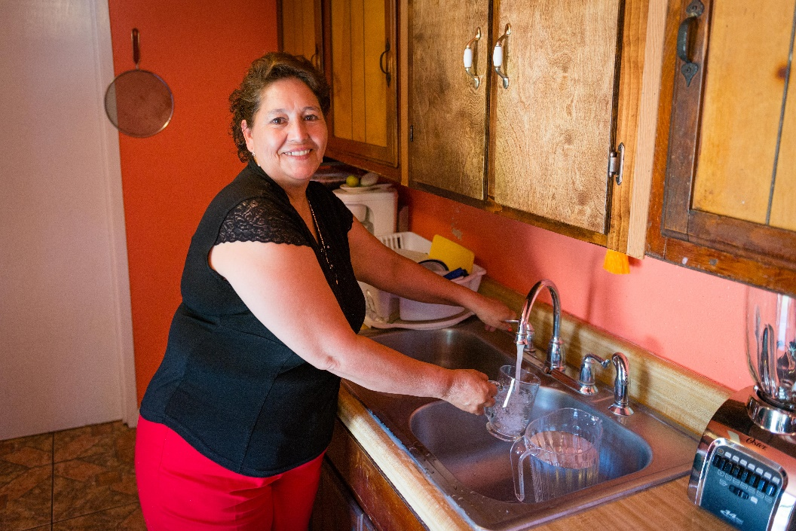

  - Prop 1 Integrated Regional Water Management Disadvantaged Community Involvement Program

  - Prepared for the Tulare-Kern Funding Area Disadvantaged Community Involvement Program
Project Advisory Committee

  - june 2020
  - Community Engagement and Planning Team, Self-Help Enterprises
aMARIS FARLEY & KRISTIN dOBBIN, UC DAVIS

Table of Contents

1 Background and Objectives 3
2 Methods 3
2.1 Assessment Methods: Attendance at IRWM Meetings 4
2.2 Assessment Methods: IRWM DAC/SDAC Funding 4
2.3 Assessment Methods: DAC/SDAC Involvement With IRWM Groups 5
3 Meeting Attendance, Grant Funding, and Involvement Assessment
Results 6
3.1 DAC Attendance Assessment At IRWM Meetings 6
3.1.1 Kaweah IRWM Group & DAC Attendance Assessment at IRWM Meetings 6
3.1.2 Kings Basin IRWM Group & DAC Attendance Assessment at IRWM Meetings 8
3.1.3 Westside-San Joaquin IRWM Group & DAC Attendance Assessment at IRWM Meetings 10
3.1.4 Kern IRWM Group & DAC Attendance Assessment at IRWM Meetings 11
3.1.5 Poso Creek IRWM Group & DAC Attendance Assessment at IRWM Meetings 13
3.1.6 Southern Sierra IRWM Group & DAC Attendance Assessment at IRWM Meetings 15
3.1.7 Tule River IRWM Group & DAC Attendance Assessment at IRWM Meetings 16
3.1.8 Tulare-Kern Funding Area, 7 IRWM groups, DAC Attendance Assessment at IRWM
Meetings……………… 18
3.2 DAC Grant Funding Assessment Results 22
3.2.1 Kaweah DAC Grant Funding Assessment 22
3.2.2 Kings Basin DAC Grant Funding Assessment 23
3.2.3 Westside-San Joaquin DAC Grant Funding Assessment 24
3.2.4 Kern DAC Grant Funding Assessment 24
3.2.5 Poso Creek DAC Grant Funding Assessment 26
3.2.6 Tule River DAC Grant Funding Assessment 27
3.2.7 Southern Sierra DAC Grant Funding Assessment 27
3.2.8 Overall Tulare-Kern Funding Area (all 7 IRWM regions) DAC Grant Funding Assessment 28
3.3 Participation Assessment Results 28
3.3.1 Discussion 43
4 CONCLUSIONS & RECOMMENDATIONS…….…………………………………………..44
5 APPENDIX A: RAW DATA TABLES – MEETING ATTENDANCE……………………...46

6 APPENDIX B: RAW DATA TABLES – IRWM PARTICIPATION ASSESSMENT………57

1 Background and Objectives

The Tulare Kern Funding Area Disadvantaged Community Involvement Program (TKFA DACIP) is a $3.4 million grant-funded effort, which aims to develop strategies to address long-term, sustainable water planning needs, and improve the participation and engagement of Disadvantaged Communities (DACs) and Severely Disadvantaged Communities (SDACs) in Integrated Regional Water Management (IRWM) within the funding area. Specifically, $550,000 of the available $3.4 million has been set aside to fund a Disadvantaged Community Engagement and Education Program (DACEEP). The DACEEP will focus on improving understanding of community water needs and the IRWM process as well as encouraging DAC/SDAC participation and engagement in IRWM activities.

The initial Disadvantaged Community Outreach and Engagement Recommendations Report sought to identify: 1) DACs that have participated in IRWM; 2) DACs that are actively participating in IRWM; 3) DACs that have never participated in IRWM; and 4) DACs that are outside of an IRWM region. Building upon that foundation, this assessment further seeks to identify how DACs have or are currently participating. This Assessment of Findings: DAC Involvement, Meeting Attendance and Grant Funding for the Tulare Kern Funding Area IRWM Groups, provides an assessment of past and present DAC/SDAC engagement in IRWM. The assessment was conducted to improve understanding of the nature of DAC involvement, and to serve as a baseline for measuring progress on DAC/SDAC participation and engagement in IRWM activities. It contains three related but separate considerations: DAC/SDAC involvement with the seven local IRWM groups, DAC/SDAC attendance at IRWM meetings and a careful analysis of two rounds of IRWM grant funding to projects that directly benefit DAC/SDACs.

2 Methods

For the initial Disadvantaged Community Outreach and Engagement Recommendations Report SHE obtained a list of DACs by IRWM region from Provost and Pritchard Consulting Group (P&P). This list was vetted internally by SHE staff familiar with the IRWM program, IRWM regions, and communities. Some revisions and additions were made to the list. SHE then gathered and reviewed the most currently available IRWM plans and project lists for each of the seven (7) IRWM groups within the Tulare-Kern Funding Area (TKFA). SHE also reviewed findings and recommendations of past DAC studies and recommendations identified in the September 2018 Rural Communities Water Managers Leadership Institute Stakeholder Perspectives Report. From this report, one recommendation that emerged was to continue the assessment of present DAC engagement in IRWM in order to thoroughly assess participation. Specifically, it was recommended that SHE review past IRWM meeting minutes and other forms of attendance/participation tracking systems that IRWM regions may manage and maintain to determine DAC participation and which DACs have obtained funding.
For this Assessment of Findings: DAC Involvement, Meeting Attendance and Grant Funding for the Tulare Kern Funding Area IRWM Groups, SHE looked at DAC attendance at IRWM meetings based on analysis of meeting minutes, the DAC/SDAC funding assessment and DAC/SDAC involvement with IRWM groups. These assessment methods are provided in detail below.
For the purpose of this study, the definition of a DAC is as set forth in Division 26.5 of the California Water Code: “Disadvantaged community” means a community with an annual median household income that is less than 80 percent of the statewide annual median household income. The number of DACs by IRWM group was taken directly from Self-Help Enterprises’ (SHE) participation assessment (see Appendix B), which identified 354 DACs in the Tulare Kern Funding Area, 344 of which fall inside the current boundaries of existing IRWM regions.
A Needs Assessment for the TKFA DACIP is being conducted concurrently with the DACEEP. While coordination with the Needs Assessment and DACEEP has been ongoing, final DAC statistics may vary. Assumptions that have impacted the DAC counts will be discussed in the Needs Assessment report.

2.1 Assessment Methods: Attendance at IRWM Meetings
The assessment of DAC/SDAC participation in IRWM meetings was conducted through an analysis of meeting minutes provided by IRWM groups. Where these were available, SHE collected meeting minutes from seven (7) IRWM groups, compiling lists of attendees at each meeting. The IRWM groups include:
- Kaweah River Basin IRWM Group
- Kern IRWM Group
- Kings Basin Water Authority IRWM Group
- Poso Creek IRWM Group
- Southern Sierra IRWM Group
- Tule River Basin IRWM Group
- Westside-San Joaquin IRWM Group
The meeting minutes were then organized and analyzed in a spreadsheet (see Appendix A) to identify DAC and SDAC representatives.
Overall, the attendance assessment considers 42 meetings in 2017 and 2018, including board meetings and advisory/stakeholder committee meetings (where applicable). The number and time frame of meetings considered for each IRWM group is noted in the spreadsheet (see Appendix A) as it varies between groups. Efforts were made to obtain the most recent meeting information and collect information directly from the IRWM groups; nonetheless it is possible that records of some meetings were not received and were therefore omitted.

2.2 Assessment Methods: IRWM DAC/SDAC Funding
Information about IRWM grants received by the seven (7) IRWM groups in the funding area were collected from various documents from the Department of Water Resources (DWR) including IRWM grant funding proposals, proposal evaluations, and DWR’s IRWM Proposal Solicitation Packages (PSPs). These documents were collected from the DWR public website and a Public Records Act Request for Proposition 84-related documents from DWR. All funding rounds from Proposition 84 were considered, as well as the sole executed funding round from Proposition 1 (which was for planning grants). IRWM funding prior to Proposition 84 (namely Proposition 50) is not included in this analysis.
For the funding assessment, projects benefiting DACs were defined as follows: A DAC project was defined as an IRWM funded project with direct benefit to one more DAC or SDAC (e.g. infrastructure improvements in a DAC or SDAC). DAC benefiting projects were defined as an IRWM funded project with claimed indirect benefits for one or more DAC/SDAC (e.g. IRWM plan updates, regional recharge).
Lastly, for the grant funding results, where a funding proposal was only partially funded it was assumed that all projects within that proposal were awarded the same partial funding (for example, if the proposal was 25% funded it was assumed each project in that proposal received 25% of the project costs requested). Depending on the project, this may not necessarily be the case, but based on the available documentation it was unknown how the partial funding award may have been adjusted by an individual IRWM group.

2.3 Assessment Methods: DAC/SDAC Involvement with IRWM Groups
The third and final consideration in this assessment relates to the formal relationships established between local IRWM groups and the DACs/SDACs within their boundaries. To compile this information, SHE staff collected documents from each group including their most recent IRWM plan and project lists. Each of these documents were then reviewed for references to specific DACs/SDACs. This information was then compiled into a spreadsheet (see Appendix A) noting which communities have or have not participated, are members of the governing board or an advisory committee, and/or have a project on the IRWM group’s project list. Basic statistical analysis was then performed to summarize these findings more concisely. Similar to the meeting attendance analysis, efforts were made to obtain the most recent and up-to-date sources of information; however, it is likely that some existing relationships may not have been fully captured by these document analyses methods.
Similarly, the methods were constrained to consideration of available documents. Further, this assessment should be considered a snapshot in time of a dynamic process. Local IRWM groups are encouraged to contribute comments and corrections to improve these findings.

3 Meeting Attendance, Grant Funding, & Involvement
Assessment Results

3.1 DAC Attendance Assessment at IRWM Meetings
This section summarizes the number and type of DACs in each IRWM region and comparatively inventories the attendance by DAC representatives at IRWM meetings. Because there is an observed difference in meeting participation levels between incorporated cities with paid staff and unincorporated communities who may lack professional staff, these community types were considered separately. Methods are described above in Section 2.1.

3.1.1 Kaweah IRWM Group & DAC Attendance Assessment at IRWM Meetings

Kaweah IRWM
Total number of DACs in this IRWM group: 34 communities
IRWM Group DAC Breakdown
Category | Total | Percentage
Incorporated | 5 out of 34 | 15%
Unincorporated | 29 out of 34 | 85%
SDACs | 18 out of 34 | 52%
DACs | 16 out of 34 | 48%

For the 2017-2018 time period, the Kaweah IRWM held a total of 9 meetings, of which 6 meetings were held in 2017 and 3 in 2018.

6 meetings held in 2017
February 22, 2017; March 15, 2017; April 26, 2017; May 17, 2017; June 21, 2017;
August 30, 2017
DAC and SDAC participants
Farmersville | SDAC incorporated
Lindsay | SDAC incorporated
Tulare | DAC incorporated
IRWM DACs Participation in Meetings Breakdown
Incorporated | 3
Unincorporated | 0
SDACs | 2
DACs | 1

3 meetings held in 2018
February 21, 2018; April 25, 2018; July 19, 2018
DAC and SDAC participants
Farmersville | SDAC incorporated
Lindsay | SDAC incorporated
Tulare | DAC incorporated
IRWM DACs Participation Breakdown
Incorporated | 3
Unincorporated | 0
SDACs | 2
DACs | 1

Overall, 3 DACs/SDACs (combined) attended at least one meeting in this period, or 9% of the total DACs/SDACs in the Kaweah IRWM region. These are: Farmersville (SDAC Incorporated), Lindsay (SDAC Incorporated), and Tulare (DAC Incorporated). The table below shows the overall results for the Kaweah IRWM group.

Kaweah IRWM Attendance Final Results
Total number of DACs in this IRWM group: 34 total communities
DAC and SDAC participants
Farmersville |  | SDAC incorporated
Lindsay |  | SDAC incorporated
Tulare |  | DAC incorporated
Number of DACs that have attended at least one meeting broken up by category
Category | Total |  | Percentage
Incorporated | 3 out of 5 |  | 60%
Unincorporated | 0 out of 29 |  | 0%
SDACs | 2 out of 18 |  | 11.1%
DACs | 1 out of 16 |  | 6.3%
Attendance rates for participating DACs/SDACs
City | Percentage
Farmersville | Attended 100% of the meetings
Lindsay | Attended 78% of the meetings
Tulare | Attended 89% of the meetings
Total | Average DAC/SDAC attendance rate: 89%

3.1.2 Kings Basin IRWM Group & DAC Attendance Assessment at IRWM Meetings

Kings Basin IRWM
Total number of DACs in this IRWM group: 92 total communities
IRWM Group DAC Breakdown
Category | Total | Percentage
Incorporated | 10 out of 92 | 11%
Unincorporated | 82 out of 92 | 89%
SDACs | 47 out of 92 | 51%
DACs | 45 out of 92 | 49%

For the 2017-2018 time period, the Kings Basin IRWM group held a total of 7 meetings, of which 4 meetings were held in 2017 and 3 in 2018.

4 meetings held in 2017
January 18, 2017; April 19, 2017; July 19, 2018; October 18, 2017
DAC and SDAC participants
Fresno | DAC incorporated
Selma | DAC incorporated
Dinuba | SDAC incorporated
Kerman | DAC incorporated
Parlier | SDAC incorporated
Reedley | DAC incorporated
Sanger | DAC incorporated
Armona | DAC unincorporated
Biola | SDAC unincorporated
Lanare | DAC unincorporated
Malaga | DAC unincorporated
IRWM DACs Participation Breakdown
Incorporated | 7
Unincorporated | 4
SDACs | 3
DACs | 8

3 meetings held in 2018
April 18, 2018; July 18, 2018; October 18, 2018
DAC and SDAC participants
Fresno | DAC incorporated
Dinuba | SDAC incorporated
Kerman | DAC incorporated
Parlier | SDAC incorporated
Reedley | DAC incorporated
Sanger | DAC incorporated
Armona | DAC unincorporated
Malaga | DAC unincorporated
IRWM DACs Participation Breakdown
Incorporated | 6
Unincorporated | 2
SDACs | 2
DACs | 6

Overall, 11 DACs/SDACs (combined) have attended at least one meeting representing 12% of all the DACs/SDACs in the region: Fresno (DAC Incorporated), Selma (DAC Incorporated), Dinuba (SDAC Incorporated), Kerman (DAC Incorporated), Parlier (SDAC Incorporated), Reedley (DAC Incorporated), Sanger (DAC Incorporated), Armona (DAC Unincorporated), Biola (SDAC Unincorporated), Lanare (DAC Unincorporated), and Malaga (DAC Unincorporated). The table below shows the overall results for the Kings Basin IRWM group.

Kings Basin IRWM Attendance Final Results
Total number of DACs in this IRWM group: 92 communities
Number of DACs that have attended at least one meeting broken up by category
Category | Total | Percentage
Incorporated | 7 out of 10 | 70%
Unincorporated | 4 out of 82 | 4.9%
SDACs | 3 out of 47 | 6.4%
DACs | 8 out of 45 | 17.8%
Attendance rates for participating DACs/SDACs
City | Percentage
Kerman | Attended 100% of the meetings
Dinuba | Attended 14% of the meetings
Fresno | Attended 57% of the meetings
Parlier | Attended 71% of the meetings
Reedley | Attended 86% of the meetings
Sanger | Attended 14% of the meetings
Selma | Attended 43% of the meetings
Armona | Attended 86% of the meetings
Biola | Attended 43% of the meetings
Lanare | Attended 29% of the meetings
Malaga | Attended 57% of the meetings
Total | Average DAC/SDAC attendance rate: 55%

3.1.3 Westside-San Joaquin IRWM Group & DAC Attendance Assessment at IRWM Meetings
Westside-San Joaquin IRWM
Total number of DACs in this IRWM group: 32 communities
IRWM Group DAC Breakdown
Category | Total | Percentage
Incorporated | 1 out of 32 | 3%
Unincorporated | 31 out of 32 | 97%
SDACs | 20 out of 32 | 62.5%
DACs | 12 out of 32 | 37.5%

For the 2017-2018 time period, the Westside-San Joaquin IRWM group held 6 meetings. All 6 meetings were held in 2018.

6 meetings held in 2018
March 20, 2018; April 17, 2018; May 15, 2018; June 19, 2018; July 31, 2018; November 5, 2018
DAC and SDAC participants
None
IRWM DACs Participation Breakdown
Incorporated | 0
Unincorporated | 0
SDACs | 0
DACs | 0

Westside IRWM Attendance Final Results
Total number of DACs in this IRWM group: 32 communities
Number of DACs that have attended at least one meeting broken up by category
Category | Total | Percentage
Incorporated | 0 out of 1 | 0%
Unincorporated | 0 out of 31 | 0%
SDACs | 0 out of 20 | 0%
DACs | 0 out of 12 | 0%

3.1.4 Kern IRWM Group & DAC Attendance Assessment at IRWM Meetings

Kern IRWM
Total number of DACs in this IRWM group: 113 communities
IRWM Group DAC Breakdown
Category | Total | Percentage
Incorporated | 6 out of 113 | 5%
Unincorporated | 107 out of 113 | 95%
SDACs | 76 out of 113 | 67%
DACs | 37 out of 113 | 33%

For the 2017-2018 time period, the Kern IRWM group held 2 meetings, of which 1 meeting was held in 2017 and 1 in 2018.

1 meeting held in 2017
January 23, 2017
DAC and SDAC participants
Oildale | SDAC unincorporated
Buttonwillow | SDAC unincorporated
Arvin | SDAC incorporated
IRWM DACs Participation Breakdown
Incorporated | 1
Unincorporated | 2
SDACs | 3
DACs | 0

1 meeting held in 2018
November 9, 2018
DAC and SDAC participants
Oildale | SDAC unincorporated
Buttonwillow | SDAC unincorporated
Arvin | SDAC incorporated
IRWM DACs Participation Breakdown
Incorporated | 1
Unincorporated | 2
SDACs | 3
DACs | 0

Overall, 3 DACs/SDACs (combined) have attended at least one meeting representing 2.65% of all the DACs/SDACs in the IRWM region: Oildale (SDAC Unincorporated), Buttonwillow (SDAC Unincorporated), and Arvin (SDAC Incorporated). The table below shows the overall results for the Kern IRWM group.

Kern IRWM Attendance Final Results
Total number of DACs in this IRWM group: 113 communities
Number of DACs that have attended at least one meeting broken up by category
Category | Total | Percentage
Incorporated | 1 out of 6 | 16.7%
Unincorporated | 2 out of 107 | 1.9%
SDACs | 3 out of 76 | 3.9%
DACs | 0 out of 37 | 0%
Attendance rates for participating DACs/SDACs
City | Percentage
Oildale | Attended 100% of the meetings
Buttonwillow | Attended 50% of the meetings
Arvin | Attended 50% of the meetings
Total | Average DAC/SDAC attendance rate: 83%

3.1.5 Poso Creek IRWM Group & DAC Attendance Assessment at IRWM Meetings
Poso Creek IRWM
Total number of DACs in this IRWM group: 15 communities
IRWM Group DAC Breakdown
Category | Total | Percentage
Incorporated | 4 out of 15 | 27%
Unincorporated | 11 out of 15 | 73%
SDACs | 6 out of 15 | 40%
DACs | 9 out of 15 | 60%

For the 2017-2018 time period, the Poso Creek IRWM group held 7 meetings, of which 4 meeting were held in 2017 and 3 in 2018.

4 meetings held in 2017
January 3, 2017; May 2, 2017; June 6, 2017; August 16, 2017
DAC and SDAC participants
Pond | SDAC unincorporated
IRWM DACs Participation Breakdown
Incorporated | 0
Unincorporated | 1
SDACs | 1
DACs | 0

3 meetings held in 2018
March 6, 2018; August 7, 2018; November 6, 2018
DAC and SDAC participants
Pond | SDAC unincorporated
IRWM DACs Participation Breakdown
Incorporated | 0
Unincorporated | 1
SDACs | 1
DACs | 0

Overall, only one DAC/SDAC (combined) has attended at least one meeting representing 6.7% of all the DACs/SDACs in the IRWM region: Pond (SDAC Unincorporated). Pond, the only DAC/SDAC to attend Poso Creek meetings and considered in this analysis attended 43% of the IRWM meetings (3/7 meetings). The table below shows the overall results for the Poso Creek IRWM group.

Poso Creek IRWM Attendance Final Results
Total number of DACs in this IRWM group: 15 communities
Number of DACs that have attended at least one meeting broken up by category
Category | Total | Percentage
Incorporated | 0 out of 4 | 0%
Unincorporated | 1 out of 11 | 9.1%
SDACs | 1 out of 6 | 16.7%
DACs | 0 out of 9 | 0%
Attendance rates for participating DACs/SDACs
City | Percentage
Pond | Attended 43% of the meetings
Total | Average DAC/SDAC attendance rate: 43%

3.1.6 Southern Sierra IRWM Group & DAC Attendance Assessment at IRWM Meetings

Southern Sierra IRWM
Total number of DACs in this IRWM group: 18 communities
IRWM Group DAC Breakdown
Category | Total | Percentage
Incorporated | 0 out of 18 | 0%
Unincorporated | 18 out of 18 | 100%
SDACs | 10 out of 18 | 56%
DACs | 8 out of 18 | 44%

For the 2017-2018 time period, the Southern Sierra IRWM group held 1 meeting (December 2, 2017).

1 meeting held in 2017
December 2, 2017
DAC and SDAC participants
Springville | SDAC unincorporated
IRWM DACs Participation Breakdown
Incorporated | 0
Unincorporated | 1
SDACs | 1
DACs | 0

Overall, one DAC/SDAC (combined) participated in the meeting considered representing 5.6% of all the DACs/SDACs in the IRWM region: Springville (SDAC Unincorporated). The table below shows the overall results for the Southern Sierra IRWM group.

Southern Sierra IRWM Attendance Final Results
Total number of DACs in this IRWM group: 18 total communities
Number of DACs that have attended at least one meeting broken up by category
Category | Total | Percentage
Incorporated | 0 out of 0 | 0%
Unincorporated | 1 out of 18 | 5.56%
SDACs | 1 out of 10 | 10%
DACs | 0 out of 8 | 0%
Attendance rates for participating DACs/SDACs
City | Percentage
Springville | Attended 100% of the meetings
Total | Average DAC/SDAC attendance rate: 100%

3.1.7 Tule River IRWM Group & DAC Attendance Assessment at IRWM Meetings
Tule River IRWM
Total number of DACs in this IRWM group: 40 communities
IRWM Group DAC Breakdown
Category | Total | Percentage
Incorporated | 1 out of 40 | 2.5%
Unincorporated | 39 out of 40 | 97.5%
SDACs | 20 out of 40 | 50%
DACs | 20 out of 40 | 50%

For the 2017-2018 time period, the Tule River IRWM group held 9 meetings, of which 5 meetings were held in 2017 and 4 in 2018.

5 meetings held in 2017
February 27, 2017; April 24, 2017; June 26, 2017; October 30, 2017; December 18, 2017
DAC and SDAC participants
Porterville | DAC incorporated
Woodville | SDAC unincorporated
Allensworth | SDAC unincorporated
Alpaugh | DAC unincorporated
IRWM DACs Participation Breakdown
Incorporated | 1
Unincorporated | 3
SDACs | 2
DACs | 2

4 meetings held in 2018
January 29, 2018; February 26, 2018; April 30, 2018; May 29, 2018
DAC and SDAC participants
Porterville | DAC incorporated
Woodville | SDAC unincorporated
Allensworth | SDAC unincorporated
Alpaugh | DAC unincorporated
IRWM DACs Participation Breakdown
Incorporated | 1
Unincorporated | 3
SDACs | 2
DACs | 2

Overall, 4 DACs/SDACs (combined) have attended at least one meeting representing 10% of all the DACs/SDACs in the IRWM region: Porterville (DAC incorporated), Woodville (SDAC Unincorporated), Allensworth (SDAC Unincorporated), Alpaugh (DAC Unincorporated). The table below shows the overall results for the Tule River IRWM group.

Tule River IRWM Attendance Final Results
Total number of DACs in this IRWM group: 40 communities
Number of DACs that have attended at least one meeting broken up by category
Category | Total | Percentage
Incorporated | 1 out of 1 | 100%
Unincorporated | 3 out of 39 | 8%
SDACs | 2 out of 20 | 10%
DACs | 2 out of 20 | 10%
Attendance rates for participating DACs/SDACs
City | Percentage
Allensworth | Attended 44% of the meetings
Alpaugh | Attended 11% of the meetings
Porterville | Attended 100% of the meetings
Woodville | Attended 56% of the meetings
Total | Average DAC/SDAC attendance rate: 53%

3.1.8 Tulare-Kern Funding Area, 7 IRWM groups, DAC Attendance Assessment at IRWM
Meetings

7 IRWM Groups
Total number of DACs/SDACs in the 7 IRWM groups: 344 total communities
Number of DACs outside of the 7 IRWM groups but within the Tulare Lake Basin region: 10
7 IRWM Groups DAC Breakdown
Category | Total | Percentage
Incorporated | 27 out of 344 | 8%
Unincorporated | 317 out of 344 | 92%
SDACs | 197 out of 344 | 57%
DACs | 147 out of 344 | 43%

Between 2017 to 2018, a total of 35 meetings were held among the 7 IRWM groups. Overall, 23 DACs/SDACs in the region have attended at least one meeting over this period representing 6.68% of all the DACs/SDACs in the region (23/344 DACs/SDACs). The table below shows the overall results for the Tulare Kern Funding Area. These findings represent DACs/SDACs in the seven IRWM groups and does not include participating DACs/SDACs that are outside an IRWM region.

A review of the tables above confirms that most IRWM groups have higher rates of attendance among incorporated communities (cities) than among unincorporated communities. This varies widely over the seven groups, of course, and it is important to note that some IRWM regions have few or no incorporated communities within their boundaries, so direct comparisons of attendance rates cannot be drawn. Still, of the seven groups, four had higher rates of attendance by incorporated DACs. Of the remaining three groups, one lacks any incorporated communities, one has competition from overlapping boundaries with a larger group (where some DACs had a choice of group), and one had no DAC participation at all.

7 IRWM Groups Attendance Final Results
Total number of DACs among the 7 IRWM groups: 344 communities
Number of DACs that have attended at least one meeting broken up by Community type
IRWM group | Community | Community Type
Tule River | Porterville | DAC incorporated
 | Woodville | SDAC unincorporated
 | Allensworth | SDAC unincorporated
 | Alpaugh | DAC unincorporated
Kern | Oildale | SDAC unincorporated
 | Buttonwillow | SDAC unincorporated
 | Arvin | SDAC incorporated
Kings Basin | Fresno | DAC incorporated
 | Selma | DAC incorporated
 | Dinuba | SDAC incorporated
 | Kerman | DAC incorporated
 | Parlier | SDAC incorporated
 | Reedley | DAC incorporated
 | Sanger | DAC incorporated
 | Armona | DAC unincorporated
 | Biola | SDAC unincorporated
 | Lanare | DAC unincorporated
 | Malaga | DAC unincorporated
Kaweah | Farmersville | SDAC incorporated
 | Lindsay | SDAC incorporated
 | Tulare | DAC incorporated
Poso Creek | Pond | SDAC unincorporated
Southern Sierra | Springville | SDAC unincorporated
Westside-San Joaquin | None | -
Attendance broken down by DAC and SDAC status and incorporated and unincorporated
Status | Total | Attendance
Incorporated | 12 out of 27 | 44.4% attended at least one meeting
Unincorporated | 11 out of 317 | 3.5% attended at least one meeting
SDACs | 12 out of 197 | 6.1% attended at least one meeting
DACs | 11 out of 147 | 7.5% attended at least one meeting
Total | 6.68% of all the DACs/SDACs in the region attended at least one IRWM meeting in 2017 or 2018

Overall, a wide discrepancy in participation by incorporated (44.4%) and unincorporated communities (3.5%) is noted. As previously mentioned, one contributing factor is a lack of resources/staff in unincorporated communities. Although this is likely the main cause, there are also significantly fewer incorporated communities, which results in a comparatively higher percentage of participation even though the actual numbers of participating communities are roughly equivalent.

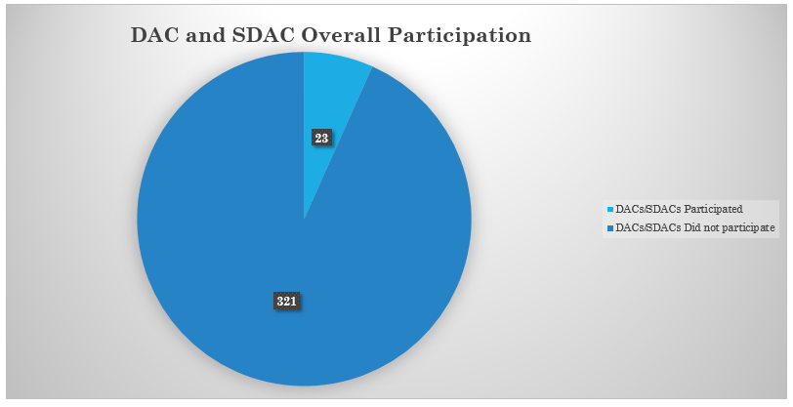

Of the 23 DACs/SDACs that participated, 11 were DACs and 12 were SDACs. The graph below shows that there tends to be nearly equal participation among DACs and SDACs.
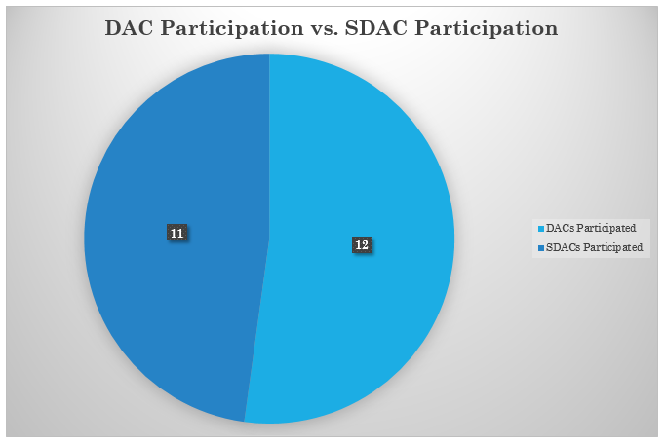
Furthermore, of the 23 DACs/SDACs that participated, 12 of the 27 incorporated DACs/SDACs participated versus only 11 of the 317 unincorporated DACs/SDACs participated. The figures below illustrate the stark contrast of participation from unincorporated communities.
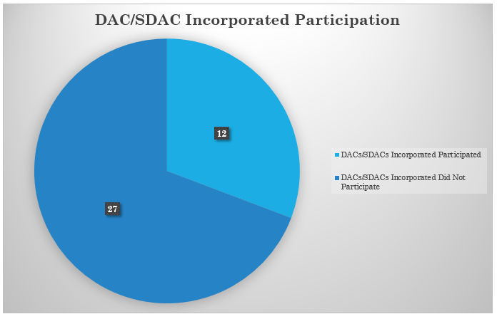
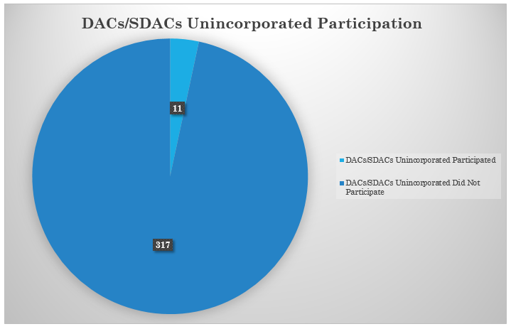

3.2 DAC Grant Funding Assessment Results
In this section, an assessment was performed of the monetary benefits derived from DAC involvement in IRWM. This information includes grants made to fund projects that directly or indirectly benefit DACs/SDACs, and also includes local cost share requirements that were waived on account of DAC benefit or inclusion. Points awarded for meeting DAC criteria are also reflected here. Methods are described in Section 2.2 above.

3.2.1 Kaweah DAC Grant Funding Assessment
Kaweah IRWM has been the recipient of a total of three rounds of Proposition 84 funding from DWR: A Round 2 Planning Grant (total funding $235,254), a Round 1 Implementation Grant (total funding $4,646,000), and a Drought Grant (total funding $241,818). Of these, only the Round 2 Planning Grant was fully funded at the levels requested by the IRWM group. Each of the three funding rounds awarded Kaweah IRWM points for DAC benefits and/or involvement, as follows:
- Round 2 Planning: Received 8 of 10 possible points for DAC involvement. The estimated DAC contribution/benefit of this project was $39,720, but this amount is not included in the total DAC funding amounts since the direct benefit is considered to be tenuous.
- Round 1 Implementation: One of five projects was identified as a DAC project (well abandonment).
- Drought: One of two projects was identified as a DAC project.
Based on the benefits to DACs, the Round 1 Implementation funds included $359,264 for the DAC project, or 7.7% of the total funding received. The Drought round included a presumed $104,364 for the DAC project, or 43.2% of the total funding received after local cost share. In both cases (Round 1 and Drought round), the DAC-related portion of the local cost share was waived.
Table of Kaweah IRWM DAC Funding Benefits
Funding Round, Type | Requested Amount, $ | Awarded Amount, $ | DAC Project & Award | DAC Cost Share Waiver, Y/N* | DAC Points Awarded
Prop 84 Round 2, Planning Grant | $235,254 | $235,254 | N/A; Planning Grant | N/A | 8 of 10
Prop 84 Round 1, Implementation | $7,259,375 | $4,646,000 | $359,264 (County of Tulare well abandonment) | Y | Y
Prop 84 Drought | $917,404 | $241,818 | $104,364 (City of Lindsay well quality protection) | Y | 2 of 3  (Human Right to Water)
*Cost Share Waiver not included in DAC-related benefit totals

3.2.2 Kings Basin DAC Grant Funding Assessment
The Kings Basin IRWM has received one round of Proposition 1 funding and three rounds of Proposition 84 funding from DWR: Proposition 1 Round 1 Planning Grant (total funding $211,982), a Proposition 84 Round 1 Planning Grant (total funding $236,890), a Proposition 84 Round 1 Implementation Grant (total funding $8,496,000), and a Proposition 84 Round 2 Implementation Grant (total funding $8,734,000). Of these, the two Planning Grants and the Round 2 Implementation Grant were fully funded; the Prop 84 Round 1 Implementation Grant was partially funded. In all four funding rounds, Kings Basin was awarded points and other benefits for DAC involvement and/or benefit, as follows:
- Proposition 1 Round 1 Planning Grant: Requested and received DAC/EDA cost waiver, reducing overall cost share to 21%. Received 4 out of 4 points for benefits to DACs.
- Proposition 84 Round 1 Planning Grant: Scored 10 out of 10 points for DAC involvement
- Proposition 84 Round 1 Implementation Grant: Four of six projects in the proposal were DAC projects.
- Proposition 84 Round 2 Implementation Grant: Two out of 5 projects in the funding proposal were DAC projects.
Based on the benefits to DACs, the Round 1 Implementation Grant included $3,908,054 or 46% of the total funding received. The Round 2 Implementation Grant included $3,701,066 or 42.4% of the funding received.
Table of Kings Basin IRWM DAC Funding Benefits
Funding Round, Type | Requested Amount, $ | Awarded Amount, $ | DAC Project & Award | DAC Cost Share Waiver, Y/N* | DAC Points Awarded
Prop 1 Round 1, Planning | $202,817 | $202,817 | N/A; Planning Grant | Y | 4 of 4
Prop 84 Round 1, Planning | $236,980 | $236,980 | N/A; Planning Grant | Y | 10 of 10
Prop 84 Round 1, Implementation | $13,333,333 | $8,496,000 | $3,908,054 for 4 projects (Fresno County sewer; East Orosi well rehab; Bakman meters; City of Fresno meters) | Y | Data not available
Prop 84 Round 2, Implementation | $8,734,000 | $8,734,000 | $3,701,066 for 2 projects  (Bakman water supply/conservation; City of San Joaquin water supply/conservation) | Y | Y
*Cost Share Waiver not included in DAC-related benefit totals

3.2.3 Westside-San Joaquin DAC Grant Funding Assessment
The Westside-San Joaquin IRWM group has received one Proposition 84 Drought Grant from DWR, for a total of $2,742,915. While the proposal received 3 out of 3 points for addressing the Human Right to Water, none of the five projects included in the proposal were DAC projects. Overall, the Drought proposal was funded at 15% of the total request. No DAC cost-share waiver was claimed nor awarded.
Table of Westside-San Joaquin IRWM DAC Funding Benefits
Funding Round, Type | Requested Amount, $ | Awarded Amount, $ | DAC Project & Award | DAC Cost Share Waiver, Y/N* | DAC Points Awarded
Prop 84, Drought | $18,578,400 | $2,742,915 | None | N | 3 of 3  (Human Right to Water)
*Cost Share Waiver not included in DAC-related benefit totals

3.2.4 Kern DAC Grant Funding Assessment
The Kern IRWM group has received three rounds of Proposition 84 funding from DWR: Proposition 84 Round 2 Implementation Grant (total funding $8,011,898), a Proposition 84 Round 2015 Implementation Grant (total funding $3,036,000), and a Proposition 84 Drought Grant (total funding $11,921,079). Of these, the Round 2 Implementation Grant and the Drought Grant were fully funded; the Prop 84 Round 2015 Implementation Grant was 75% funded. In all three funding rounds, Kern IRWM was awarded points and other benefits for DAC involvement and/or benefit, as follows:
- Proposition 84 Round 2 Implementation Grant: One out of 5 projects included was a DAC project.
- Proposition 84 Drought Grant: One out of four projects in the funding proposal was a DAC project. The proposal received 3 out of 3 points for addressing the Human Right to Water.
- Proposition 84 Round 2015 Implementation Grant: One of three projects in the proposal was a DAC project. The proposal received 2 out of 2 points for addressing the Human Right to Water.
Based on the benefits to DACs, the Round 2 Implementation funds included $3,796,326 for the DAC project, or 47% of the total funding received. The Drought Round included $3,746,080 for the DAC project, or 31% of the total funding received. The Implementation Round 2015 included $1,425,000 for the DAC project, or 47% of the total grant amount. Additionally, a second project was funded in Round 2015 that did not claim DAC benefits or cost share waiver, but which did in fact benefit a DAC. This second project was funded for a presumed $731,300, or another 24% of the funding received.
Table of Kern IRWM DAC Funding Benefits
Funding Round, Type | Requested Amount, $ | Awarded Amount, $ | DAC Project & Award | DAC Cost Share Waiver, Y/N* | DAC Points Awarded
Prop 84 Round 2, Implementation | $8,011,898 | $8,011,898 | $3,796,326 (Sycamore Road Flood Reduction) | Y | Data not available
Prop 84, Drought | $11,921,079 | $11,921,079 | $3,746,080 (Buttonwillow water main & meters) | Y | 3 of 3  (Human Right to Water)
Prop 84 2015, Implementation | $4,048,000 | $3,036,000 | $1,425,000 (Lake of the Woods water main & meters) | Y | 2 of 2  (Human Right to Water)
*Cost Share Waiver not included in DAC-related benefit totals

3.2.5 Poso Creek DAC Grant Funding Assessment
The Poso Creek IRWM has received two rounds of Proposition 84 funding and one round of Proposition 1 funding: Proposition 1 Round 1 Planning Grant (total funding $250,000), a Proposition 84 Round 1 Implementation Grant (total funding $8,215,000), and a Proposition 84 2015 Implementation Grant (total funding $1,018,299). Of these, the Prop 1 Planning Grant was fully funded; the two Proposition 84 grants were partially funded. In all three funding rounds, Poso Creek IRWM was awarded points and other benefits for DAC involvement and/or benefit, as follows:
- Proposition 1 Round 1 Planning Grant: Received 4 out of 4 points on application evaluation for benefiting DACs/EDAs
- Proposition 84 Round 1 Implementation Grant: Four of eight projects in the funding proposal were DAC projects.
- Proposition 84 2015 Round Implementation Grant: One of two projects in the proposal was a DAC project. The proposal received 2 out of 2 points for addressing the Human Right to Water.
Based on the benefits to DACs, the Round 1 Implementation funds included $1,218,444 for the four DAC projects, or 14.8% of the total funding received. The 2015 Implementation Round included $216,650 for the DAC project, or 21% of the total grant amount. Both rounds of Implementation funding included some DAC-related cost share waiver.
Table of Poso Creek IRWM DAC Funding Benefits
Funding Round, Type | Requested Amount, $ | Awarded Amount, $ | DAC Project & Award | DAC Cost Share Waiver, Y/N* | DAC Points Awarded
Prop 1 Round 1, Planning | $250,000 | $250,000 | N/A; Planning Grant | Did not request waiver | 4 of 4
Prop 84 Round 1, Implementation | $12,835,938 | $8,215,000 | $1,218,444 for 4 projects (Feasibility studies & well destruction; Bishop Acres consolidation; North Shafter sewer; City of Shafter meters) | Y | Y
Prop 84 2015, Implementation | $4,073,196 | $1,018,299 | $216,650  (Lost Hills well) | Not needed; other funds were available | 2 of 2  (Human Right to Water)
*Cost Share Waiver not included in DAC-related benefit totals

3.2.6 Tule River DAC Grant Funding Assessment
The Tule River IRWM received one Proposition 1 (Round 1) Planning Grant from DWR, in the amount of $122,550. The proposal was fully funded, and benefited from a DAC/EDA cost share waiver, reducing local cost share to 18%. The proposal scored 4 out of 4 points for benefits to DACs/EDAs.
Table of Tule River IRWM DAC Funding Benefits
Funding Round, Type | Requested Amount, $ | Awarded Amount, $ | DAC Project & Award | DAC Cost Share Waiver, Y/N* | DAC Points Awarded
Prop 1 Round 1, Planning | $122,550 | $122,550 | N/A; Planning Grant | Y | 4 of 4
*Cost Share Waiver not included in DAC-related benefit totals

3.2.7 Southern Sierra DAC Grant Funding Assessment
Southern Sierra IRWM has received two planning grants from DWR: Proposition 1 (Round 1) Planning (total funding $217,927) and a Proposition 84 Round 2 Planning Grant (total funding $519,987). The Prop 1 proposal was fully funded; the Prop 84 proposal was partially funded. In all three funding rounds, Southern Sierra IRWM was awarded points and other benefits for DAC involvement and/or benefit, as follows:
- Proposition 1 Round 1 Planning Grant: Awarded 3 out of 4 points on application for DAC benefits.
- Proposition 84 Round 2 Planning Grant: Received 10 out of 10 points for DAC involvement.
Based on the benefits to DACs, both rounds of funding included some DAC-related cost share waiver. Being planning grants, these benefits were not quantified specific to DACs.
Table of Southern Sierra IRWM DAC Funding Benefits
Funding Round, Type | Requested Amount, $ | Awarded Amount, $ | DAC Project & Award | DAC Cost Share Waiver, Y/N* | DAC Points Awarded
Prop 1 Round 1, Planning | $217,927 | $217,927 | N/A; Planning Grant | Y | 3 of 4
Prop 84 Round 2, Planning | $519,987 | $519,987 | N/A; Planning Grant | Y | 10 of 10
*Cost Share Waiver not included in DAC-related benefit totals

3.2.8 Overall Tulare-Kern Funding Area (all 7 IRWM regions) DAC Grant Funding Assessment
  - Total amount of money received through Propositions 1 and 84: $58,856,599
  - Total amount of money received for DAC projects: $19,206,548 (32.6% of total)

Total of Awards, Funding Area | Total DAC/SDAC Awards, Funding Area
$58,856,599 | $19,206,548

In the aggregate, DAC projects funded through IRWM brought more than $19 million into the funding area. The next section examines which communities were associated with this funding, and identifies whether those communities have established formal relationships with their respective IRWM groups.

3.3. Participation Assessment Results
This section identifies the formal relationships established between local IRWM groups and the DACs/SDACs within their boundaries (i.e., levels of participation in IRWM that exceeded simple attendance at meetings). Groups have their own approaches to governance and membership, but examples of “involvement” and “participation” considered here include holding seats on a governing board or advisory committee, registering with the group as an Interested Party, or having projects placed on the groups’ respective lists. To compile this information SHE staff collected documents from each group including their most recent plan and project lists, an approach intended to identify a level of involvement that surpassed attendance at meetings, but which may have fallen short of receipt of actual funding. Methods are described in Section 2.3 above.
Kaweah
- 7 out of 34 (20.6%) have participated
  - 3 out of 16 DACs have participated (18.7%)
    - Tulare
  - 4 out of 18 SDACs have participated (22.2%)
    - Woodlake
    - Lindsay
    - Ivanhoe
    - Farmersville
  - 4 out of 5 incorporated DACs have participated (80%)
    - Lindsay
    - Woodlake
    - Tulare
    - Farmersville
  - 3 out of 29 unincorporated DACs have participated (10.3%)
    - Ivanhoe
- 27 out of 34 (79.4%) never participated
  - DAC 13 out of 16 have never participated (81.3%)
  - SDAC 14 out 18 have never participated (78%)
  - Incorporated 1 out of 5 have never participated (20%)
  - Unincorporated 26 out of 29 have never participated (89.6%)
- 5 out of 34 (14.7%) that are on the group’s governing board
  - DAC: 3 out of the 16 are board members (18.7%)
    - Tulare
  - SDAC: 2 out of 18 are board members (11.1%)
    - Farmersville
    - Lindsay
  - Incorporated: 3 out of 5 are incorporated (60%)
    - Tulare
    - Farmersville
    - Lindsay
  - Unincorporated: 2 out of 29 are unincorporated (7%)
- 7 out of 34 (20.588 % ) that are on the advisory board/stakeholder committee
  - DAC: 3 out of 18 are members of Advisory Committee (17%)
    - Tulare
  - SDAC: 4 out of 16 are members of Advisory Committee (25%)
    - Farmersville
    - Ivanhoe
    - Lindsay
    - Woodlake
  - Incorporated: 4 out of 5 are members of Advisory Committee (80%)
    - Tulare
    - Farmersville
    - Lindsay
    - Woodlake
  - Unincorporated: 3 out of 29 are members of Advisory Committee (10.3%)
    - Ivanhoe
- 0 out of 34 (0%) that are an interested party
- 2 out of 34 (5.882%) that have a project on list
  - DAC: 0 out of 16 have a project on list (0%)
  - SDAC: 2 out of 18 have projects on list (11.1%)
    - Ivanhoe
    - Lindsay
  - Incorporated: 1 out of 5 have projects on list (20%)
    - Lindsay
  - Unincorporated: 1 out of 29 have projects on list (3.4%)
    - Ivanhoe
Kings Basin
- 21 out of 92 (22.8%) that have participated:
  - DAC: 7 out of 45 have participated (15.5%)
    - Armona
    - Fresno
    - Kerman
    - Lanare
    - Reedley
    - Sanger
    - Selma
  - SDAC: 14 out of 47 have participated (29.7%)
    - Biola
    - Cutler
    - East Orosi
    - Dinuba
    - Hardwick
    - Laton
    - London
    - Orange Grove
    - Orosi
    - Parlier
    - Raisin City
    - Riverdale
    - San Joaquin
    - Sultana
  - Incorporated: 9 out of 10 have participated (90%)
    - Dinuba
    - Fresno
    - Kerman
    - Orange Cove
    - Parlier
    - Reedley
    - San Joaquin
    - Sanger
    - Selma
  - Unincorporated: 12 out of 82 have participated (14.6%)
    - Armona
    - Biola
    - Cutler
    - East Orosi
    - Hardwick
    - Lanare
    - Laton
    - London
    - Orosi
    - Raisin City
    - Riverdale
    - Sultana
- 71 out of 92 (77.1%) that have never participated
  - DAC: 38 out of 45 have never participated (84.4%)
  - SDAC: 33 out of 47 have never participated (70.2%)
  - Incorporated: 1 out of 10 have never participated (10%)
  - Unincorporated: 70 out of 82 (85.3%)
- 7 out of 92 (7.6%) that are on the board
  - DAC: 5 out of 45 are on the Board (11.1%)
    - Fresno
    - Kerman
    - Reedley
    - Sanger
    - Selma
  - SDAC: 2 out 47 are on the Board (4.2%)
    - Dinuba
    - Reedley
  - Incorporated: 7 out of 10 are on the Board (70%)
    - Dinuba
    - Fresno
    - Kerman
    - Parlier
    - Reedley
    - Sanger
    - Selma
  - Unincorporated: 0 out of 82 are on the Board (0%)
    - Not applicable
- 21 out of 92 (22.8%) that are on the advisory board/stakeholder committee
  - DAC: 7 out of 45 are on Advisory Committee (15.5%)
    - Armona
    - Fresno
    - Kerman
    - Lanare
    - Reedley
    - Sanger
    - Selma
  - SDAC: 14 out of 47 are on Advisory Committee (29.7%)
    - Biola
    - Cutler
    - Dinuba
    - East Orosi
    - Hardwick
    - Laton
    - London
    - Orange Cove
    - Orosi
    - Parlier
    - Raisin City
    - Riverdale
    - San Joaquin
    - Sultana
  - Incorporated: 9 out of 10 are on Advisory Committee (90%)
    - Dinuba
    - Fresno
    - Kerman
    - Orange Cove
    - Parlier
    - Reedley
    - San Joaquin
    - Sanger
    - Selma
  - Unincorporated: 12 out of 82 are on Advisory Committee (57.1%)
    - Armona
    - Biola
    - Cutler
    - East Orosi
    - Hardwick
    - Lanare
    - Laton
    - London
    - Orosi
    - Raisin City
    - Riverdale
    - Sultana
- 14 out of 92 (15.2%) that are an interested party
  - DAC: 2 out of 45 (4.4%)
    - Armona
    - Lanare
  - SDAC: 12 out of 47 (25.5%)
    - Biola
    - Cutler
    - East Orosi
    - Hardwick
    - Laton
    - London
    - Orange Cove
    - Orosi
    - Raisin City
    - Riverdale
    - San Joaquin
    - Sultana
  - Incorporated: 2 out of 10 (20%)
    - Orange Cove
    - San Joaquin
  - Unincorporated: 12 out of 82 (14.6%)
    - Armona
    - Biola
    - Cutler
    - East Orosi
    - Hardwick
    - Lanare
    - Laton
    - London
    - Orosi
    - Raisin City
    - Riverdale
    - Sultana
- 13 out of 92 (14.1%) that have a project on list
  - DAC: 4 out of 45 have a project on list (8.8%)
    - Fresno
    - Kerman
    - Reedley
    - Selma
  - SDAC: 9 out of 47 have a project on list (19.1%)
    - Dinuba
    - East Orosi
    - Hardwick
    - London
    - Orange Cove
    - Parlier
    - Raisin City
    - San Joaquin
    - Sultana
  - Incorporated: 8 out of 10 have a project on list (80%)
    - Dinuba
    - Fresno
    - Kerman
    - Orange Cove
    - Parlier
    - Reedley
    - San Joaquin
    - Selma
  - Unincorporated: 5 out of 82 have a project on list (6%)
    - East Orosi
    - Hardwick
    - London
    - Raisin City
    - Sultana

Westside
- 1 out of 32 (3.1%) has participated
  - DAC: 0 out of 12 have participated (0%)
    - Not Applicable
  - SDAC: 1 out of 20 has participated (5%)
    - Huron
  - Incorporated: 1 out of 1 has participated (100%)
    - Huron
  - Unincorporated: 0 out of 31 have participated (0%)
    - Not Applicable
  - List those that have participated
    - Huron
- 31 out of 32 (96.8%) that have never participated
  - DAC: 12 out of 12 have never participated (100%)
  - SDAC: 19 out of 20 have never participated (95%)
  - Incorporated: 0 out of 1 have never participated (0%)
  - Unincorporated: 31 out of 31 have never participated (100%)
- 0 out of 32 (0%) that are on the board
- 0 out of 32 (0%) that are on the advisory board/stakeholder committee
- 1 out of 32 (3.1%) that are an interested party
  - DAC: 0 out of 12 are interested parties (0%)
  - SDAC: 1 out of 20 are interested parties (5.2%)
    - Huron
  - Incorporated: 1 out of 1 are interested parties (100%)
    - Huron
  - Unincorporated: 0 out of 31 are interested parties (0%)
- 0 out of 32 (0%) that have a project on list
Kern
- 32 out of 113 (28.3%) that have participated
  - DAC: 3 out of 37 have participated (8.1%)
    - Taft
    - Tehachapi
    - Greenfield County WD
  - SDAC: 20 out of 76 have participated (26.3%)
    - Arvin
    - Delano
    - Maricopa
    - McFarland
    - Bella Vista
    - Buttonwillow
    - Casa Loma Water Co, Inc.
    - East Niles
    - Frazier Park
    - Lake Isabella
    - Lamont
    - Lebec
    - Long Canyon
    - Lost Hills
    - Mettler
    - Mountain Mesa
    - Oildale
    - Rainbird Valley
    - Reeder Tract
    - Weedpatch
  - Incorporated: 6 out of 6 have participated (100%)
    - Taft
    - Tehachapi
    - Arvin
    - Delano
    - Maricopa
    - McFarland
  - Unincorporated: 17 out of 107 have participated (15.8%)
    - Greenfield County WD
    - Bella Vista
    - Buttonwillow
    - Casa Loma Water Co, Inc.
    - East Niles
    - Frazier Park
    - Lake Isabella
    - Lamont
    - Lebec
    - Long Canyon
    - Lost Hills
    - Mettler
    - Mountain Mesa
    - Oildale
    - Rainbird Valley
    - Reeder Tract
    - Weedpatch
- 88 out of 113 (77.8%) that have never participated
  - DAC: 34 out of 37 have never participated (91.8%)
  - SDAC: 56 out of 76 have never participated (73.6%)
  - Incorporated: 0 out of 6 have never participated (0%)
  - Unincorporated: 90 out of 107 have never participated (84.1%)
- 18 out of 113 (15.9%) that are on the board
  - DAC: 2 out of 37 are on the board (5.4%)
    - Taft
    - Tehachapi
  - SDAC: 16 out of 76 are on the board (21%)
    - Arvin
    - Delano
    - Maricopa
    - Mcfarland
    - Buttonwillow
    - Casa Loma Water Co, Inc.
    - East Niles
    - Frazier Park
    - Lamont
    - Lebec
    - Long Canyon
    - Lost Hills
    - Mettler
    - Mountain Mesa
    - Rainbird Valley
  - Incorporated: 6 out of 6 are on the board (100%)
    - Taft
    - Tehachapi
    - Arvin
    - Delano
    - Maricopa
    - McFarland
  - Unincorporated: 12 out of 107 are on the board (11.2%)
    - Buttonwillow
    - Casa Loma Water Co, Inc.
    - East Niles
    - Frazier Park
    - Lamont
    - Lebec
    - Long Canyon
    - Lost Hills
    - Mettler
    - Mountain Mesa
    - Rainbird Valley
- 17 out of 113 (15%) that are on the advisory board/stakeholder committee
  - DAC: 2 of 37 are on the advisory board/stakeholder communities (5.4%)
    - Taft
    - Tehachapi
  - SDAC: 15 of 76 are on the advisory board/stakeholder committee (19.7%)
    - Arvin
    - Delano
    - Maricopa
    - Mcfarland
    - Buttonwillow
    - Casa Loma Water Co, Inc.
    - East Niles
    - Frazier Park
    - Lamont
    - Lebec
    - Long Canyon
    - Lost Hills
    - Mettler
    - Mountain Mesa
    - Rainbird Valley
  - Incorporated: 6 of 6 are on the advisory board/stakeholder communities (100%)
    - Taft
    - Tehachapi
    - Arvin
    - Delano
    - Maricopa
    - McFarland
  - Unincorporated: 11 of 107 are on the advisory board/stakeholder communities (10.2%)
    - Buttonwillow
    - Casa Loma Water Co, Inc.
    - East Niles
    - Frazier Park
    - Lamont
    - Lebec
    - Long Canyon
    - Lost Hills
    - Mettler
    - Mountain Mesa
    - Rainbird Valley
- 0 out of 113 (0%) that are an interested party
  - DAC: 0 out of 37 are an interested party (0%)
  - SDAC: 0 out of 76 are an interested party (0%)
  - Incorporated: 0 out of 6 are an interested party (0%)
  - Unincorporated: 0 out of 107 are an interested party (0%)
- 27 out of 113 (23.893%) that have a project on list
  - DAC: 3 out of 37 have a project on list (8.1%)
    - Taft
    - Tehachapi
    - Greenfield County WD
  - SDAC: 19 out of 76 have a project on list (25%)
    - Arvin
    - Delano
    - Maricopa
    - McFarland
    - Bella Vista
    - Buttonwillow
    - East Niles
    - Frazier Park
    - Lake Isabella
    - Lamont
    - Lebec
    - Long Canyon
    - Lost Hills
    - Mettler
    - Mountain Mesa
    - Oildale
    - Rainbird Valley
    - Reeder Tract
    - Weedpatch
  - Incorporated: 6 out of 6 have a project on list (100%)
    - Taft
    - Tehachapi
    - Arvin
    - Delano
    - Maricopa
    - McFarland
  - Unincorporated: 16 out of 107 have a project on list (14.9%)
    - Greenfield County WD
    - Bella Vista
    - Buttonwillow
    - East Niles
    - Frazier Park
    - Lake Isabella
    - Lamont
    - Lebec
    - Long Canyon
    - Lost Hills
    - Mettler
    - Mountain Mesa
    - Oildale
    - Rainbird Valley
    - Reeder Tract
    - Weedpatch
Poso Creek
- 6 out of 15 (40%) that have participated
  - DAC: 4 out of 9 have participated (44.4%)
    - Pond
    - Rodriguez Labor Camp
    - Shafter
    - Wasco
  - SDAC: 6 out of 6 have participated (100%)
    - Delano
    - Earlimart
    - McFarland
    - Pond School
    - Richgrove
    - Semitropic School
  - Incorporated: 4 out of 4 have participated (100%)
    - Delano
    - McFarland
    - Shafter
    - Wasco
  - Unincorporated: 6 out of 11 have participated (54.5%)
    - Earlimart
    - Pond
    - Pond School
    - Richgrove
    - Rodriguez Labor Camp
    - Semitropic School
- 5 out of 15 (33.3%) have never participated
  - DAC: 5 out of 9 have never participated (55.5%)
  - SDAC: 0 out of 6 have never participated (0%)
  - Incorporated: 0 out of 4 have never participated (0%)
  - Unincorporated: 5 out of 11 have never participated (45.4%)
- 3 out of 15 (20%) that are on the board
  - DAC: 1 out of 9 are on the board (11.1%)
    - Shafter
  - SDAC: 2 out of 6 are on the board (33.3%)
    - Delano
    - McFarland
  - Incorporated: 3 out of 4 are on the board (75%)
    - Delano
    - McFarland
    - Shafter
  - Unincorporated: 0 out of 11 are on the board (0%)
- 9 out of 15 (60%) that are on the advisory board/stakeholder committee
  - DAC: 3 out of 9 are on advisory board/committee (33.3%)
    - Pond
    - Rodriguez Labor Camp
    - Shafter
  - SDAC: 6 out of 6 are on advisory board/committee (100%)
    - Delano
    - Earlimart
    - McFarland
    - Pond School
    - Richgrove
    - Semitropic School
  - Incorporated: 3 out of 4 are on advisory board/committee (75%)
    - Delano
    - McFarland
    - Shafter
  - Unincorporated: 6 out of 11 are on advisory board/committee (54.5%)
    - Earlimart
    - Pond
    - Pond School
    - Richgrove
    - Rodriguez Labor Camp
    - Semitropic School
- 0 out of 15 (0%) that are an interested party
  - DAC: 0 out of 37 are an interested party (0%)
  - SDAC: 0 out of 76 are an interested party (0%)
  - Incorporated: 0 out of 6 are an interested party (0%)
  - Unincorporated: 0 out of 107 are an interested party (0%)
- 12 out of 15 (80%) that have a project on list
  - DAC: 4 out of 9 have a project on list (44.4%)
    - Pond
    - Rodriguez Labor Camp
    - Shafter
    - Wasco
  - SDAC: 3 out of 6 have a project on list (50%)
    - Delano
    - McFarland
    - Richgrove
  - Incorporated: 4 out of 4 have a project on list (100%)
    - Delano
    - McFarland
    - Shafter
    - Wasco
  - Unincorporated: 3 out of 11 have a project on list (27.2%)
    - Pond
    - Richgrove
    - Rodriguez Labor Camp

Southern Sierra
- 1 out of 18 (5.5%) that have participated
  - DAC: 0 out of 8 have participated (0%)
  - SDAC: 1 out of 10 have participated (10%)
    - Springville
  - Incorporated: NA
  - Unincorporated: 1 out of 18 have participated (5.5%)
    - Springville
- 17 out of 18 (94.4%) that have never participated
  - DAC: 8 out of 8 have never participated (100%)
  - SDAC: 9 out of 10 have never participated (90%)
  - Incorporated: Not Applicable
  - Unincorporated: 17 out of 18 have never participated (94.4%)
- 1 out of 18 (5.5%) that are on the board
  - DAC: 0 out of 8 are on the board (0%)
    - Not Applicable
  - SDAC: 1 out of 10 are on the board (10%)
    - Springville
  - Incorporated: NA
  - Unincorporated: 1 out of 18 are on the board (5.5%)
    - Springville
- 0 out of 18 (0%) that are on the advisory board/stakeholder committee
  - DAC: 0 out of 8 are on the board/stakeholder committee (0%)
  - SDAC: 0 out of 10 are on the board/stakeholder committee (0%)
  - Incorporated: Not Applicable
  - Unincorporated: 0 out of 18 are on the board/stakeholder committee (0%)
- 0 out of 18 (0%) that are an interested party
  - DAC: 0 out of 8 are interested parties (0%)
  - SDAC: 0 out of 10 are interested parties (0%)
  - Incorporated: NA
  - Unincorporated: 0 out of 18 are interested parties (0%)
- 1 out of 18 (5.556%) that have a project on list
  - DAC: 0 out of 8 have project on list (0%)
  - SDAC: 1 out of 10 have project on list (10%)
    - Springville
  - Incorporated: NA
  - Unincorporated: 1 out of 18 have project on list (5.5%)
    - Springville

Tule River
- 10 out of 40 (25%) that have participated
  - DAC: 2 out of 20 have participated (10%)
    - Porterville
    - Alpaugh
  - SDAC: 8 out of 20 have participated (40%)
    - Allensworth
    - Ducor
    - Pixley
    - Poplar
    - Terra Bella
    - Teviston
    - Tipton
    - Woodville
  - Incorporated: 1 out of 1 have participated (100%)
    - Porterville
  - Unincorporated: 9 out of 39 have participated (23%)
    - Allensworth
    - Alpaugh
    - Ducor
    - Pixley
    - Poplar
    - Terra Bella
    - Teviston
    - Tipton
    - Woodville
- 30 out of 40 (75%) have never participated
  - DAC: 18 out of 20 have never participated (90%)
  - SDAC: 12 out of 20 have never participated (60%)
  - Incorporated: 0 out of 1 have never participated (0%)
  - Unincorporated: 30 out of 39 have never participated (76.9%)
- 1 out of 40 (2.5%) that are on the board
  - DAC: 1 out of 20 are on the board (5%)
    - Porterville
  - SDAC: 0 out of 20 are on the board (0%)
  - Incorporated: 1 out of 1 are on the board (100%)
    - Porterville
  - Unincorporated: 0 out of 39 are on the board (0%)
  - List those on board:
    - Porterville
- 9 out of 40 (22.5%) are on the advisory board/stakeholder committee
  - DAC: 1 out of 20 are on advisory board/stakeholder committee (5%)
    - Alpaugh
  - SDAC: 8 out of 20 are on advisory board/stakeholder committee (40%)
    - Allensworth
    - Ducor
    - Pixley
    - Poplar
    - Terra Bella
    - Teviston
    - Tipton
    - Woodville
  - Incorporated: 0 out of 1 are on advisory board/stakeholder committee (0%)
  - Unincorporated: 9 out of 39 are on advisory board/stakeholder committee (23.08%)
    - Allensworth
    - Alpaugh
    - Ducor
    - Pixley
    - Poplar
    - Terra Bella
    - Teviston
    - Tipton
    - Woodville
- 5 out of 40 (12.5%) are an interested party
  - DAC: 1 out of 20 are interested party (5%)
    - Porterville
  - SDAC: 4 out of 20 are interested party (20%)
    - Allensworth
    - Ducor
    - Teviston
    - Woodville
  - Incorporated: 1 out of 1 are interested party (100%)
    - Porterville
  - Unincorporated: 4 out of 39 are an interested party (10.2%)
    - Allensworth
    - Ducor
    - Teviston
    - Woodville
- 4 out of 40 (10%) have a project on list
  - DAC: 2 out of 20 have projects on list (10%)
    - Alpaugh
    - Porterville
  - SDAC: 2 out of 20 have projects on list (10%)
    - Ducor
    - Allensworth
  - Incorporated: 1 out of 1 has a project on list (100%)
    - Porterville
  - Unincorporated: 3 out of 20 have project on list (15%)
    - Allenswoth
    - Alpaugh
    - Ducor

Overall (all 7 regions)
- 73 out of 344 (21.2%) have participated
  - DAC:19 out of 147
  - SDAC: 54 out of 197
  - Incorporated: 25 out of 27
  - Unincorporated: 48 out of 317
- 271 out of 344 (78.7%) have never participated
  - DAC: 128 out of 147
  - SDAC: 143 out of 197
  - Incorporated: 2 out of 27
  - Unincorporated: 296 out of 317
- 35 out of 344 (10.1%) are on the board
  - DAC: 12 out of 147
  - SDAC: 23 out of 197
  - Incorporated: 20 out of 27
  - Unincorporated:15 out of 317
- 63 out of 344 (18.3%) are on the advisory board/stakeholder committee
  - DAC: 16 out of 147
  - SDAC: 47 out of 197
  - Incorporated: 22 out of 27
  - Unincorporated: 41 out of 317
- 20 out of 344 (5.8%) are an interested party
  - DAC: 3 out of 147
  - SDAC:17 out of 197
  - Incorporated: 4 out of 27
  - Unincorporated: 16 out of 317
- 49 out of 344 (14.2%) have a project on list
  - DAC: 13 out of 147
  - SDAC: 36 out of 197
  - Incorporated: 20 out of 27
  - Unincorporated: 29 out of 317

3.3.1 Discussion
Formal participation takes a variety of forms, from submitting a project to an IRWM project list, to holding a voting seat on a governing board, and several other variations. Since the type of participation available varies between groups, this analysis does not make great distinctions between holding a seat on an advisory committee versus holding a governing board seat, nor does it try to parse the difference between being a member and being an interested party.
It is clear, however, that projects that receive funding are almost always brought forth by communities who have some type of formal relationship with the IRWM group in which they are located. Stated another way, communities should not rely on the IRWM groups to identify and embrace projects unless community representatives establish a formal relationship with the group and from that position, bring forth projects.
In total, this analysis identified 16 DAC-specific projects. Five of these did not correlate directly to one specific community (for example, those awarded to Counties), but the remaining 11 projects were reviewed for attendance, involvement, and incorporated status.
In keeping with findings made earlier in this report, incorporated DACs did tend to fare better, being the recipients of seven of the 16 total funded projects. Only four projects directly benefited unincorporated DACs, although it is probable that the five projects brought forth by non-community entities such as counties did in fact benefit unincorporated communities. If we assume this is the case, then the proportion may favor unincorporated communities, with nine of the 16 projects.
Of the 16 DAC projects, all but one was associated with at least some attendance at meetings. Most of the projects (eleven in both cases) were associated with the holding of a board or committee seat, and with member or interested party status. We may conclude that while it is not required that communities attend IRWM meetings or assume leadership roles, it is clearly to the benefit of their projects to do so.

4 CONCLUSIONS & RECOMMENDATIONS
Based on the evaluations presented in both reports, the data shows some participation by incorporated and unincorporated DACs and SDACs. However, only 6.7% of all the DACs/SDACs in the region attended at least one IRWM meeting in 2017 through 2018. This highlights the need for continuous assessments and re-evaluation of participation and engagement strategies, of educating DACs of the benefits and importance of IRWM, the development of specific tools to help them participate in regional water planning, and the need to help groups better understand the barriers faced by DACs.
Specifically, findings of this report included:
- Lower levels of participation among unincorporated compared to incorporated communities by all measures (i.e. attendance, funding, group involvement)
- Attending meetings or establishing formal relationships is associated with receipt of project funding.
- Communities who receive project funding show at least some level of participation, and more often than not, they are represented on the governing boards or advisory committees of their respective IRWM groups.
- There tends to be nearly equal participation among DACs and SDACs
- The Tulare Kern Funding Area as a whole has benefited financially from DAC funding, with DAC projects bringing over $19 million in funding to the area.
- Incorporated DACs are more often successful at getting projects funded, but unincorporated DACs can be successful too. When non-community entities such as counties are considered to represent unincorporated DACs, the proportion of funded projects may even tilt in favor of unincorporated DACs.
Based on the findings of the Assessment of Past and Present DAC Engagement and meetings with IRWM regions to review results of the Assessment, several potential recommendations were developed. These recommendations, developed in collaboration with the IRWM groups, are based on the findings and feedback obtained during the meetings. The recommendations below were suggested to all IRWM groups.
- Maintain an Updated DAC/SDAC Contact List: Maintain a contact list for the DACs/SDACs within the IRWM group to better conduct outreach and engage with these communities.

- IRWM Educational Materials: Utilize bilingual educational materials already developed (e.g. Get to Know Your IRWM Factsheet and Tulare-Kern Funding Area DACIP Informational Sheet) to inform DAC representatives of the IRWM process. Develop new educational materials as needed for specific IRWM programs or opportunities.

- Stipends/Sponsorship: Incentivize DACs by providing stipends/sponsorships for community members to attend meetings. Stipends should be substantial enough to cover time lost from work, child care, travel, etc. Unlike IRWM group staff who may be paid to attend IRWM meetings, travel expenses and loss of work time can be a barrier to participation for DACs.
- Set Aside Budget for DAC Engagement: Account for DAC outreach, engagement and translation services when establishing and approving operating budgets, enacting fees and/or applying for state funding.

- Using Non-Governmental Organizations (NGOs) or Community Based Organizations (CBOs) for Outreach and DAC Contacts: Conduct community outreach and education activities to engage DACs and enable DACs to participate in water management planning.

- Continue Assessment of Present DAC Participation in IRWM: Conduct yearly assessment of DAC participation (e.g., who is currently participating and who has previously obtained IRWM funding) to address and respond to possible participation barriers and/or interest in participating in IRWM related activities. The survey tool utilized through the DACEEP could be modified for an annual analysis.

- Access Funding: The IRWM process needs to be more “user friendly” to attract participation by representatives of small unincorporated DACs and SDACs. The application process, after placing a project on the IRWM list, encourages competition at the IRWM level that takes time and expense; then considerably more time and expense to prepare a portion of the competitive application to DWR. If funded, the community waits for project expense reimbursements for months and must find a way to cover the 10 percent retention DWR withholds until project completion and acceptance by DWR. All of the above aspects make the program difficult for the neediest communities to navigate and engage in the IRWM process. The IRWM could also help DACs access storm water funding, groundwater remediation funding or other potential funding sources.

It is recommended that the IRWM groups review, prioritize, and implement the above DAC engagement and outreach recommendations.

5 APPENDIX A: RAW DATA TABLES – MEETING ATTENDANCE

The following tables represent the raw data for the analysis of meeting attendance.

The following tables reflect raw data for each respective attendance category per IRWM region.

Table 1
Kaweah IRWM Region

Table 2
Kings Basin IRWM Region

Table 3
Kern IRWM Region

Table 4
Poso Creek IRWM Region

Table 5
Southern Sierra IRWM Region

Table 6
Tule River IRWM Region

6 APPENDIX B: RAW DATA TABLES – IRWM PARTICIPATION
ASSESSMENT

The following tables reflect raw data for each respective participation category per IRWM region, as discussed in initial Disadvantaged Community Outreach and Engagement Recommendations Report.
Table 1
Kaweah IRWM Region
Table 2
Kings IRWM Region
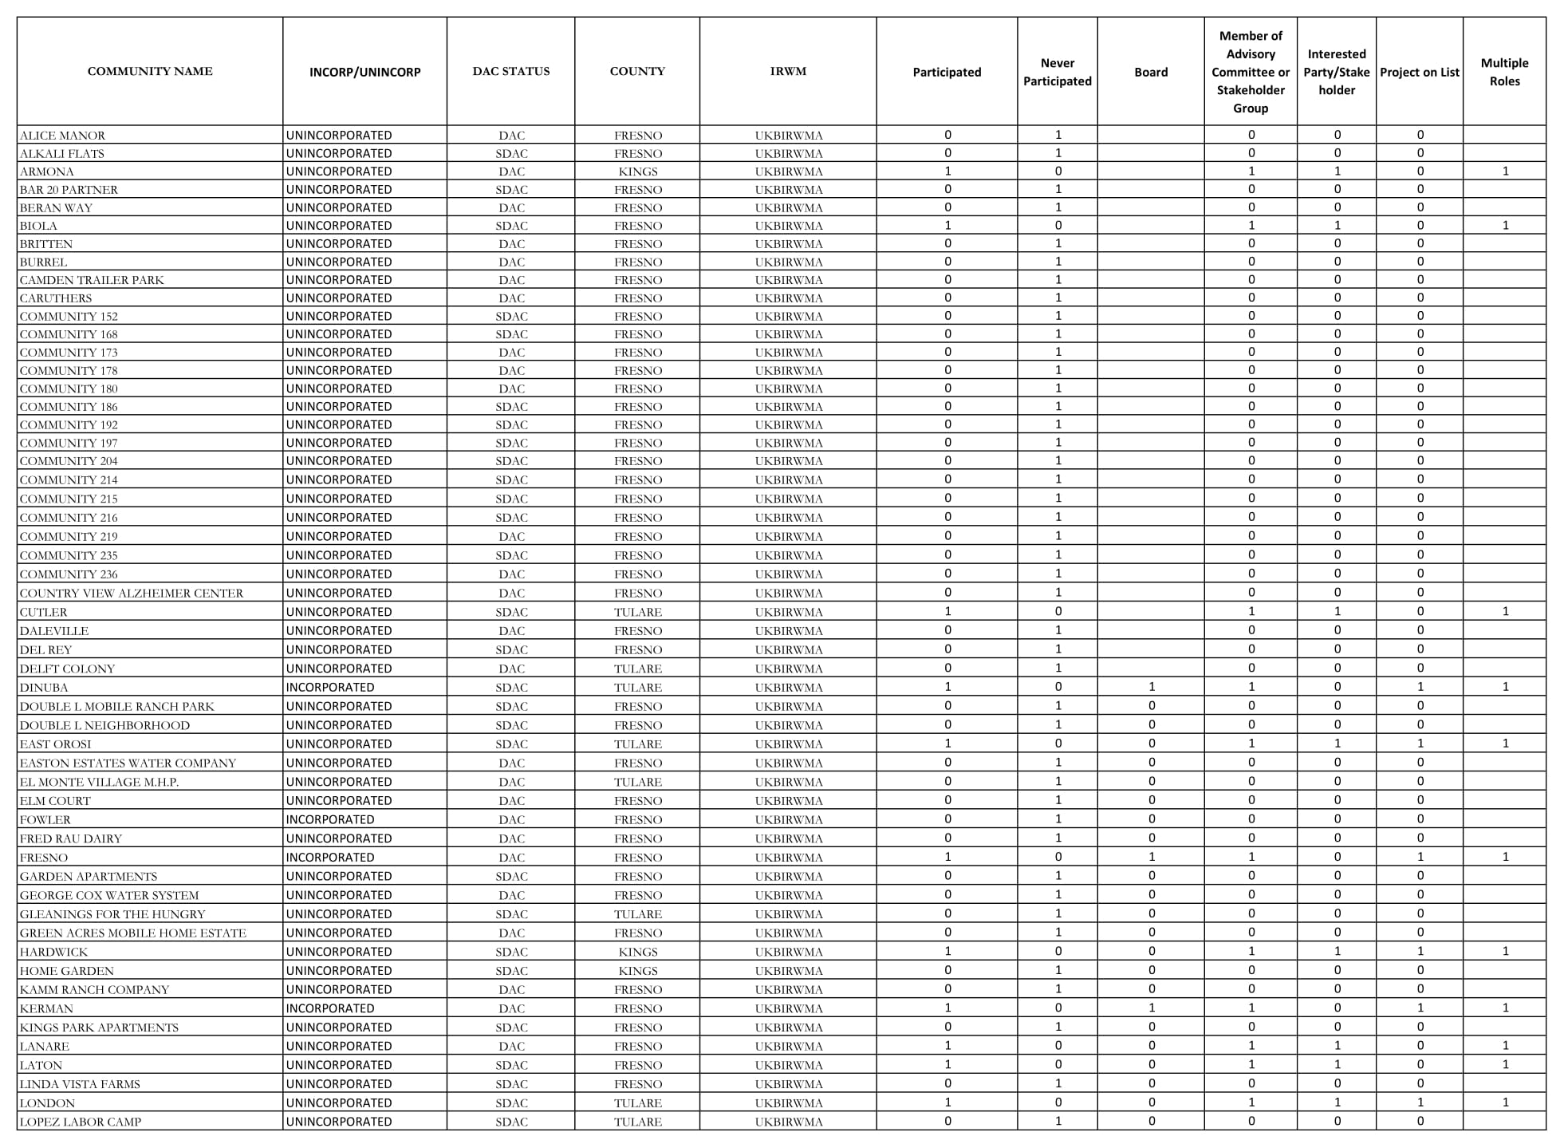

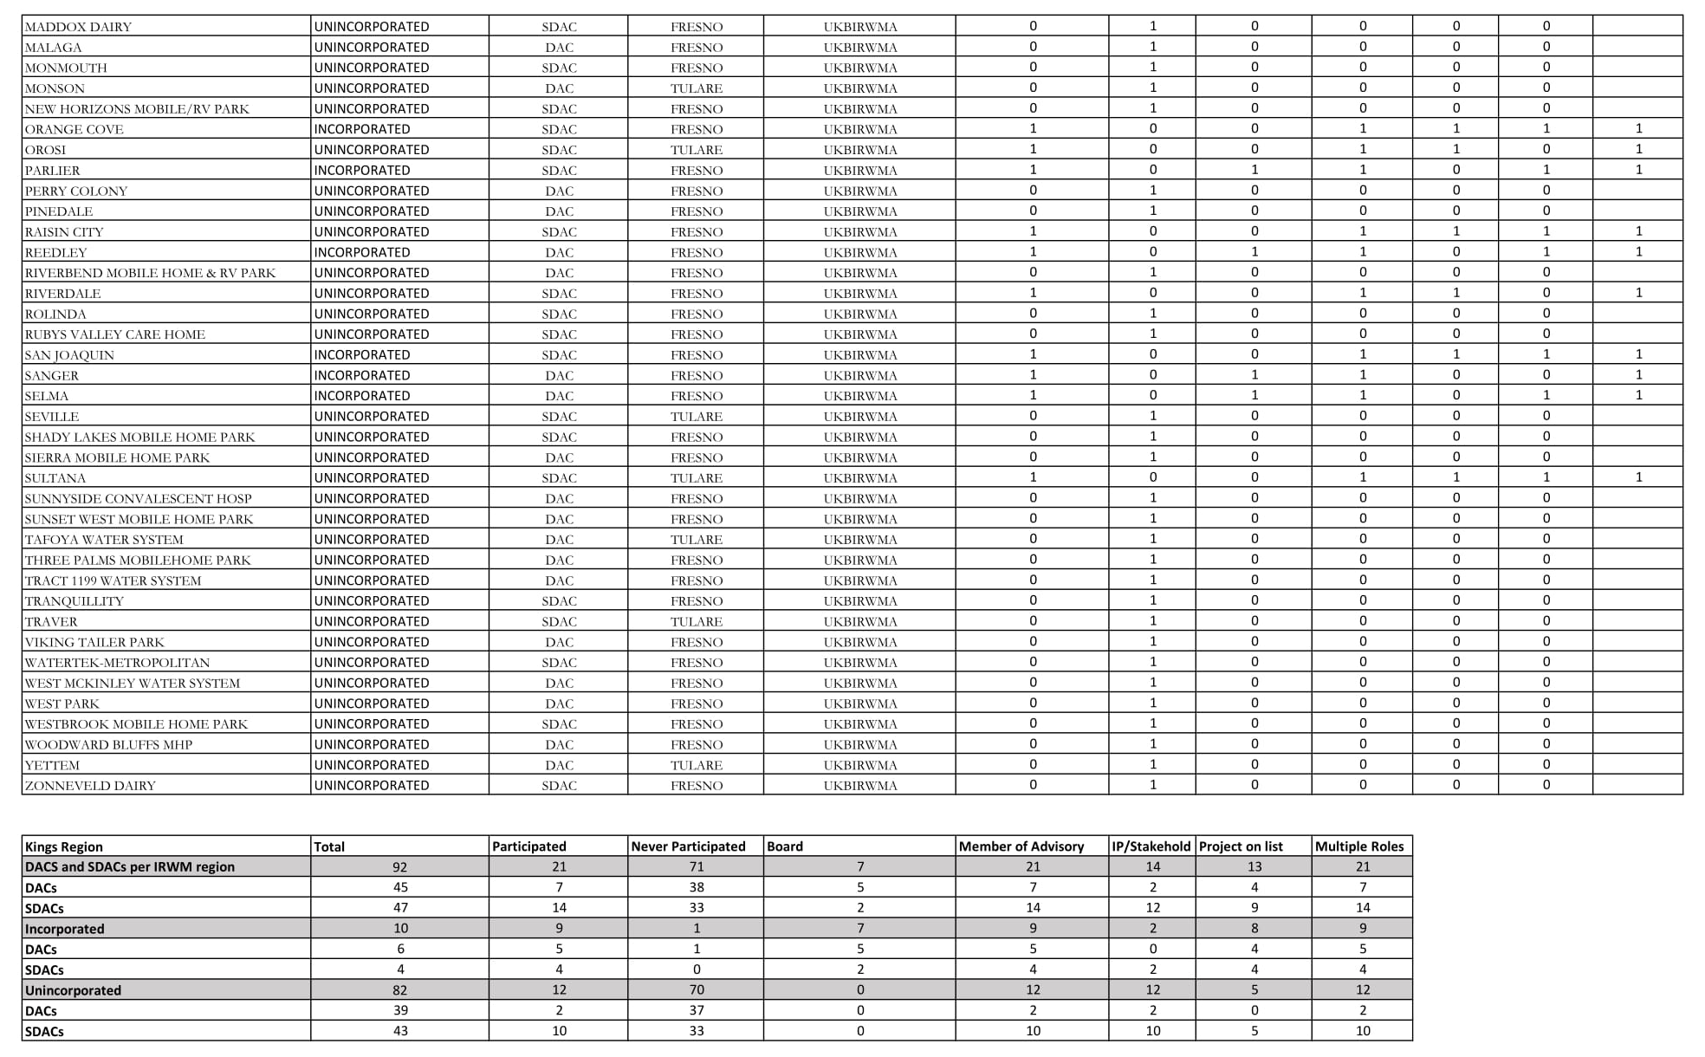

Table 3
Westside-San Joaquin IRWM Region
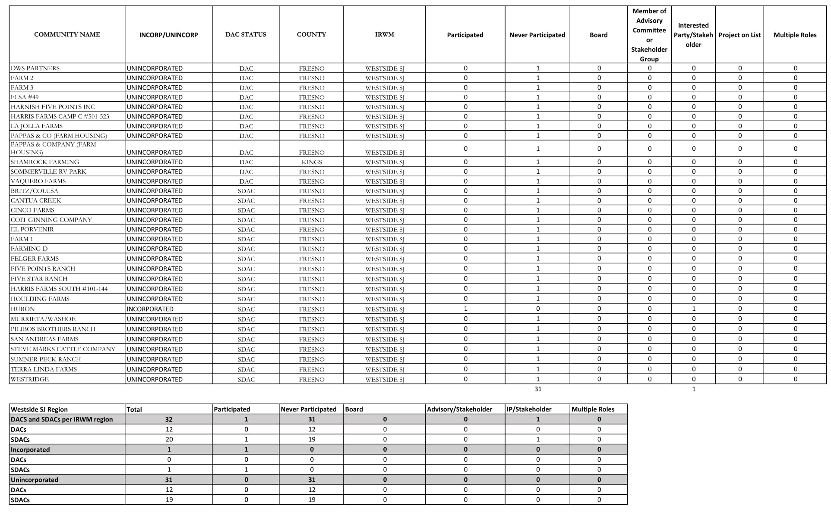

Table 4: Kern IRWM Region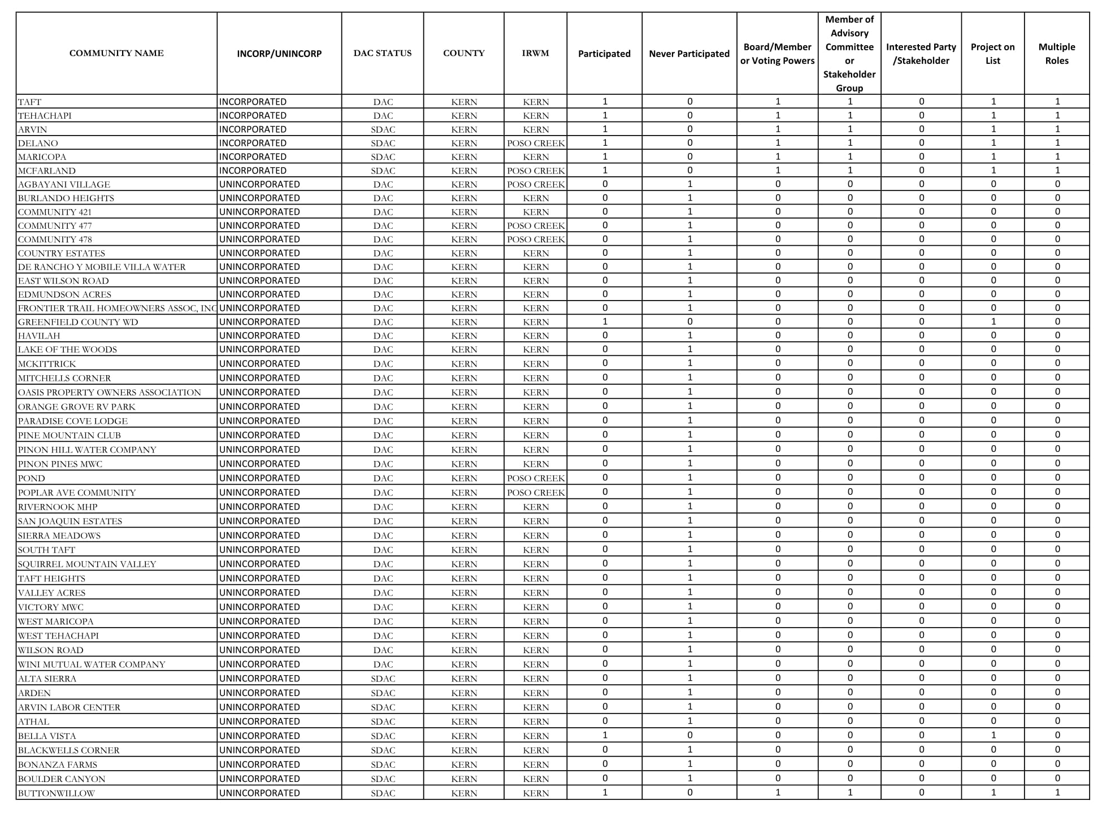
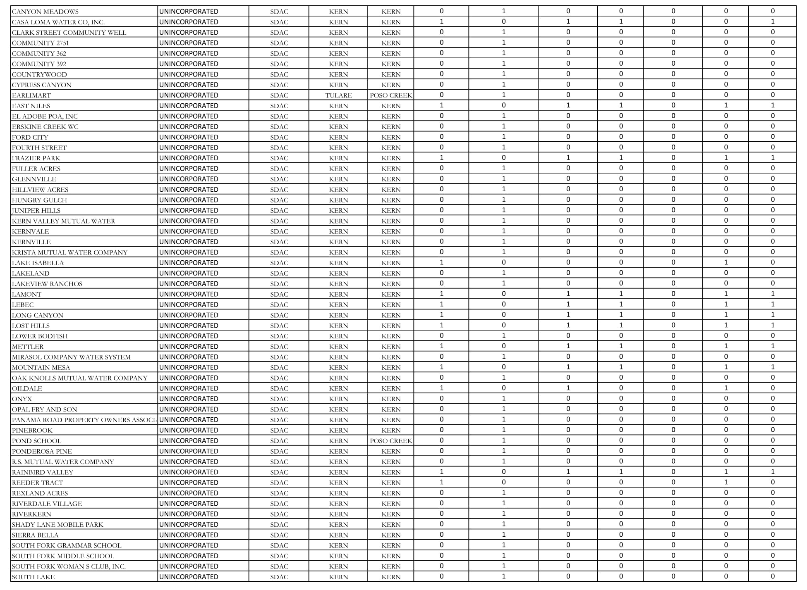

Table 5
Poso Creek IRWM Region
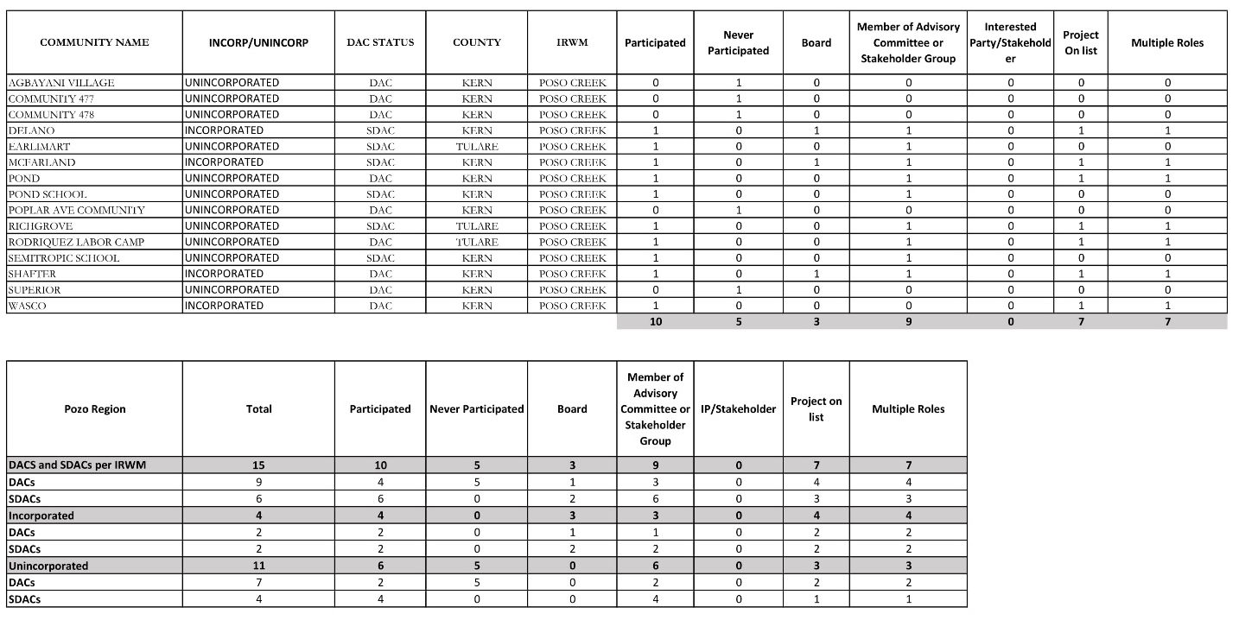

Table 6
Southern Sierra IRWM Region

Table 7
Tule River IRWM Region

California Water Code § 79505.5 (a)
Due to challenges accessing older records, Proposition 50 was not included in the analysis. Additionally, Proposition 50 did not have a DAC set aside. Therefore, the analysis is limited to Propositions where there were formal DAC allocations.
When proposals were partially funded by DWR, IRWM groups generally reduced the allocation to each individual project equally. Distribution of the reduced funding was, however, at the discretion of each group. Throughout this assessment, we have assumed that groups scaled down the funding for each project proportionally to the overall reduction in funding.
When a proposal was not fully funded by DWR, this analysis presumes that reductions in awards were shared proportionally across all projects included in the proposal. See Methods, Section 2.2 (and footnote 3) for more discussion of how this data was treated.
The Drought Grant proposal included five projects, all five of which were noted as benefiting DACs through reducing groundwater pumping, etc. However, no DAC cost share waiver was claimed nor awarded, so this assessment does not consider these projects to be “DAC projects.”

