15.3 General Impacts from Climate Change

Introduction

An increase in global atmospheric greenhouse gas concentrations is contributing to higher temperatures in California (Office of Environmental Health Hazard Assessment, 2018). As greenhouse gas concentrations continue to rise, further changes to California’s climate are anticipated, with additional effects on California water resources, ecosystems, and economy. The extent of these effects will depend on the ultimate level and timing of peak greenhouse gas concentrations. Under the Paris Climate Accord in 2015, a framework was established for limiting the rise in global temperatures under two degrees Celsius. In California, policies have been put in place to reduce greenhouse gas emissions to at least 40% and 80% below the 1990 levels by 2030 and 2050, respectively (California Air Resources Board, 2017). These policies will help to moderate increases in temperature, but uncertainty remains regarding how high greenhouse gas concentrations will be in the future.

Global climate models (GCM) are mechanistic models used to understand and predict how changes in variables such as greenhouse gas concentrations will affect future climate at global scales. GCMs are developed and maintained by various research groups around the world, with each group using a slightly different approach to modeling the underlying atmospheric physics. The 5th Coupled Model Intercomparison Project (CMIP5) is a coordinated experiment to simulate each GCM using the same forcing inputs (i.e. greenhouse gas concentrations). This project permits the comparison of output between different GCMs, providing an estimate of the uncertainty in climate projections. As future concentrations are unknown, CMIP5 uses four different Representative Concentration Pathways (RCPs) to force the models (van Vuuren et al., 2011). The four RCPs, RCP2.6, RCP4.5, RCP6.0, and RCP8.5, represent different levels of greenhouse gas emissions and subsequent concentrations in the atmosphere. The four pathways in order roughly equate to aggressive, moderate, little and no action being taken to reduce greenhouse gas emissions, respectively.

Spatial output from individual GCMs is generally greater than 100km by 100km, making it difficult to directly apply GCM results to heterogeneous areas such as the Southern Sierra Region, which is topographically, climatically, ecologically and hydrologically variable. Instead, output from GCMs must be downscaled, or transformed to a higher resolution, in order to be analyzed at a regional scale. Two commonly used approaches for downscaling are dynamic and statistical. Dynamic downscaling involves running high-resolution, regional mechanistic models using low resolution GCM output as the driving data. Alternatively, statistical downscaling consists of developing statistical relationships between local-scale climate variables and large-scale climate variables that can be modeled by GCMs (Abatzoglou and Brown, 2012).

In this section, we provide a literature review of what is known about climate change impacts on California and the Sierra Nevada. In addition, we incorporate new understanding about the how climate change will affect the Southern Sierra Region by incorporating key findings from the a report from UC Merced. Full details of the findings (and methodology) can be found in appendix **.

Temperatures

Temperatures throughout California and the Sierra Nevada are increasing. Over the period from 1918 to 2006, maximum and minimum temperatures in California rose an average of 0.07°C and 0.17°C per decade, respectively (Cordero et al., 2011). These trends have accelerated since 1970 (Cordero et al., 2011) and particularly during the past decade, with the four hottest years on record occurring between 2014-2017 (Office of Environmental Health Hazard Assessment, 2018). These increases in temperature are consistent with climate projections and indicate that California is already seeing the effects of climate change. In the Sierra Nevada, significant warming has also been observed, although the increases have been smaller than for California as a whole (0.08 and 0.21°C per decade for maximum and minimum temperatures, respectively) (Cordero et al., 2011). For both the Sierra Nevada and California, nighttime temperatures have been rising faster than daytime temperatures.

California temperatures are projected to continue to increase during the 21st century. Using downscaled CMIP5 GCM projections, He et al. (2018) estimated that California temperatures would increase between 1.8 and 2.0°C by mid-century and 2.2 to 2.4°C by the end of the century, even under the optimistic RCP4.5 scenario. Slightly higher estimates are projected for the Southern Sierra Region. For the RCP4.5, mean annual maximum temperatures are projected to increase 2.5°C by mid-century (2040-2069) and 3.3°C by the end of the century (2070-2099) (Figure **). Under the RCP8.5, temperatures are projected to increase 3.4°C and 5.2°C, respectively, over the same time periods. Mean annual minimum temperatures in the Southern Sierra Region are projected to increase 2.3°C (2040-2069) and 2.9°C (2070-2099) under the RCP4.5 scenario and 3.1°C (2040-2069) and 5.0°C (2070-2099) under RCP8.5. All of these finding indicate that temperatures in the Southern Sierra Region are going to substantially increase. Further, the model projections indicate that maximum temperatures will increase more than minimum temperatures. These changes run counter to currently observed temperature increases in California, where minimum temperatures appear to be increasing faster than maximum. However, He et al. (2018) reported similar results throughout California.
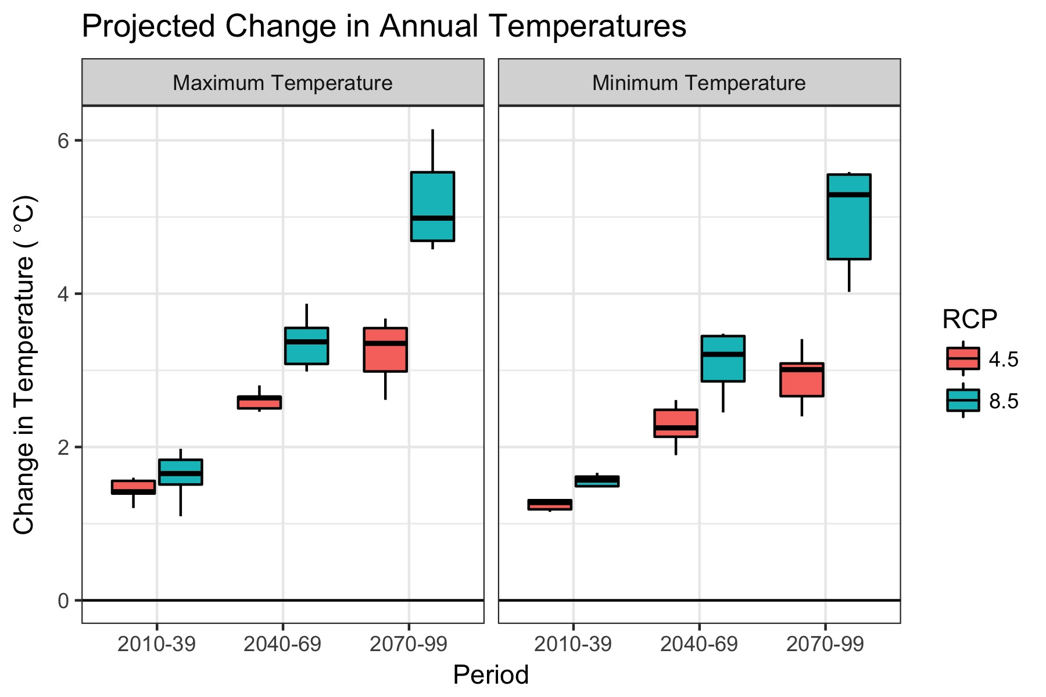
Figure 1: Projected changes in mean annual temperatures for the Southern Sierra Region. Variability in projections represents different GCMs. Historical baseline values of maximum and minimum mean annual temperatures are 15.4°C and 2.2°C, respectively.

Spatial Comparison. Map of the spatial changes in maximum temperature under six scenarios: Historical, RCP4.5 2070-2099 and RCP8.5 2070-2099 for max and min for a representative GCM. (forthcoming)

[Figure **]

Projected increases in temperatures are expected to vary seasonally in the Southern Sierra Region. Increases in winter (Jan-Feb-Mar) maximum temperatures are projected to be slightly smaller than seasonal maximum temperatures during the remainder of the years (Figure **). While winter maximum temperatures will still be well above historical baseline levels, the relatively smaller increases may aid in snowpack accumulation. However, this will be counterbalanced by relatively larger increases in maximum temperatures during the non-winter months, which will decrease soil moisture and increase forest water stress. For seasonal minimum temperatures, the summer (Jul-Aug-Sep) season is projected to show the largest relative increase in temperature (Figure **).

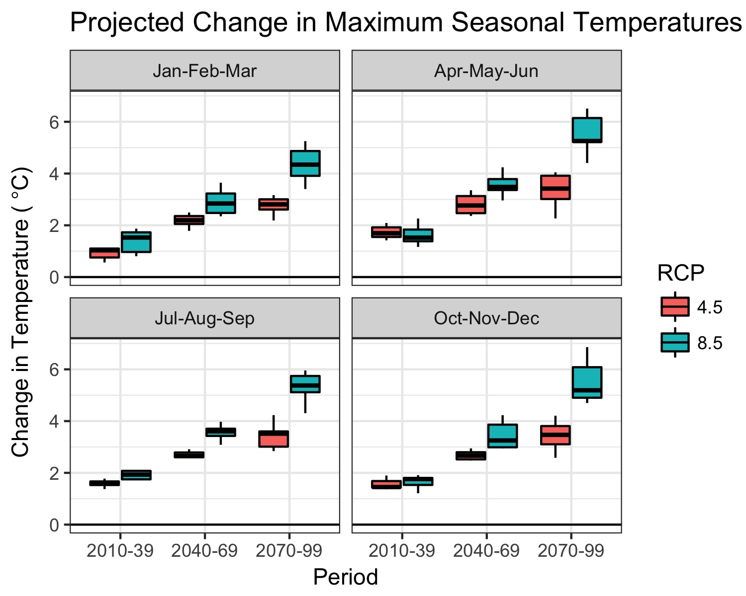
Figure 2: Projected changes in maximum mean seasonal temperatures for the Southern Sierra Region. Variability in projections represents different GCMs. Historical baseline values of maximum mean seasonal temperatures are 8.3°C, 17.4°C, 24.4°C and 11.5°C for Jan-Feb-Mar, Apr-May-Jun, Jul-Aug-Sep, and Oct-Nov-Dec, respectively.

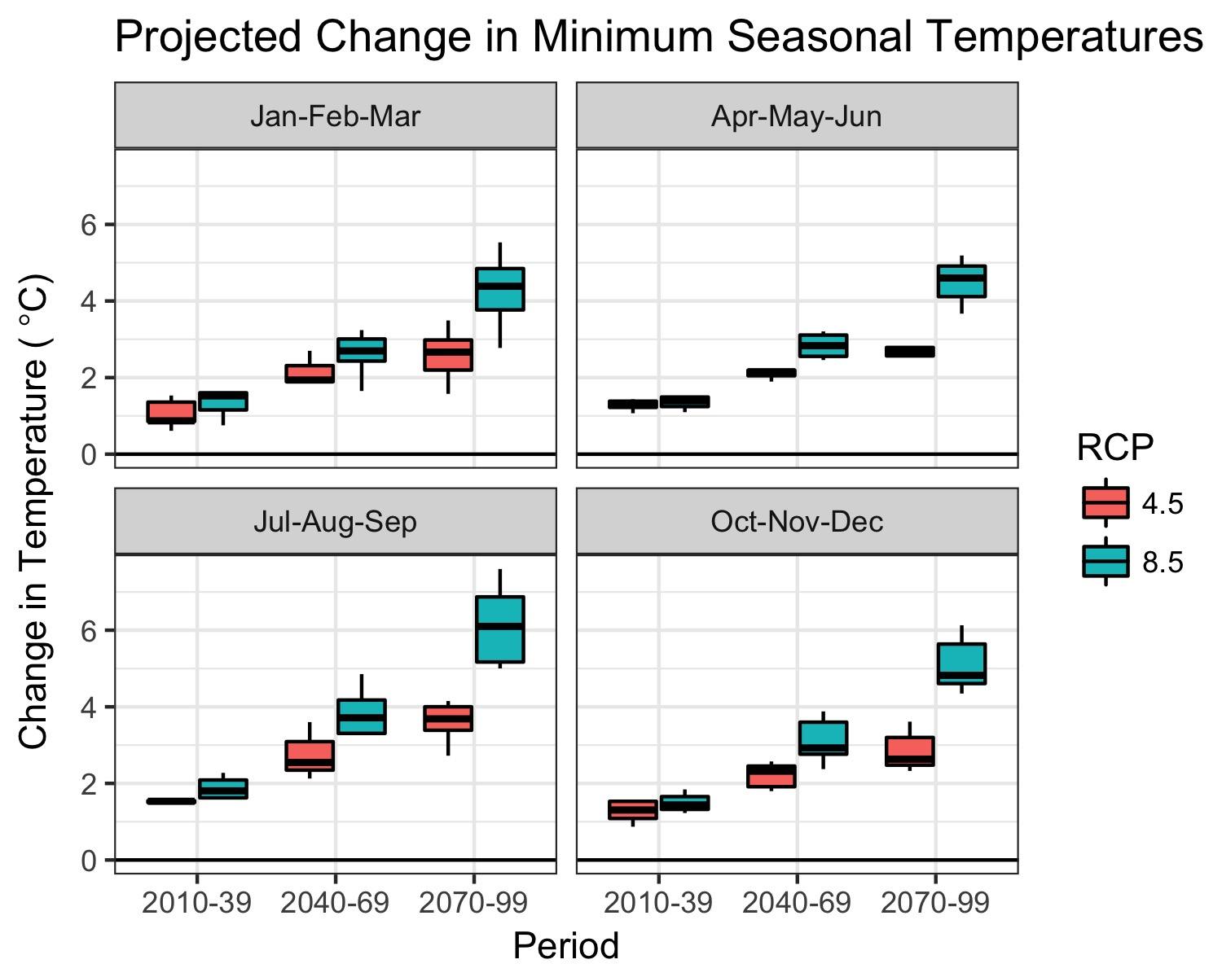
Figure 3: Projected changes in minimum mean seasonal temperatures for the Southern Sierra Region. Variability in projections represents different GCMs. Historical baseline values of minimum mean seasonal temperatures are -3.6°C, 3.5°C, 9.6°C and -0.7°C for Jan-Feb-Mar, Apr-May-Jun, Jul-Aug-Sep, and Oct-Nov-Dec, respectively.
The frequency of heat waves, which are defined as when daily maximum and minimum temperatures exceed a respective percentile threshold, are projected to increase in California (Diffenbaugh and Ashfaq, 2010; Gershunov and Guirguis, 2012). Gershunov and Guirguis (2012) found that both humid nighttime heat waves and dry daytime heat waves would increase will increase with climate change in California, though they note the former is expected to increase more intensely. Extreme heat waves are well-documented to have an adverse affect on ecosystems, agriculture and human health (Meehl and Tebaldi, 2004). It will be important for communities within the Southern Sierra Region to take precautions to protect vulnerable populations during extreme heat waves (Guirguis et al., 2013).

On a final note, increases in temperature are a primary driver behind most of the other climate change related effects that are documented below. For example, changes in snowpack, streamflow timing, forest vulnerability, wildfire, and bark beetles are each directly influenced by increases in temperature. Hence, temperature will be a key metric to accurately predict how climate change will affect the Southern Sierra Region.

Precipitation

Precipitation in California exhibits Mediterranean-climate characteristics, with most precipitation falling during the winter season (November to March) while the remainder of the year is dry. Precipitation in California is also highly variable, with inter-annual variability being the highest in the U.S and annual precipitation totals varying by up to an order of magnitude (Dettinger et al., 2011). This variability is in part due to atmospheric rivers constituting a substantial fraction (20% to 50%) of the total annual precipitation in California (Dettinger et al., 2011). Since California receives relatively atmospheric river events in a given year, a swing of a few more or less storms during a wet season can produce large differences in total precipitation.

Downscaled GCM climate projections for California have generally shown minimal changes in annual precipitation under future warming scenarios (Hayhoe et al., 2004). However, for more recent CMIP5 GCM projections, He et al. (2018) found that annual precipitation ranged from +50% to -25% depending on the individual GCM/scenario investigated (He et al., 2018). However, collectively the models showed small increases in precipitation (1-11%) across different regions of California under the RCP4.5 scenario. Similar results were observed for the Southern Sierra Region, where except RCP8.5 2070-2099 scenario, climate change increased annual precipitation an average of 5%-10% (Figure **).

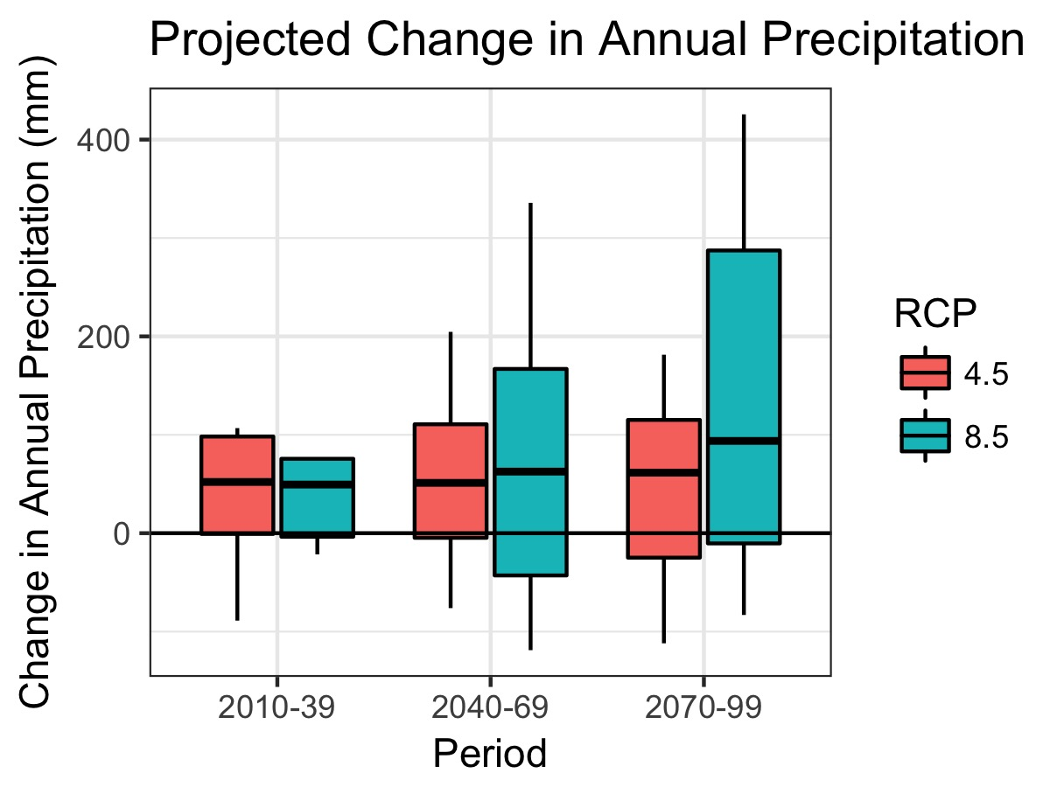
Figure 4: Projected changes in annual precipitation for the Southern Sierra Region. Variability in projections represents different GCMs. Historical baseline annual precipitation is 819 mm/year.

Spatial Comparison. Map of the spatial changes in precipitation for three scenarios: Historical, RCP4.5 2070-2099 and RCP8.5 2070-2099. (forthcoming)

[Figure **]

Although the average amount of precipitation in the Southern Sierra Region is projected to only slightly increase with climate change, there is mounting evidence that inter-annual variability of precipitation will substantially increase, with dry years becoming drier and wet years becoming wetter (Pendergrass et al., 2017). Berg and Hall (2015) have reported that by the end of the century, extremely dry years will become 1.5 - 2 times more frequent and extremely wet years will become 3 times more frequent, with the number of average years becoming more scarce. Climate change will also increase year-to-year volatility swings. Swain et al. (2018) report that transitions from extreme drought to extremely wet conditions, such as was observed from the 2012-2016 drought to the wet 2016/2017 winter, is projected to increase 25% to 100% by the end of the century.

This increase in precipitation extremes will make management of water resources in the Southern Sierra Region more challenging. Excess precipitation during wet years can frequently not be stored in reservoirs due to flood risks. Further, flood risks in the Southern Sierra Region are also increasing due to precipitation shifts from snow to rain. An increase in extremely wet years will only exacerbate this problem. On the other hand, a higher frequency of dry years means that the Southern Sierra Region will also have to deal with extreme droughts more often, stretching water supplies.

Drought

Due to high precipitation variability, California has always been subject to multi-year droughts, where precipitation totals fall well below normal. However, the recent drought from 2012-2016 and projected future droughts are different because periods of low precipitation are more likely to coincide with periods of high temperatures, increasing atmospheric water demands and making conditions drier. It was this combination, very little precipitation and record high temperatures, that contributed to the severity of the California drought (Shukla et al., 2015). As temperatures continue to rise, drought risk is predicted to become even more severe in the future even in the absence of precipitation change (Cook et al., 2015).

For the Southern Sierra Region, the magnitude of droughts under climate change will depend on the magnitude and length of dry years in combination with temperature. In a recent study, He et al. (2018) used a drought index, the Standardized Precipitation-Evapotranspiration Index (SPEI), to investigate changes in future drought severity in California. They found that in the Tulare region of California, which encompassed most of the Southern Sierra Region, that the severity of droughts would increase throughout the century, indicating that small increases in precipitation for the region would not offset the effects of higher temperatures.

Snowpack

Snowpack in the Southern Sierra Region will be affected in many ways as temperatures increase in California. First off, a larger proportion of precipitation is falling as rain than as snow. This effect is most pronounced near the rain-snow transition zone. This zone is particularly sensitive to temperature changes since winter temperatures hover near the freezing point. Increasing temperatures will cause the rain-snow transition zone to migrate upslope and produce a smaller snow footprint. Throughout the western U.S., the areal extent of historical snowfall area is expected to decrease by an average of 30% under RCP8.5 scenarios (Klos et al., 2014). Since the Southern Sierra Region has relatively high elevations, the snowfall area that transitions to predominately rainfall may be smaller than this average. However, significant effects will still be observed at lower elevations.

Winter snowpack will persist for a shorter period of time with climate change. This is partly due to less snow accumulation and partly due to more rapid snow melt. Projections for the western U.S. suggest that the snow-covered period may decrease by 25 days/year by the mid-century under RCP8.5 (Naz et al., 2016). A more transient snowpack will also have implications for the measurement of snow water equivalent (SWE) on April 1st, the traditional date when the snowpack is measured for spring runoff. Naz et al. (2016) project that April 1 SWE may decrease by 50% by mid-century across the western U.S. (RCP8.5), which has considerable implications for water resources. In the Southern Sierra Region, snowpack accumulation during the winter wet season acts as a water reservoir that is slowly released as temperatures warm throughout the spring and summer. Reductions in this reservoir will complicate water resource management in the Region and will likely necessitate that alternative storage solutions be found such as groundwater banking.

Evaporation
- Increase evaporative demand
- Longer growing season

Streamflow
- Quantity
- Streamflow timing
- Flooding
- Hydropower
- Summer low flows

Water Quality

Climate change, in combination with future changes in streamflow regimes and vegetation, will impact water quality in the Southern Sierra Region. These changes, in turn, will have consequences on the management of water in the Region.

Stream temperatures are a key regulator of riparian ecosystems, affecting aquatic species distributions, growth rates and reproduction. Higher water temperatures often have an adverse affect on native species (Isaak et al., 2017). Temperatures in a stream generally vary spatially and temporally and are affected by controls such as atmospheric temperature, radiation, riparian shading, and upstream reservoir releases. As atmospheric temperatures increase with climate change, stream temperatures will also increase. In a study of how streamflow temperatures in the western US are expected to respond to future climate change, Isaak et al. (2017) found that August streamflow temperatures in Central California will increase by about 1.0°C by the end of the century. Using the same dataset, we found that the increase in August streamflow temperatures for the Southern Sierra Region ranged from 0.3°C to 1.6°C, with an average change of 0.9°C. In general, lower elevation/warmer streams should a higher change in temperature than higher elevation/cooler streams.

Review of climate change effects on sediment (forthcoming)

Vegetation Transformation

- Disturbances – forest die-off
- Disturbances – wildfire
- Disturbances – bark beetle
- Species distributions
- Vegetation conversion

References

Abatzoglou, J., Brown, T., 2012. A comparison of statistical downscaling methods suited for wildfire applications. Int. J. Climatol. 32, 772–780. doi:10.1002/joc.2312
Berg, N., Hall, A., 2015. Increased Interannual Precipitation Extremes over California under Climate Change. J. Clim. 28, 6324–6334. doi:10.1175/JCLI-D-14-00624.1
California Air Resources Board, 2017. California’s 2017 Climate Change Scoping Plan.
Cook, B.I., Ault, T.R., Smerdon, J.E., 2015. Unprecedented 21st century drought risk in the American Southwest and Central Plains. Sci. Adv. 1, e1400082. doi:10.1126/sciadv.1400082
Cordero, E.C., Kessomkiat, W., Abatzoglou, J., Mauget, S.A., 2011. The identification of distinct patterns in California temperature trends. Clim. Change 108, 357–382. doi:10.1007/s10584-011-0023-y
Dettinger, M.D., Ralph, F.M., Das, T., Neiman, P.J., Cayan, D.R., 2011. Atmospheric Rivers, Floods and the Water Resources of California. Water 3, 445–478. doi:10.3390/w3020445
Diffenbaugh, N., Ashfaq, M., 2010. Intensification of hot extremes in the United States. Geophys. Res. Lett. 37. doi:10.1029/2010GL043888
Gershunov, A., Guirguis, K., 2012. California heat waves in the present and future. Geophys. Res. Lett. 39. doi:10.1029/2012GL052979
Guirguis, K., Gershunov, A., Tardy, A., Basu, R., 2013. The Impact of Recent Heat Waves on Human Health in California. J. Appl. Meteorol. Climatol. 53, 3–19. doi:10.1175/JAMC-D-13-0130.1
Hayhoe, K., Cayan, D., Field, C.B., Frumhoff, P.C., Maurer, E.P., Miller, N.L., Moser, S.C., Schneider, S.H., Cahill, K.N., Cleland, E.E., Dale, L., Drapek, R., Hanemann, R.M., Kalkstein, L.S., Lenihan, J., Lunch, C.K., Neilson, R.P., Sheridan, S.C., Verville, J.H., 2004. Emissions pathways, climate change, and impacts on California. Proc. Natl. Acad. Sci. 101, 12422–12427. doi:10.1073/pnas.0404500101
He, M., Schwarz, A., Lynn, E., Anderson, M., 2018. Projected Changes in Precipitation, Temperature, and Drought across California’s Hydrologic Regions in the 21st Century. Climate 6, 31. doi:10.3390/cli6020031
Isaak, D.J., Wenger, S.J., Peterson, E.E., Hoef, J.M.V., Nagel, D.E., Luce, C.H., Hostetler, S.W., Dunham, J.B., Roper, B.B., Wollrab, S.P., Chandler, G.L., Horan, D.L., Parkes‐Payne, S., 2017. The NorWeST Summer Stream Temperature Model and Scenarios for the Western U.S.: A Crowd‐Sourced Database and New Geospatial Tools Foster a User Community and Predict Broad Climate Warming of Rivers and Streams. Water Resour. Res. 53, 9181–9205. doi:10.1002/2017WR020969
Klos, P.Z., Link, T.E., Abatzoglou, J.T., 2014. Extent of the rain-snow transition zone in the western U.S. under historic and projected climate. Geophys. Res. Lett. 41, 4560–4568. doi:10.1002/2014GL060500
Meehl, G.A., Tebaldi, C., 2004. More Intense, More Frequent, and Longer Lasting Heat Waves in the 21st Century. Science 305, 994–997. doi:10.1126/science.1098704
Naz, B.S., Kao, S.-C., Ashfaq, M., Rastogi, D., Mei, R., Bowling, L.C., 2016. Regional hydrologic response to climate change in the conterminous United States using high-resolution hydroclimate simulations. Glob. Planet. Change 143, 100–117. doi:10.1016/j.gloplacha.2016.06.003
Office of Environmental Health Hazard Assessment, 2018. Indicators of Climate Change in California. California Environmental Protection Agency.
Pendergrass, A.G., Knutti, R., Lehner, F., Deser, C., Sanderson, B.M., 2017. Precipitation variability increases in a warmer climate. Sci. Rep. 7, 17966. doi:10.1038/s41598-017-17966-y
Shukla, S., Safeeq, M., AghaKouchak, A., Guan, K., Funk, C., 2015. Temperature impacts on the water year 2014 drought in California. Geophys. Res. Lett. 42, 2015GL063666. doi:10.1002/2015GL063666
Swain, D.L., Langenbrunner, B., Neelin, J.D., Hall, A., 2018. Increasing precipitation volatility in twenty-first-century California. Nat. Clim. Change 8, 427. doi:10.1038/s41558-018-0140-y
van Vuuren, D.P., Edmonds, J., Kainuma, M., Riahi, K., Thomson, A., Hibbard, K., Hurtt, G.C., Kram, T., Krey, V., Lamarque, J.-F., Masui, T., Meinshausen, M., Nakicenovic, N., Smith, S.J., Rose, S.K., 2011. The representative concentration pathways: an overview. Clim. Change 109, 5. doi:10.1007/s10584-011-0148-z

